Asset Management System

MILESTONE 3

Orlando Nico Rosario

Table of Contents

Milestone 1

**1.0 Introduction** 5

**2.0 System Planning and Selection** 6

2.1 Service Request Form 6

2.2 Scenario 7

**2.2.1 Project Scope** 7

**2.2.2 Project Alternatives** 7

**2.2.3 Project Feasibility** 8

*2.2.3.1 Economic* 8

*2.2.3.2 Operational* 8

*2.2.3.3 Technical* 8

*2.2.3.4 Schedule* 9

*2.2.3.5 Legal and Contractual* 9

*2.2.3.6 Political* 9

2.3 Project Tasks 10

2.4 Budgeting 13

2.5 ROI and Break-Even Analysis 15

2.6 Communication Plan 16

2.7 Project Standards and Procedures 17

2.8 Risk Assessment 18

2.9 Baseline Project Plan 19

2.10 Project Scope Statement 21

**3.0 User Requirements** 22

**4.0 System Requirements** 22

Milestone 2

**5.0 Data Flow Diagrams** 23

5.1 Context Diagram 23

5.2 Level 0 Diagram 24

5.3 Leveled Diagrams 25

**5.3.1 Level 1 Data Flow Diagrams** 25

**5.3.2 Primitive Data Flow Diagrams 27**

**5.3.3 Gap Analysis 27**

**5.3.4 Naming Standards for Processes 27**

**5.3.5 Naming Standards for Data Flows 27**

**5.3.6 Data Consistency and Conservation 27**

**6.0 Entity Relationship Diagrams** 28

6.1 Relationships and Cardinalities Explained 28

6.2 Conceptual Entity Relationship Diagrams 29

6.3 Entity Relationships 30

**7.0 Data Dictionary** 31

Milestone 3

**8.0 Form and Report Designs** 32

**9.0 Interface and Dialogue Designs** 50

9.1 Design Dialogue Sequence Diagram 63

**10.0 Documentation** 64

10.1 User Manual and Training Material 64

10.2 System Documentation 78

**10.2.1 Database Manual** 78

**10.2.2 Program Manual** 82

**10.2.3 Testing Data** 82

**10.2.4 Maintenance Manual** 83

**11.0 Source Code** 84

**12.0 GPT Zero and Turnitin Scores** 114

**1.0 Introduction**

Conquer HomeWorks is an inter-state home remodeling shop that has grown beyond its current systems of organization. In 2020 Conquer was formed on the basis of providing local, personalized solutions for people considering home remodeling consultation, design, and construction. However, over the past 5 years, Conquer has taken on over 300 concurrent clients and expanded to more than 50 employee and 5 locations in Massachusetts alone. With the burst in business and employment need, there must be internal efforts to maintain organization and protect business assets.

As the amount of hardware in use continues to grow, maintaining visibility and accountability has become and challenge for the locations Directors of Operations (DOO) as well as the Information Technology (IT) department. With hardware being provisioned to users not coming back, hardware lost in transit, and no formal tracking of these multi thousand dollar items, there is a great need for a formal management system that can be local, and not an excel spreadsheet.

This new system should allow for the insertion of new assets (devices, specialty hardware, and licenses), management of users and locations, warranty tracking, and asset retirement in one system. Logs should be able to be pulled on device assignment history and reports of devices close to warranty expiration.

**2.0 System Planning and Selection**

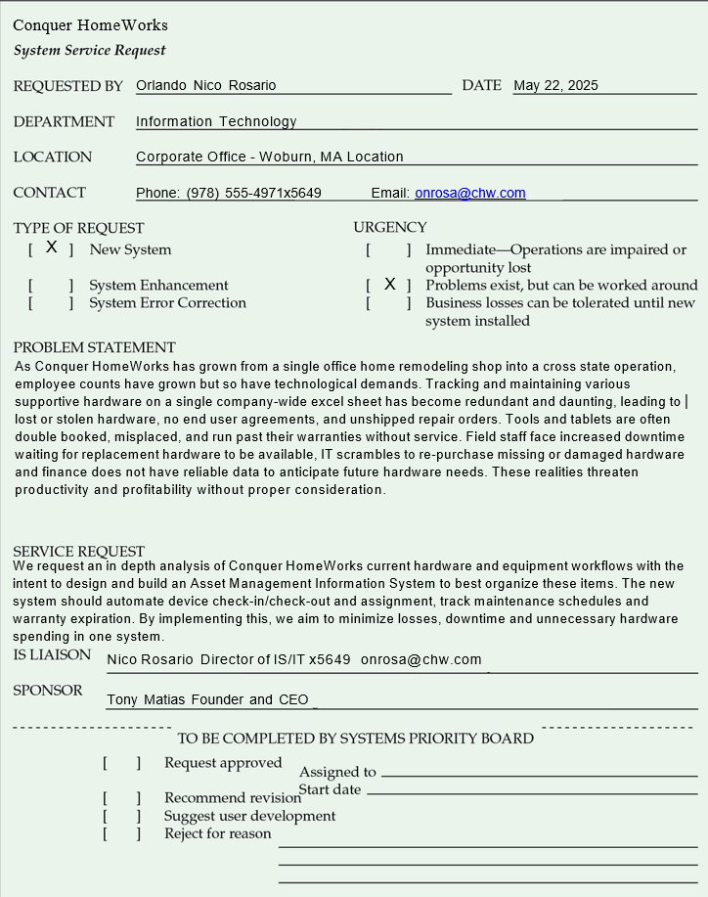2.1 Service Request Form

2.2 Scenario

**2.2.1 Project Scope**

The project being presented is as Asset Management System (AMS) that will provide an all-in-one management solution for hardware and software assets across the organization. The system will support asset assignment to users, warranty tracking, and device check-ins/checkouts. For IT and Management alike, administrators will be able to view current assignments, usage logs, and generate reports on company assets. This system is not intended to support items that could be considered consumable (construction supplies, paint, or custom ordered material) or provide employee hardware usage data. Integration into other system can be discussed post integration.

**2.2.2 Project Alternatives**

During our research many options and paths were considered. The underlying factor for each option that was considered is the need to stray away from our current system of using excel sheets. While there is no upfront cost to development or training, there are major error rates, no audit capability, high threat of loss, fraud, or abuse, and its overall not scalable.

Option One, purchase an off the shelf, ‘Turnkey’ software. Products such as Asset Tiger or FreshService ITAM provide a variety features with mobile functionalities and tech support but have limited customization to organization specific needs, recurring costs, and are ultimately cloud hosted, which come with their own set of vulnerabilities.

Option Two, using open source software such as Snipe-IT. Snipe-IT has no cost to license, many enterprise deployments and an active community with integration capabilities and public API’s. However, Snipe-IT requires a heavy understanding of various technical standpoints that can be daunting to maintain or deploy. Snipe-IT provides various features that are not required by Conquer and could lead to increased implementation time as well as support limited to community or paid tiers.

Option Three, developing software internally. This option was ultimately chosen as the system can be customized to specific needs of Conquer and avoids unnecessary features while being scalable. This does require development time, documentation, and testing but provides intimate knowledge of a lightweight application that can easily be supported for future case.

**2.2.3 Project Feasibility**

*2.2.3.1 Economic (more details in 2.4 and 2.5)*

The development of an in-house, lightweight, scalable solution is not as impactful as we originally thought. Only requiring 4 weeks of actual development, this application can be set for completion in less time than stakeholders would spend in a knowledge phase for outsourced systems. The long term savings outweigh the upfront cost, being beyond justifiable from an economic standpoint.

Conquer has been facing hardware losses due to our poor practices and insecure system. Repurchasing of various multi-thousand dollar items and double booking of shared devices or tools brings the company losses financially and in-field operating hours. That’s lost billable hours, and heavily reduced operational efficiency.

Over the next 12-24 months, the system is expected to save tens of thousands on equipment losses, lost billable hours, and reallocate IT hours to more important needs.

*2.2.3.2 Operational*

Primary users of this new systems, Directors of Operations (DOOs), IT staff, and Administrative Support Staff already have integrated into their workflows the preexisting shared excel document use. Moving to an integrated, UI based system will make this easier than before and will benefit these staff directly.

This systems design is intended to replace the existing system with one that has less reliance on email chains and shared folders and directly updates workflows easily. Asset check-in/checkout, assignment, and tracking is all already being done, just in a more archaic way. Adoption/integration time is expected to be minimal and widely accepted by users as a long overdue update.

*2.2.3.3 Technical*

The project builds onto existing systems put in place from the IT department. This new system will be hosted on the preexisting Conquer server and reside on a network drive for enterprise wide updates to be shared and managed, together. Shortcuts can be placed or created onto the required personnels desktops for easier access. Hosting on the server allows all Admins with access to the new ‘Asset Management Folder’ and Asset Management System means no extra server space or hosting systems are required, driving down recurring cost.

This system is feasible within Conquers’ current infrastructure, as detailed above, and aligns with current staff knowledgebases. The application will be python-based and developed with a GUI for front-end use, using MySQL for the backend database. This stack is both lightweight and highly responsive allowing for quick and easy operation. Both Python and MySQL are widely supported and documented meaning anyone can learn the intrinsics of the system, even with little programatical knowledge. No licensure or new hardware is needed, reducing overall project cost exponentially.

*2.2.3.4 Schedule*

This project is feasible within a 50-60 day period, using business hours. All core development is scheduled to get done within 3-4 weeks and have been broken down into Gantt and PERT charts. Supportive tasks are spread out throughout this project development and balanced to avoid deadline pressures or work overflows. Dependencies have been declared, and realistic time estimates have been made, this project can be comfortably finalized within 2 months.

*2.2.3.5 Legal*

All subsystems are hosted internally and are secured via inhouse security protocols. Conquer does not need to apply and compliance standards to this system. Python and MySQL carry permissive licensing, requiring no extra permission for use. The Asset Management System does not involve any data sharing with third parties as it will be created in house. With this, the project is legally and contractually feasible.

*2.2.3.6 Political*

This project has strong internal support from leadership and DOO’s. All parties agree that a new system should be created and implemented with potential, minor resistance from the field teams. Finance will benefit from improved visibility and reduced equipment losses. This system is intended for all-around workflow simplification.

2.3 Project Tasks

|  |  |  |  |
| --- | --- | --- | --- |
| TASK | Estimated Days | Begin Date | End Date |
| 1 - Requirements Gathering | 3 | 6/2/2025 | 6/4/2025 |
| 2 - System Design | 7 | 6/4/2025 | 6/11/2025 |
| 3 - Database Engineering | 7 | 6/11/2025 | 6/18/2025 |
| 4 - GUI Development | 7 | 6/18/2025 | 6/25/2025 |
| 5 - Logic Development | 7 | 6/25/2025 | 7/2/2025 |
| 6 - Reporting Development | 5 | 7/2/2025 | 7/7/2025 |
| 7 - Testing and Debugging | 7 | 7/7/2025 | 7/14/2025 |
| 8 - Documentation | 3 | 7/14/2025 | 7/17/2025 |
| 9 - Installation | 4 | 7/17/2025 | 7/21/2025 |

**Estimated Time**

**Gantt Chart**

**PERT Table with Estimated Total Completion**

|  |  |  |  |  |  |
| --- | --- | --- | --- | --- | --- |
| TASK | Estimated Duration (Days) | | | Estimated Time | Dependencies |
| O | R | P | (O+4R+P)/6 |
| 1 - Requirements Gathering | 2 | 3 | 4 | 3.0 |  |
| 2 - System Design | 5 | 7 | 9 | 7.0 | 1 |
| 3 - Database Engineering | 5 | 7 | 9 | 7.0 | 1,2 |
| 4 - GUI Development | 5 | 7 | 9 | 7.0 | 1,2 |
| 5 - Logic Development | 5 | 7 | 9 | 7.0 | 3, 4 |
| 6 - Reporting Development | 3 | 5 | 7 | 5.0 | 5 |
| 7 - Testing and Debugging | 5 | 7 | 9 | 7.0 | 6 |
| 8 - Documentation | 2 | 3 | 4 | 3.0 | 6 |
| 9 - Installation | 2 | 4 | 6 | 5.0 | 8 |
|  | Estimated Total Completion Time: | | | 50 Days |  |

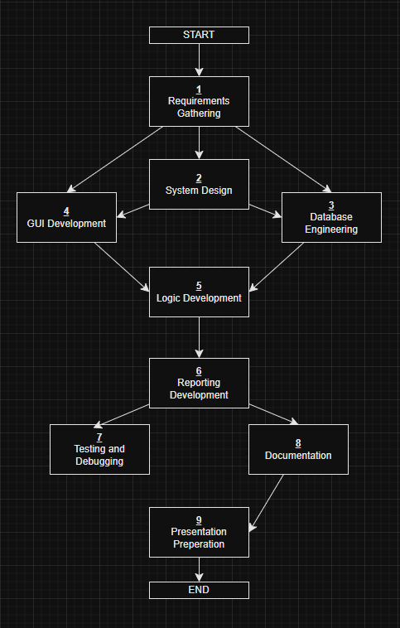**Critical Path and Pert Diagram**

|  |  |  |  |  |
| --- | --- | --- | --- | --- |
| TASK | TE | TI | Slack | Critical Path? |
| 1 - Requirements Gathering | 3 | 3 | 0 | Yes |
| 2 - System Design | 7 | 7 | 0 | Yes |
| 3 - Database Engineering | 7 | 7 | 0 | Yes |
| 4 - GUI Development | 7 | 7 | 0 | Yes |
| 5 - Logic Development | 7 | 7 | 0 | Yes |
| 6 - Reporting Development | 5 | 5 | 0 | Yes |
| 7 - Testing and Debugging | 7 | 9.5 | 2.5 | No |
| 8 - Documentation | 3 | 3 | 0 | Yes |
| 9 - Installation | 4 | 4 | 0 | Yes |

**Slack**

2.4 Budgeting

**Tangible Benefits**

|  |  |  |
| --- | --- | --- |
| Benefit | Detail | Amount |
| Recovered Assets | Lost/Misplaced/Stolen Asset reduction (est. 6 ) | ~$9,000 |
|  |
| Downtime Reduction | Inactive field hours awaiting replacement hardware (@100/hr) | ~$5,000 |  |
|  |
| Hardware Reordering | Reduced duplication of hardware (ordering when assumed lost, est. 3) | ~$4,500 |  |
|  |
| License/Software Control | Removing unused licenses (est. 5) | ~$100 |  |
|  |
| Warranty Control | Warranties revitalizing broken/damaged assets (est. 5) | ~$7,500 |  |
|  |
|  | Estimated Total Savings Year 0 | $26,100.00 |  |
| *Discount Rate 12%* | Estimated Total Savings Year 1 | $22,968.00 |  |
| *Discount Rate 12%* | Estimated Total Savings Year 2 | $20,211.84 |  |
| *Discount Rate 12%* | Estimated Total Savings Year 3 | $17,786.42 |  |
| *Discount Rate 12%* | Estimated Total Savings Year 4 | $15,652.05 |  |

With the introduction of this new system, end users (DOO’s, IT Staff, and administrative support staff) will experience a streamlined, efficient, and new way of asset management and reporting. All hardware is now accounted for and can be tracked to staff across all management tiers and various locations if stocked. This will hold accountability to people and departments, reducing loss, preventing abuse and fraud, and limiting misplacement. All hardware that is pre-allocated to field techs will no longer be double booked, and field visits will be properly prepared for reducing inactive field hours. A great reduction in hardware reordering is expected as there will be less loss and less ad hoc/as needed purchasing. Expenses are reduced on that front because of proper initial preparation. Audits of expiring or out of use licenses can be pulled for cost reduction. Warranties can now be actively accounted for, and device can be tracked as ‘In Warranty’ streamlining warranty claim workflows and getting hardware back into the hands of staff.

**One Time Costs – Year 0**

|  |  |  |
| --- | --- | --- |
| Benefit | Detail | Amount |
| Internal Development | 28 work days @ $35/hr (avg rate) (IT gets paid anyways) | ~$7,840 |
|  |
| User Training | Onboarding Admins, presentation and meeting with Admins (2 Hour Meeting) | ~$300 |  |
|  |
| Documentation and Training Material | Creating Internal User Guides 3 work days @ $35/hr | ~$840 |  |
|  |
| Host Infrastructure | Existing OnPrem Server | ~$0 |  |
|  |
|  | Estimated Total Cost Year 0 | ~$8,980 |  |

There are set costs for the creation and implementation of this system, accounted for above. These mainly consist of costs of labor for our staff that would be an expense if we outsourced the system development to a Software Development Company or IT Managed Service Provider. Ultimately, IT staff would be getting paid their hourly rates anyways and this can be looked at not as a one-time cost, but part of regular staff salaries. Of course this could also be turned into a bonus or overtime budget for IT staff incentive. Thankfully, we already hold an onprem server at the headquartered location in Lawrence, MA and staff already have VPN access via Cisco provisioned to their devices for access to Network Drives within this onprem server from any of our 5 shop locations. This all limits the hosting infrastructure cost as it simply already is set in place. This project is really built off of what we already have, limiting costs, maximizing return, and generating operational efficiency.

**Recurring Costs – Year 1-5**

|  |  |  |
| --- | --- | --- |
| Benefit | Detail | Amount |
| Annual Trainings | 1 Hour Meeting with Admins | ~$150 |
|
| Application Maintenance | As Needed Patches and HotFixes (est. semi-annually 4hr each @ 35/hour | ~$280 |
|
|
|  | Estimated Recurring Costs | ~$430 |

|  |  |  |  |  |  |  |  |
| --- | --- | --- | --- | --- | --- | --- | --- |
|  |  |  |  |  |  |  |  |
|  | Years | | | | | | |
|  | 0 | 1 | 2 | 3 | 4 | 5 | Totals |
| Net Economic Benefit | $ - | $ 26,100.00 | $ 26,100.00 | $ 26,100.00 | $ 26,100.00 | $ 26,100.00 |  |
| Discount Rate (12%) | 1.00 | 0.88 | 0.77 | 0.68 | 0.60 | 0.53 |  |
| PV of Benefits | $ - | $ 22,968.00 | $20,211.84 | $17,786.42 | $15,652.05 | $13,773.80 |  |
|  |  |  |  |  |  |  |  |
| NPV of All Benefits |  | $19,008.00 | $39,219.84 | $57,006.26 | $72,658.31 | $86,432.11 | $86,432.11 |
|  |  |  |  |  |  |  |  |
| One Time Cost | $ 8,980.00 |  |  |  |  |  |  |
|  |  |  |  |  |  |  |  |
| Recurring Costs | $ - | $ (430.00) | $ (430.00) | $ (430.00) | $ (430.00) | $ (430.00) |  |
| Discount Rate (12%) | 1.00 | 0.8929 | 0.7972 | 0.7118 | 0.6355 | 0.5674 |  |
| PV of Costs | $ - | $ (378.40) | $ (332.99) | $ (293.03) | $ (257.87) | $ (226.92) |  |
|  |  |  |  |  |  |  |  |
| NPV of All Cost | $ (8,980.00) | $ (9,358.40) | $ (9,691.39) | $ (9,984.42) | $ (10,242.29) | $ (10,469.21) | $ (10,469.21) |
|  |  |  |  |  |  |  |  |
| Overall NPV |  |  |  |  |  |  | $ 96,901.32 |
|  |  |  |  |  |  |  |  |
| ROI = Overall NPV/NPV of All Costs | |  |  |  |  |  | 926% |
|  |  |  |  |  |  |  |  |
| Break-Even Analysis | |  |  |  |  |  |  |
| Years | | 0 | 1 | 2 | 3 | 4 | 5 |
| Yearly NPV CashFlow | | $ (8,980.00) | $18,629.60 | $16,394.05 | $14,426.77 | $12,695.55 | $11,171.09 |
| Overall NPV CashFlow | | $ (8,980.00) | $9,649.60 | $26,043.65 | $40,470.42 | $53,165.97 | $64,337.06 |
|  |  |  |  |  |  |  |  |
| Project Break-Even occurs between year 0 and 1 | | | | |  |  |  |
| Year 0 Cash Flow/ Year 1 CashFlow = .3976 | | |  |  |  |  |  |
| Actual Break-Even occurred at .3976 years | | | | |  |  |  |
| Break-even occurs on October 25, 2025. | | | | |  |  |  |
| (365*.3976 = 145days, 145+ start date of 6/2/25 = 10/25/25) | | | |  |  |  |  |

2.5 ROI and Break-Even Analysis

2.6 Communication Plan

Per communication outlines defined is the Communication Plan, there are to be Weekly Development meetings to track the progress of the development cycle of this project. Those are to be held between the CTO/Project Manager and Project Manager/Developer. Prior to that there is an initial stakeholder meeting to describe timeframes and higher level understandings. After, there will be Implementation meetings, then announcements and application training seminars following by a closing meeting and surveys.

|  |  |  |  |
| --- | --- | --- | --- |
| Stakeholders | Goal | Medium | Date/Frequency |
| IT/IS, CTO, Project Manager, Directors of Operations, COO, Administrative Support Staff | Initial Project Plan Meeting, discuss timeframes, budget, concerns, high level system capabilities | F2F | 6/4/2025 |
|  |
|  |
| CTO, Project Manager | High level Project Updates and Progress | F2F or Teams | Thursday Weekly |  |
| Assigned IT/IS Developer and Project Manager | Discuss last week’s completions, current week schedule/workflow | F2F or Teams | Monday Weekly |  |
|  |
| CTO, Project Manager, Assigned IT/IS Developer | Implementation workflows, post development ideas and concerns, application walkthrough | F2F or Teams | 7/16/2025 |  |
|  |
| IT/IS, CTO, Project Manager, Directors of Operations, COO, Administrative Support Staff | Implementation Announcement, Documentation Overview, changes to expect | F2F | 7/17/2025 |  |
|  |
|  |
| IT/IS, DOO's, Administrative Support Staff | Hands on Application Training, Q&A | F2F or Teams | 7/18/2025 |  |
|  |
| IT/IS, CTO, Project Manager | Project Close, questions comments concerns, possible future integrations | F2F or Teams | 7/21/2025 |  |
|  |
| IT/IS, CTO, Project Manager, Directors of Operations, COO, Administrative Support Staff | End User Survey to measure overall feeling towards application | email | 7/25/2025 |  |
|  |
|  |

2.7 Project Standards and Procedures

To ensure fluid progress and transparency throughout the process, weekly meetings have been put into place between IT/IS, CTO, and the PM. The project manager hold the responsibility of ensuring that all parties are properly informed and operate within the same goals and objectives. The CTO receives project check-ins and ensure work is being completed. The IT/IS developer provides project updates that align with the Project Tasks list to the PM and manages timeliness and work. Any and all concerns or time-related issues are to be addressed within these meetings.

To ensure the application considerations are being met, the project manager will relay any and all information from the CTO down to the developer. IT/IS helpdesk staff will communicate and infromation that comes in via email to the project manager and passed off to the appropriate party.

This system will be integrated into HR workflows as hardware agreements are delivered to onboarded staff, devices are assigned to them physically and digitally. Similar process will be followed for offboarding.

All documentation will follow a predefined format of naming conventions and structures to ensure all end users can pick up and operate fluidly. All code will contain comment documentation in cleartext for debugging and tracking for future, potential IT/IS staff to review. Clear guidelines have been set for application development and the IT/IS developer will code features in that are in best interest of the company.

Post integration a survey will be sent out to all end users that are to have contact with the new system as a medium of conveying ideas, unknown bugs, and possible integrations into other systems. These responses can be sent to the helpdesk email account for assignment and review to the developer and potentially addressed in future patches or hotfixes.

2.8 Risk Assessment

This system will wholly manage nearly one hundred thousand dollars ($100,000) worth of assets belonging to Conquer and with hardware there is always risk of fraud and abuse from any employee in contact with any device. We aim to minimize risk of hardware abuse or fraud with the built in logging functionality. Logs can be pulled from any user with access to the system and view into changes (transactions) between devices and assigned personnel. Where staff that may try to abuse the trust and agreement signed by them, the logs count device assignment history and can be addressed as such. Similar goes with admins, if many hardware units are being assigned or re-assigned to staff, these transactions are reported in the system and can be used for disciplinary or legal action.

Similarly, this system is available to risk via threat actors at a system level. With the specific libraries used in the system and SQL usage, malicious code can be injected (SQL Injections) or ran on staff devices to export or capture this data. While the database may not hold any sensitive data, injections can alter data bypassing log functions. These are worst case scenarios but should be considered, nonetheless. Hi threat cases are to be reported and logged, discussed and responded to within the IS/IT department, then appropriately forwarded to the Director of IT.

2.9 Baseline Project Plan

**Introduction**

*Project Overview* – Conquer HomeWorks is moving to replace its outdated methods of asset management to one that can manage assignment, movement, and lifecycle tracking for hardware, software, and field tools.

*Recommendation –* Develop a lightweight system in-house using Python and MySQL to support operational needs. This avoids bloat, offers full open source control, and is scalable for future wants and needs.

**System Assessment**

*Alternatives –* Three alternatives were measured: current Excel Sheets, purchasing Turn-Key software, or deploying open-source systems. Each was ruled out because of limitations in control, cost, or complexity.

*System Description* – New system will allow for users and device registration, check-in/checkouts, warranty tracking, and reporting infrastructure. All data will be stored on an internet MySQL database and accessible via a GUI.

**Project Feasibility**

*Economic* – Initial costs are estimated around $8,980 for development and training with an annual savings exceeding $21,000. The system will pay for itself within the first year.

*Operational* – The system is similar to current workflows that are familiar to end users, however, are more efficient. This minimizes training and encourages faster system acclimation.

*Technical* – Python and MySQL are widely used and integratable within existing infrastructure. This application will be hosted on Conquers on premise server.

*Legal and Contractual* – No third parties are involved, and all tools are permissible without licensing. Data is hosted internally regulating data concerns.

*Political* – There is already strong support from all stakeholders for the system. Minor resistance may come from field teams but is manageable, nonetheless.

*Schedules, Timeline, and Resource* – Development is expected to take 4-5 weeks with the entire process taking just under 2 months. All tasks and their dependencies are tracked with Gantt and PERT charts with IT/IS staff handling most of the project.

**Implementation**

*Team Configuration and Management* – This project is being managed by Project Manager Orlando Rosario and developed by IT/IS developer Nico Rosario. Orlando is to check in with Nico on a weekly basis on project updates and progress.

*Communication Plan* – Check-ins are every Monday and Thursday between IT/IS, CTO, and the PM. Milestone reviews and end user feedback sessions are scheduled for during walkthroughs and rollout phases.

*Technical* – System will use PythonGUI for the GUI and MySQL for the backend database. This will all be hosted on the Conquer existing server. Shortcuts will be created for end users to copy and paste onto their laptops. The system will have managed access via network permissions.

*Project Standards and Procedures* – Documents and code are to follow consistent formatting, with plaintext comments for clarity. Notes, feedback, and bugs reports are to be tracked and addressed through an internal process.

2.10 Project Scope Statement

**General Project Information**

*Project Name*: Conquer HomeWorks Asset Management System

*Sponsor*: Tony Matias Owner and CEO

*Project Manager*: Orlando Rosario

**Problem/Opportunity Statement**

Conquer HomeWorks currently uses Excel sheets to manage hardware and software. This results in asset loss, no reporting, and no tracking. A formal system needs to be developed for tracking, accountability, and lifecycle management.

**Project Objectives**

Design and implement an asset management application that can track assignments, check-in/checkout, lookup warranty status, and report for all Conquer Assets.

**Business Benefits**

* Reduces Losses
* Improved Field Uptime
* Enhance Tracking
* Improved Budgeting with less expenses
* Reliable Asset Data

**Deliverables**

* Python GUI application with MySQL backend
* Check-in/Checkout functionality
* Asset tracking dashboards and reports
* Documentation and material for user training

**Estimated Project Duration**

~50 days

**3.0 User Requirements**

This systems allows users CRUD actions to assets, pull asset logs, and view into warranties. Users are required to understand company policy regarding assets and their provisioning regulations. Documentation will be provided for additional learning material but participation during the training meeting is mandatory for this new system.

Users must be able to register new devices, assign them to the proper staff, check hardware in or out, and mark items as damaged for processing. Users can only access this via their company assigned device on the company network via direct or VPN access.

**4.0 System Requirements**

**Hardware:**

End User:

* Laptop
* Access to Company Network

Server:

* LAN connection
* Sufficient Hard Drive Storage

**Software:**

End User:

* Windows, MacOS, or Linux enabled device
* Network Drive Connectivity
* Up to date system drivers

System:

* Python 3.9
* MySQL 8.0 Suite and Connector
* Configured drive for network storage
* PySimpleGUI

**5.0 Data Flow Diagrams**

5.1 Context Diagram

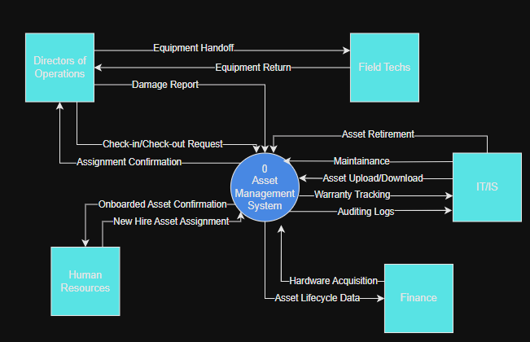

The context diagram above depicts a generalized high-level view for the use of the new system. This focuses on who interacts with the system and what is being done. Directors of Operations (DOOs) and HR handle most of the asset transactions with assignments to field technicians and newly onboarded staff. The main transactions from these end points include check-in/checkouts, hardware damage logging, and movement tracking to name a few. IT/IS is responsible for uploading new assets and downloading data for reporting or logs. Additionally, they provide application maintenance, hardware maintenance, warranty processing, and location tracking. Finance uses system logs to determine the life cycle of hardware with retired device counts, date/times, and warranty data. This diagram keeps things simple, so we are all clear on the generalized use of the system.

5.2 Level 0 Diagram

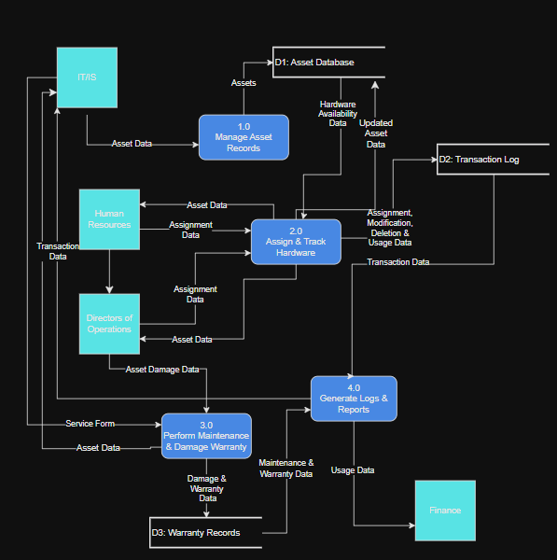

From a Level 0 perspective, we can break down the core system into 4 subsystems. Asset Records management holds the input of assets into the database done by IT/IS. The data within the database is available to HR and the Directors of Operations (DOO) for assignment to new staff and field technicians. Each assignment and asset modification is tracked and logged in the systems backend. DOO’s are required to log any and all damaged assets into the system for maintenance or warranty. IT/IS is responsible for handling those warranties and providing maintenance to the system, these actions are logged. All records are available for download for IT/IS auditing and Finance budgeting efforts. Everything ties back to the internal database to maintain order and organization.

5.3 Leveled Diagrams

**5.3.1 Level 1 Data Flow Diagrams**

2.0 Assign & Track Hardware

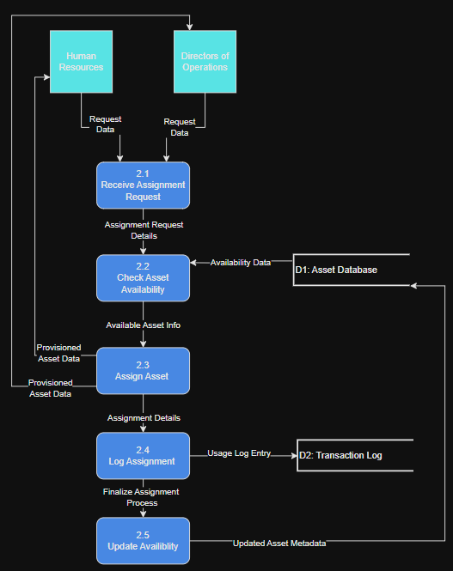

Above we are taking subprocess 2.0 (Assign & Track Hardware) and breaking it down into its own subprocesses. This visualizes asset requests from start to finish. Whether the request is from HR or the DOO’s, its fed into a centralized request intake process. The details are passed in and checked for availability on the backend database. If good, asset data is passed down and the hardware provisioned back to the requesting party. Asset changes are then logged and availability updated in the backend. The breakdown makes the process easier to understand and gives insight into how user input becomes a more structured assignment process ensuring visibility and accountability across the board.

3.0 Perform Maintenance & Damage Warranty

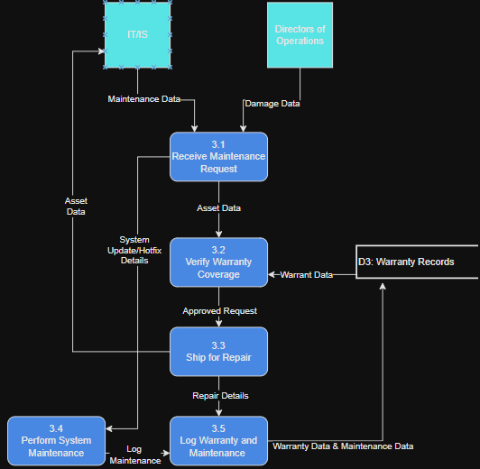

For the Perform Maintenance & Damage Warranty process (3.0), we broke it up to capture the 2 main parts of the process, system maintenance and asset revitalization. DOO’s are to submit damage reports on hardware that is in circulation in that location. Asset data is passed through to verify warranty coverage. Hardware is then shipped out for warrantied repair or replacement and logged within the system. IT/IS typically manages the shipping out process as delegated by the department. System maintenance is performed after a request is made via the communication plan or other forms of request. After the update is done, the maintenance is logged and sent to the warranty records. All actions are tracked, and readily available for audit.

**5.3.2 Primitive Data Flow Diagram**

The primitive data flow diagram is capped out at level 1 for subprocess 2.0 and 3.0. The other actions would be too simple to breakdown as they are boiled down to single queries or logging. Subprocess 3.0 and 3.0 were the most complex parts of the system. They had multiple steps, required logic, and interacted with external and internal components. Each process was broken in 5 subprocesses that fully describe the entirety of the process. These level 1 diagrams portray the most primitive level in the systems modelling and provide intimate knowledge of the system deepest functions.

**5.3.3 Gap Analysis**

Gap analysis was performed to determine if any discrepancies were present in any of the diagrams, nothing was found. There are plenty of discrepancies in the old model, the previous system. These included double booked tools, no warranty validation, no automated assignment, and no logs. These are moved to be repaired with the new system and its automated features.

**5.3.4 Naming Standards for Processes**

All process are labeled using the verb-noun format as required to clearly describe all functions. Examples include “Assign & Tracking Hardware” and “Verify Warranty Coverage”, these ensures understanding across all domains.

**5.3.5 Naming Standards for Data Flows**

Data flows are named with clear noun phrases, as required, to describe the infromation as it moves. Examples like “Asset Query” and “Assignment Request” keeps the focus on what is being passed not how its processed.

**5.3.6 Data Consistency and Conservation**

Every data flow and data store in the diagram is consistent across all diagrams. If a data store receives asset info in one process, it’s the same format in the other. Data conservation is maintained because data entering the system is either transformed, stored, or forwarded without being lost.

**6.0 Entity Relationship Diagrams**

6.1 Relationships and Cardinalities Explained

The Asset Management System database consists of 4 entities, Locations, Users, Transactions, and Assets. All but locations receives foreign keys from one another with transactions being the main host of data, used for logging and audits. The Users entity has a 1:M relationship with transactions as only one user can be in a transaction, but multiple transactions can occur for one user. Each user and asset is assigned a location. Locations can have multiple users and assets, but users and assets can only have one location.

As stated prior, the transactions table linked together assets, users, and locations (from and to locations) to capture movement of items. Each location can be associated with multiple transactions, in either location column, while transactions can only have 1 source and final destination. All relationships are reflected in the data flow diagrams via the data flows and stores such as the transaction log data store and the transactions table.

6.2 Conceptual Entity Re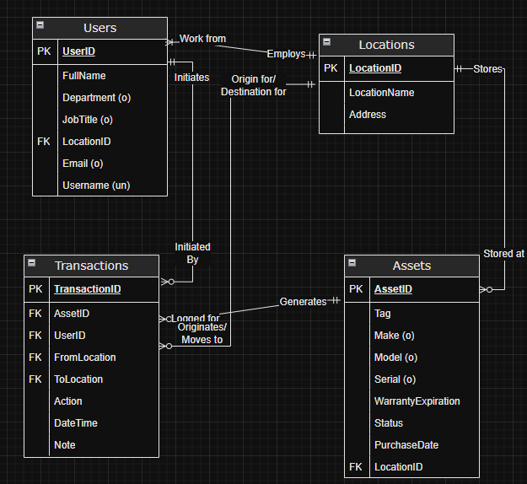lationship Diagram

6.3 Entity Relationships

There are ternary relationships between the following:

* Transactions, Users, Assets: A user starts the transaction to check out or reassign a hardware asset and that transaction records which user operated on which asset, this is logged.
* Transactions, Locations, Assets: An asset is moved from one location to another via a transaction. Both locations, the asset, and the time are logged via transactions table.

The binary relationships include:

* Users, Locations: Each user is assigned to one location, and one location can have many users.
* Assets, Location: Similarly, each asset has one location, and one location can have many assets.
* Transactions, Users: A user performs a transaction, and that transaction can only have one user assigned to it.
* Transactions, Assets: An asset is altered via a transaction, one transaction links to one asset however one asset may have many transactions.

**7.0 Data Dictionary**

|  |  |  |  |  |  |
| --- | --- | --- | --- | --- | --- |
| Entity | Attribute | Type | Size | Example | Description |
| Users | UserID (PK) | int | 3 | 21 | User Primary Key |
| Users | FullName | varchar | 30 | Jacob Gull | Users First and Last Name |
| Users | Department | varchar | 20 | Finance | User Department |
| Users | JobTitle | varchar | 20 | Associate | Users Position at Conquer HW |
| Users | LocationID (FK) | int | 2 | 35 | Users assigned location |
| Users | Email | varchar | 20 | [jgull@chw.com](mailto:jgull@chw.com) | User company Email |
| Users | Username | varchar | 15 | jgull | Username (email minus domain) |
| Transactions | TransactionID (PK) | int | 10 | 55646 | Transaction Primary Key |
| Transactions | AssetID (FK) | int | 5 | 56 | Asset foreign Key |
| Transactions | UserID (FK) | int | 3 | 21 | User foreign Key |
| Transactions | FromLocation (FK) | int | 2 | 5 | Source Location Foreign Key |
| Transactions | ToLocation (FK) | int | 2 | 4 | Destination Location Foreign Key |
| Transactions | Action | varchar | 25 | Move | Operation on Asset |
| Transactions | DateTime | date | 19 | 2025-07-17 13:56:58 | Time of operation |
| Transactions | Note | varchar | 800 | Changed Branches | Optional Note Input |
| Location | LocationID (PK) | int | 2 | 5 | Location Primary Key |
| Location | LocationName | varchar | 25 | Woburn | Location/Office name |
| Location | Address | varchar | 100 | 111 Unicorn Ave, Woburn MA 01801 | Location Mailing Address |
| Assets | AssetID (PK) | int | 5 | 56 | Asset primary key |
| Assets | Tag | varchar | 50 | Impact Gun | Asset general item name |
| Assets | Make | varchar | 50 | Snap On | Asset brand |
| Assets | Model | varchar | 50 | Monster Lithium Cordless | Asset Model Name |
| Assets | Serial | varchar | 25 | WG599451 | Asset Serial Number |
| Assets | WarrantyExpiration | date | 19 | 2028-04-30 10:56:40 | Asset Warranty expiration date |
| Assets | Status | varchar | 50 | In Field | Asset operation status |
| Assets | PurchaseDate | date | 19 | 2021-04-30 10:56:40 | Asset date of purchase |
| Assets | LocationID (FK) | int | 2 | 5 | Asset active location foreign key |

LocationID’s up to 2 in size for 99 max locations.

Dates are 19 characters for the entire YYYY-MM-DD HH:MM:SS.

AssetID’s capped at 99999, Users capped at 999.

**8.0 Form and Report Designs**

|  |  |
| --- | --- |
| NARRATIVE OVERVIEW | |
| Form | Dashboard Tab |
| User | DOO or Admin |
| Task | Startup tab, displays statistics on all Assets |
| System | Microsoft Windows, any OS configured properly |
| Environment | Office, Conquer Computer System |

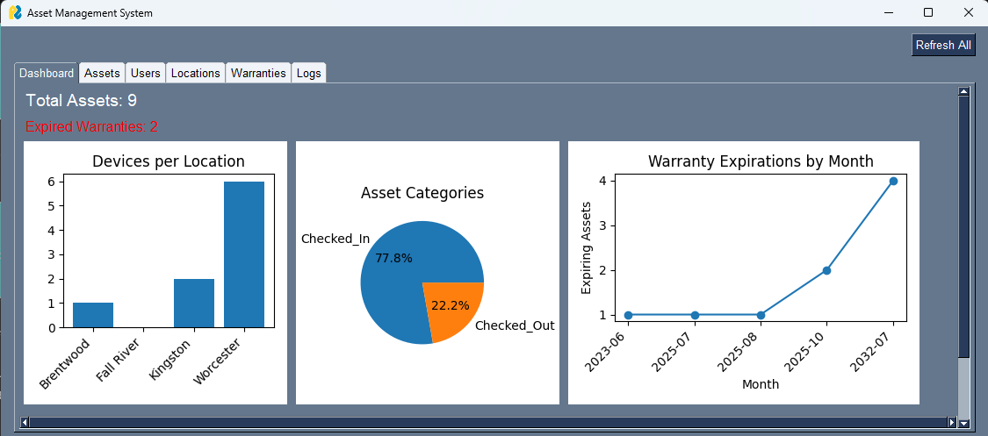

|  |  |
| --- | --- |
| TESTING AND USABILITY ASSESSMENT | |
| Consistency [1= consistent to 7= inconsistent]: | 1 |
| Sufficiency [1= sufficient to 7= insufficient]: | 2 |
| Accuracy [1= accurate to 7= inaccurate]: | 1 |
| Usability [1= easy to use to 7= difficult to use]: | 1 |

|  |  |
| --- | --- |
| NARRATIVE OVERVIEW | |
| Form | Assets Tab |
| User | DOO or Admin |
| Task | Display all assets and their metadata |
| System | Microsoft Windows, any OS configured properly |
| Environment | Office, Conquer Computer System |

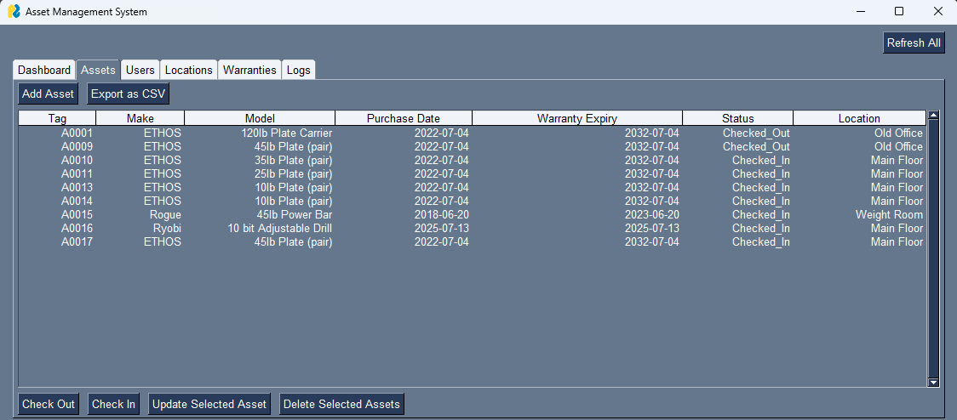

|  |  |
| --- | --- |
| TESTING AND USABILITY ASSESSMENT | |
| Consistency [1= consistent to 7= inconsistent]: | 1 |
| Sufficiency [1= sufficient to 7= insufficient]: | 1 |
| Accuracy [1= accurate to 7= inaccurate]: | 1 |
| Usability [1= easy to use to 7= difficult to use]: | 1 |

|  |  |
| --- | --- |
| NARRATIVE OVERVIEW | |
| Form | Add Assets Tab |
| User | DOO or Admin |
| Task | Add asset popup, user populates with data |
| System | Microsoft Windows, any OS configured properly |
| Environment | Office, Conquer Computer System |

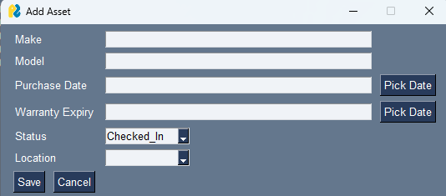

|  |  |
| --- | --- |
| TESTING AND USABILITY ASSESSMENT | |
| Consistency [1= consistent to 7= inconsistent]: | 1 |
| Sufficiency [1= sufficient to 7= insufficient]: | 1 |
| Accuracy [1= accurate to 7= inaccurate]: | 1 |
| Usability [1= easy to use to 7= difficult to use]: | 1 |

|  |  |
| --- | --- |
| NARRATIVE OVERVIEW | |
| Form | Asset Check-Out Button Popup |
| User | DOO or Admin |
| Task | Asset check out pop up, happens when ‘check-out’ is pressed. Can be one or more assets. |
| System | Microsoft Windows, any OS configured properly |
| Environment | Office, Conquer Computer System |

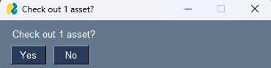

|  |  |
| --- | --- |
| TESTING AND USABILITY ASSESSMENT | |
| Consistency [1= consistent to 7= inconsistent]: | 1 |
| Sufficiency [1= sufficient to 7= insufficient]: | 1 |
| Accuracy [1= accurate to 7= inaccurate]: | 1 |
| Usability [1= easy to use to 7= difficult to use]: | 1 |

|  |  |
| --- | --- |
| NARRATIVE OVERVIEW | |
| Form | Asset Check-In Button Popup |
| User | DOO or Admin |
| Task | Asset check in pop up, happens when ‘check-in is pressed. Can be one or more assets. |
| System | Microsoft Windows, any OS configured properly |
| Environment | Office, Conquer Computer System |

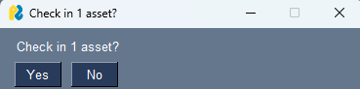

|  |  |
| --- | --- |
| TESTING AND USABILITY ASSESSMENT | |
| Consistency [1= consistent to 7= inconsistent]: | 1 |
| Sufficiency [1= sufficient to 7= insufficient]: | 1 |
| Accuracy [1= accurate to 7= inaccurate]: | 1 |
| Usability [1= easy to use to 7= difficult to use]: | 1 |

|  |  |
| --- | --- |
| NARRATIVE OVERVIEW | |
| Form | Update Asset Popup |
| User | DOO or Admin |
| Task | Select 1 asset, updates any metadata minus tag and id. |
| System | Microsoft Windows, any OS configured properly |
| Environment | Office, Conquer Computer System |

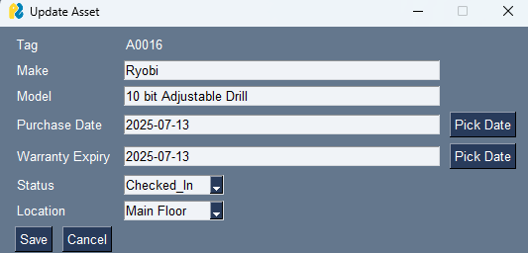

|  |  |
| --- | --- |
| TESTING AND USABILITY ASSESSMENT | |
| Consistency [1= consistent to 7= inconsistent]: | 1 |
| Sufficiency [1= sufficient to 7= insufficient]: | 1 |
| Accuracy [1= accurate to 7= inaccurate]: | 1 |
| Usability [1= easy to use to 7= difficult to use]: | 1 |

|  |  |
| --- | --- |
| NARRATIVE OVERVIEW | |
| Form | Delete Selected Asset(s) Popup |
| User | DOO or Admin |
| Task | Select 1 or more assets, this deletes them so long as no transactions have been made. |
| System | Microsoft Windows, any OS configured properly |
| Environment | Office, Conquer Computer System |

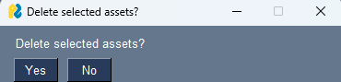

|  |  |
| --- | --- |
| TESTING AND USABILITY ASSESSMENT | |
| Consistency [1= consistent to 7= inconsistent]: | 1 |
| Sufficiency [1= sufficient to 7= insufficient]: | 1 |
| Accuracy [1= accurate to 7= inaccurate]: | 1 |
| Usability [1= easy to use to 7= difficult to use]: | 1 |

|  |  |
| --- | --- |
| NARRATIVE OVERVIEW | |
| Form | Transaction Details Popup |
| User | DOO or Admin |
| Task | Pops up after every asset change, this include CheckIn, CheckOut, and Update. |
| System | Microsoft Windows, any OS configured properly |
| Environment | Office, Conquer Computer System |

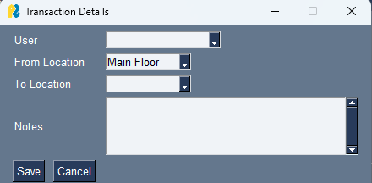

|  |  |
| --- | --- |
| TESTING AND USABILITY ASSESSMENT | |
| Consistency [1= consistent to 7= inconsistent]: | 1 |
| Sufficiency [1= sufficient to 7= insufficient]: | 2 |
| Accuracy [1= accurate to 7= inaccurate]: | 1 |
| Usability [1= easy to use to 7= difficult to use]: | 1 |

|  |  |
| --- | --- |
| NARRATIVE OVERVIEW | |
| Form | Save as CSV Popup |
| User | DOO or Admin |
| Task | Happens when ‘Export as CSV’ is selected. User browses for location, selects save, and the export populates in that file location. |
| System | Microsoft Windows, any OS configured properly |
| Environment | Office, Conquer Computer System |

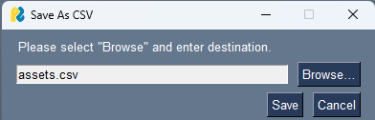

|  |  |
| --- | --- |
| TESTING AND USABILITY ASSESSMENT | |
| Consistency [1= consistent to 7= inconsistent]: | 1 |
| Sufficiency [1= sufficient to 7= insufficient]: | 1 |
| Accuracy [1= accurate to 7= inaccurate]: | 1 |
| Usability [1= easy to use to 7= difficult to use]: | 1 |

|  |  |
| --- | --- |
| NARRATIVE OVERVIEW | |
| Form | Users Tab |
| User | DOO or Admin |
| Task | Display all users and their metadata |
| System | Microsoft Windows, any OS configured properly |
| Environment | Office, Conquer Computer System |

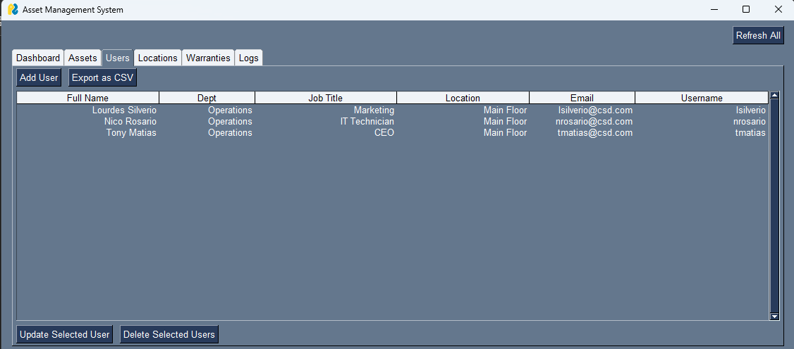

|  |  |
| --- | --- |
| TESTING AND USABILITY ASSESSMENT | |
| Consistency [1= consistent to 7= inconsistent]: | 1 |
| Sufficiency [1= sufficient to 7= insufficient]: | 1 |
| Accuracy [1= accurate to 7= inaccurate]: | 1 |
| Usability [1= easy to use to 7= difficult to use]: | 1 |

|  |  |
| --- | --- |
| NARRATIVE OVERVIEW | |
| Form | Add User Popup |
| User | DOO or Admin |
| Task | When ‘Add User’ is selected, user enters all metadata minus id and the record is added to the database. |
| System | Microsoft Windows, any OS configured properly |
| Environment | Office, Conquer Computer System |

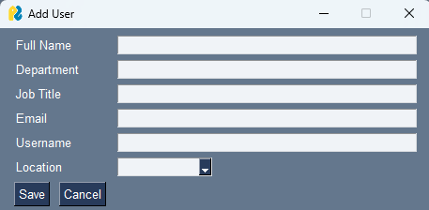

|  |  |
| --- | --- |
| TESTING AND USABILITY ASSESSMENT | |
| Consistency [1= consistent to 7= inconsistent]: | 1 |
| Sufficiency [1= sufficient to 7= insufficient]: | 1 |
| Accuracy [1= accurate to 7= inaccurate]: | 1 |
| Usability [1= easy to use to 7= difficult to use]: | 1 |

|  |  |
| --- | --- |
| NARRATIVE OVERVIEW | |
| Form | Update User Popup |
| User | DOO or Admin |
| Task | When ‘Update User’ is pressed, requires 1 user to be selected. Allows editing of user metadata minus id. |
| System | Microsoft Windows, any OS configured properly |
| Environment | Office, Conquer Computer System |

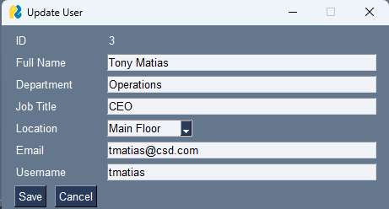

|  |  |
| --- | --- |
| TESTING AND USABILITY ASSESSMENT | |
| Consistency [1= consistent to 7= inconsistent]: | 1 |
| Sufficiency [1= sufficient to 7= insufficient]: | 1 |
| Accuracy [1= accurate to 7= inaccurate]: | 1 |
| Usability [1= easy to use to 7= difficult to use]: | 1 |

|  |  |
| --- | --- |
| NARRATIVE OVERVIEW | |
| Form | Delete Selected User(s) Popup |
| User | DOO or Admin |
| Task | Select 1 or more users, this deletes them so long as no transactions have been made. |
| System | Microsoft Windows, any OS configured properly |
| Environment | Office, Conquer Computer System |

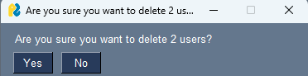

|  |  |
| --- | --- |
| TESTING AND USABILITY ASSESSMENT | |
| Consistency [1= consistent to 7= inconsistent]: | 1 |
| Sufficiency [1= sufficient to 7= insufficient]: | 1 |
| Accuracy [1= accurate to 7= inaccurate]: | 1 |
| Usability [1= easy to use to 7= difficult to use]: | 1 |

|  |  |
| --- | --- |
| NARRATIVE OVERVIEW | |
| Form | Locations Tab |
| User | DOO or Admin |
| Task | Display all locations and their metadata |
| System | Microsoft Windows, any OS configured properly |
| Environment | Office, Conquer Computer System |

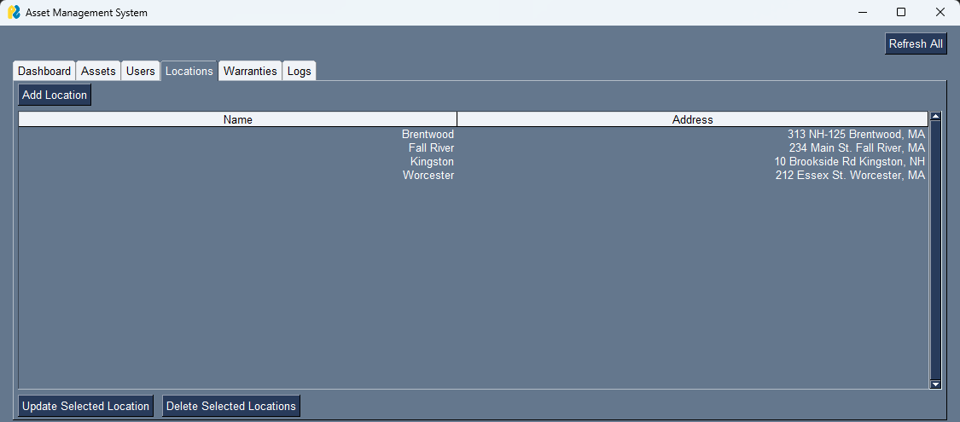

|  |  |
| --- | --- |
| TESTING AND USABILITY ASSESSMENT | |
| Consistency [1= consistent to 7= inconsistent]: | 1 |
| Sufficiency [1= sufficient to 7= insufficient]: | 1 |
| Accuracy [1= accurate to 7= inaccurate]: | 1 |
| Usability [1= easy to use to 7= difficult to use]: | 1 |

|  |  |
| --- | --- |
| NARRATIVE OVERVIEW | |
| Form | Update Location Popup |
| User | DOO or Admin |
| Task | When ‘Update Selected Location’ is pressed. Requires 1 location to be selected, allows for the edit of location metadata minus id. |
| System | Microsoft Windows, any OS configured properly |
| Environment | Office, Conquer Computer System |

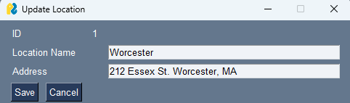

|  |  |
| --- | --- |
| TESTING AND USABILITY ASSESSMENT | |
| Consistency [1= consistent to 7= inconsistent]: | 1 |
| Sufficiency [1= sufficient to 7= insufficient]: | 1 |
| Accuracy [1= accurate to 7= inaccurate]: | 1 |
| Usability [1= easy to use to 7= difficult to use]: | 1 |

|  |  |
| --- | --- |
| NARRATIVE OVERVIEW | |
| Form | Delete Selected Locations Popup |
| User | DOO or Admin |
| Task | When ‘Delete Selected Locations’ is pressed. Requires 1 or more selections, so long as no transactions have been made with this location. |
| System | Microsoft Windows, any OS configured properly |
| Environment | Office, Conquer Computer System |

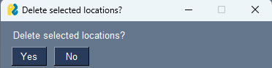

|  |  |
| --- | --- |
| TESTING AND USABILITY ASSESSMENT | |
| Consistency [1= consistent to 7= inconsistent]: | 1 |
| Sufficiency [1= sufficient to 7= insufficient]: | 1 |
| Accuracy [1= accurate to 7= inaccurate]: | 1 |
| Usability [1= easy to use to 7= difficult to use]: | 1 |

|  |  |
| --- | --- |
| NARRATIVE OVERVIEW | |
| Form | Warranties Tab |
| User | DOO or Admin |
| Task | Display all warranties and derived model, expiry, and status from assets. Only displays specific 30, 90, and 180 day expiration periods. Use case is to monitor assets near warranty expiration. |
| System | Microsoft Windows, any OS configured properly |
| Environment | Office, Conquer Computer System |

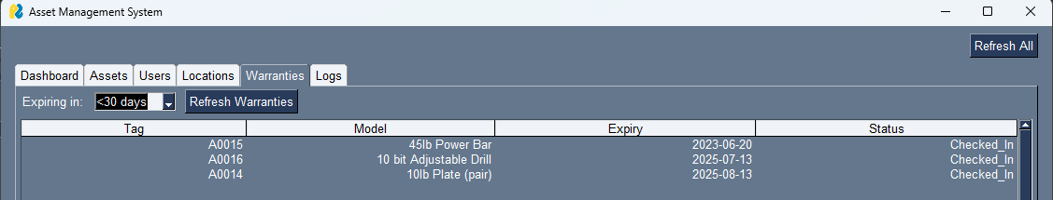

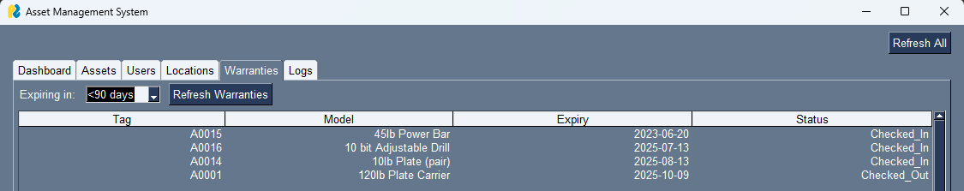

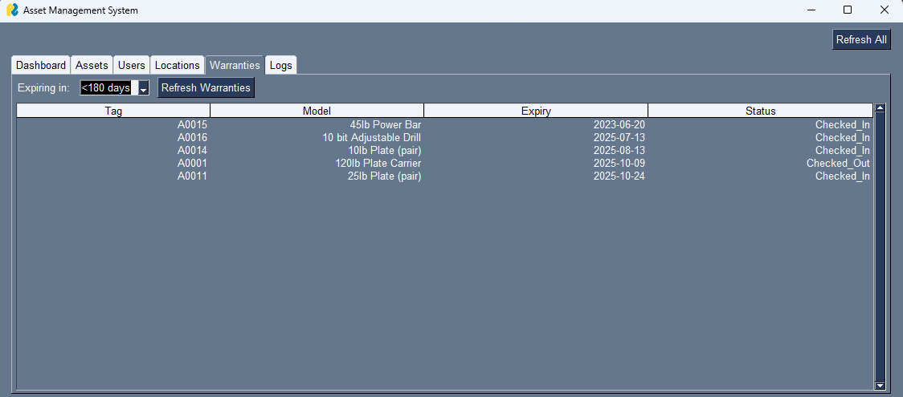

|  |  |
| --- | --- |
| TESTING AND USABILITY ASSESSMENT | |
| Consistency [1= consistent to 7= inconsistent]: | 1 |
| Sufficiency [1= sufficient to 7= insufficient]: | 1 |
| Accuracy [1= accurate to 7= inaccurate]: | 1 |
| Usability [1= easy to use to 7= difficult to use]: | 1 |

|  |  |
| --- | --- |
| NARRATIVE OVERVIEW | |
| Form | Logs (Transactions) Tab |
| User | DOO or Admin |
| Task | Display all transactions and their metadata. Directly output from transactions table, functionally acts as a log/auditing tool for admins. Actions determine the status change on an asset, update asset = metadata change outside of status. |
| System | Microsoft Windows, any OS configured properly |
| Environment | Office, Conquer Computer System |

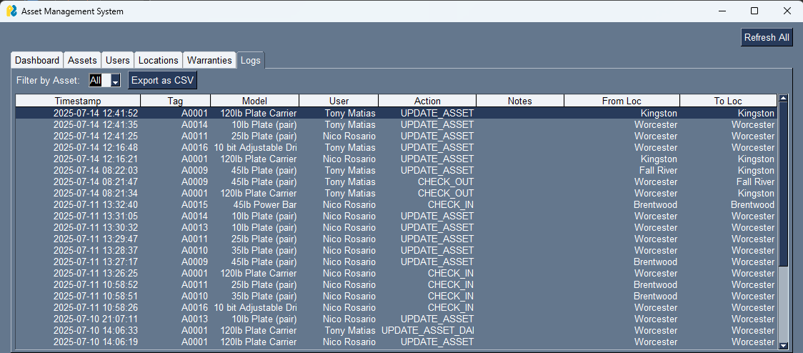

|  |  |
| --- | --- |
| TESTING AND USABILITY ASSESSMENT | |
| Consistency [1= consistent to 7= inconsistent]: | 1 |
| Sufficiency [1= sufficient to 7= insufficient]: | 1 |
| Accuracy [1= accurate to 7= inaccurate]: | 1 |
| Usability [1= easy to use to 7= difficult to use]: | 1 |

**9.0 Interface and Dialogue Designs**

|  |  |
| --- | --- |
| NARRATIVE OVERVIEW | |
| Interface/Dialogue Name | Add Asset Popup |
| User Characteristics | Admin with Access to AMS |
| Task Characteristics | Add Asset to database |
| System Characteristics | Provisioned with Program or access via network drive. |
| Environmental Characteristics | Windows system, or any properly configured OS |

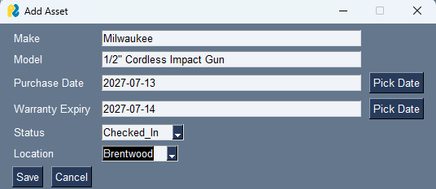

|  |  |
| --- | --- |
| TESTING AND USABILITY ASSESSMENT | |
| Testing Objective : | Ensure ability to add Asset to Database |
| Testing Procedure : | Select ‘Add Asset’ button, input meta data where prompted. Select ‘Save’ |
| Testing Result : | Success, no errors. Asset added to database. |

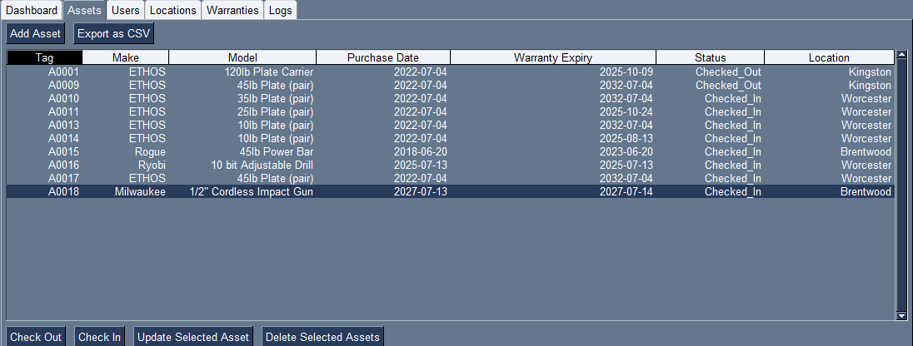

|  |  |
| --- | --- |
| NARRATIVE OVERVIEW | |
| Interface/Dialogue | Add User Popup |
| User Characteristics | Admin with Access to AMS |
| Task Characteristics | Add User to database |
| System Characteristics | Provisioned with Program or access via network drive. |
| Environmental Characteristics | Windows system, or any properly configured OS |

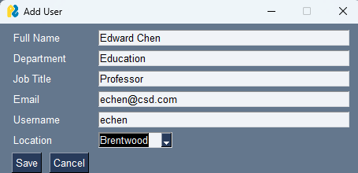

|  |  |
| --- | --- |
| TESTING AND USABILITY ASSESSMENT | |
| Testing Objective : | Ensure ability to add User to Database |
| Testing Procedure : | Select ‘Add User’ button, input meta data where prompted. Select ‘Save’ |
| Testing Result : | Success, no errors. |

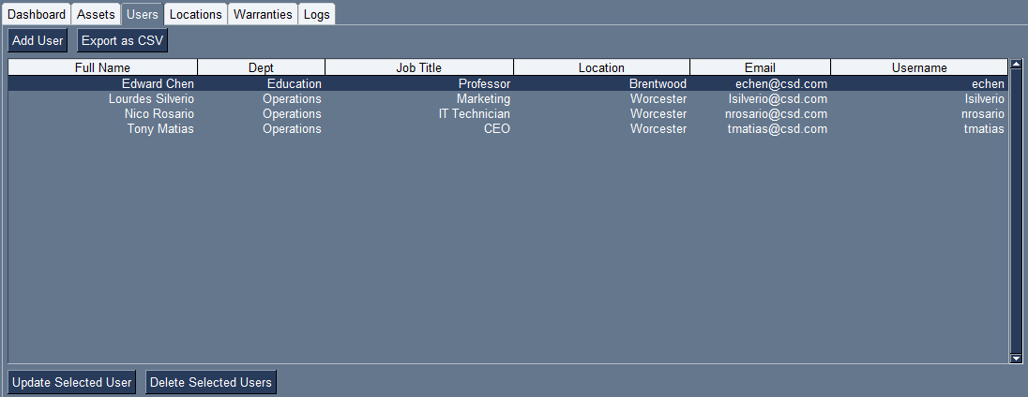

|  |  |
| --- | --- |
| NARRATIVE OVERVIEW | |
| Interface/Dialogue | Add Location Popup |
| User Characteristics | Admin with Access to AMS |
| Task Characteristics | Add Location to database |
| System Characteristics | Provisioned with Program or access via network drive. |
| Environmental Characteristics | Windows system, or any properly configured OS |

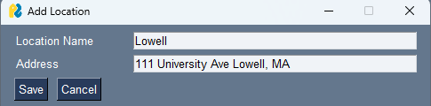

|  |  |
| --- | --- |
| TESTING AND USABILITY ASSESSMENT | |
| Testing Objective : | Ensure ability to add Location to Database |
| Testing Procedure : | Select ‘Add Location button, input meta data where prompted. Select ‘Save’ |
| Testing Result : | Success, location added to Database. |

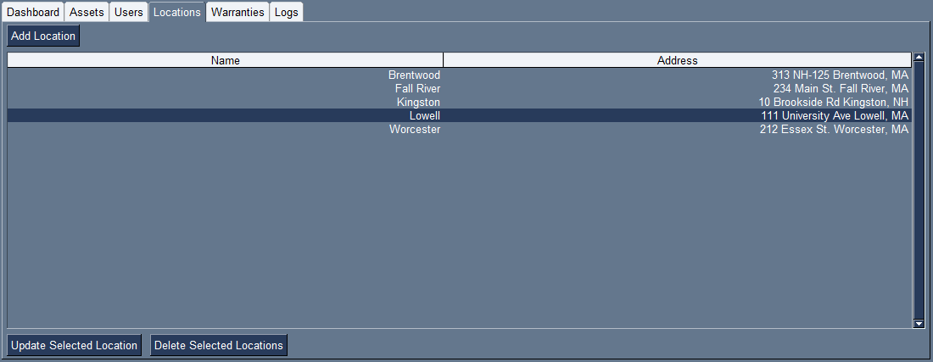

|  |  |
| --- | --- |
| NARRATIVE OVERVIEW | |
| Interface/Dialogue | Save as CSV Popup |
| User Characteristics | Admin with Access to AMS |
| Task Characteristics | Export data to CSV, example with Assets |
| System Characteristics | Provisioned with Program or access via network drive. |
| Environmental Characteristics | Windows system, or any properly configured OS |

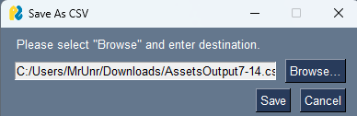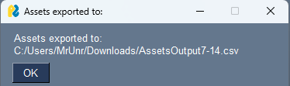

|  |  |
| --- | --- |
| TESTING AND USABILITY ASSESSMENT | |
| Testing Objective : | Ensure ability to export data to csv |
| Testing Procedure : | Select ‘Export as CSV’ button, browse and select path, click ‘save’. |
| Testing Result : | Success, no errors. File output and is readable. |

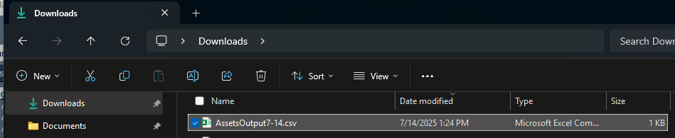

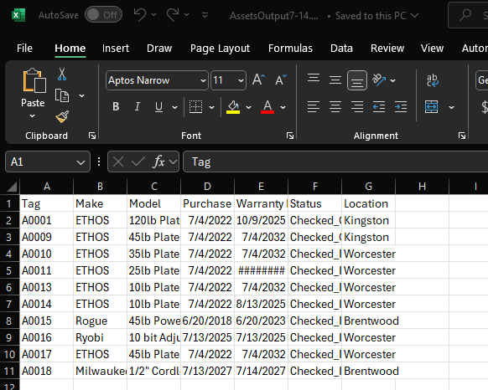

|  |  |
| --- | --- |
| NARRATIVE OVERVIEW | |
| Interface/Dialogue | Update Selected Asset Popup |
| User Characteristics | Admin with Access to AMS |
| Task Characteristics | Update Asset in database |
| System Characteristics | Provisioned with Program or access via network drive. |
| Environmental Characteristics | Windows system, or any properly configured OS |

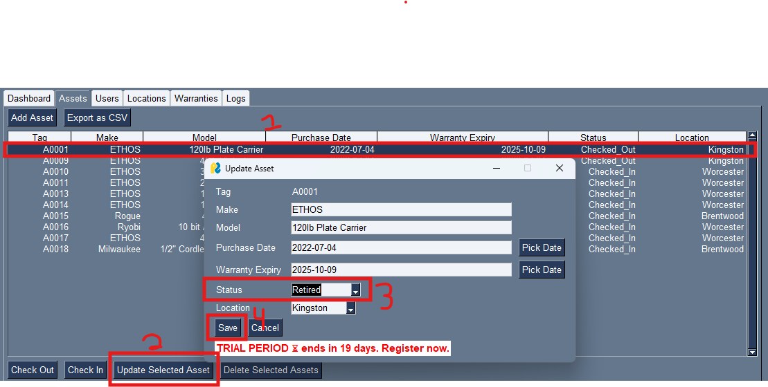

|  |  |
| --- | --- |
| TESTING AND USABILITY ASSESSMENT | |
| Testing Objective : | Ensure ability to update an Asset in the Database |
| Testing Procedure : | Select 1 asset, select ‘Update Selected Asset’ button, input meta data where needed. Select ‘Save’ |
| Testing Result : | Success, status change recorded. |

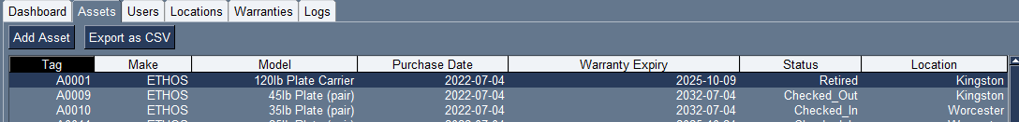

|  |  |
| --- | --- |
| NARRATIVE OVERVIEW | |
| Interface/Dialogue | Transaction Detail |
| User Characteristics | Admin with Access to AMS |
| Task Characteristics | Update Asset, transaction event pops up |
| System Characteristics | Provisioned with Program or access via network drive. |
| Environmental Characteristics | Windows system, or any properly configured OS |

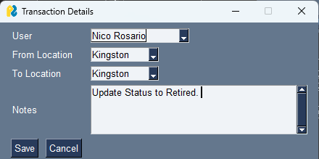

|  |  |
| --- | --- |
| TESTING AND USABILITY ASSESSMENT | |
| Testing Objective : | Ensure transaction pop up displays before asset edit is complete. Ensure data is recorded in transactions log. |
| Testing Procedure : | After updates are made to an asset the transactions pop up displays, inputs are in, and record is added to logs tab. |
| Testing Result : | Success, changes are recorded (see previous) and transaction was recorded as well. |

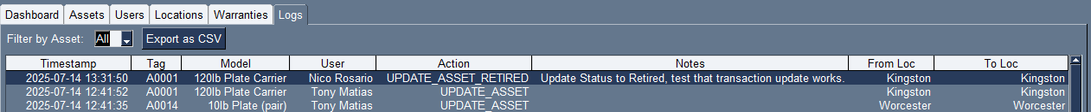

|  |  |
| --- | --- |
| NARRATIVE OVERVIEW | |
| Interface/Dialogue | Delete Asset Popup |
| User Characteristics | Admin with Access to AMS |
| Task Characteristics | Delete Asset from database |
| System Characteristics | Provisioned with Program or access via network drive. |
| Environmental Characteristics | Windows system, or any properly configured OS |

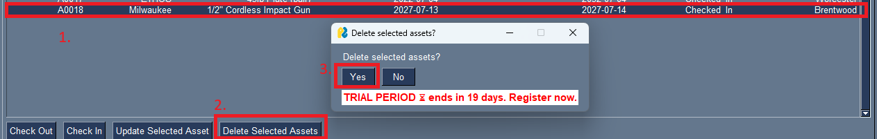

|  |  |
| --- | --- |
| TESTING AND USABILITY ASSESSMENT | |
| Testing Objective : | Ensure ability to add Asset to Database |
| Testing Procedure : | Select an asset, select ‘Delete Selected Assets’, and select ok when confirmation arises. Ensure that record is deleted so long as there are no logs. |
| Testing Result : | Success asset was removed. Below is error when asset has corresponding logs and an attempt to delete is made. |

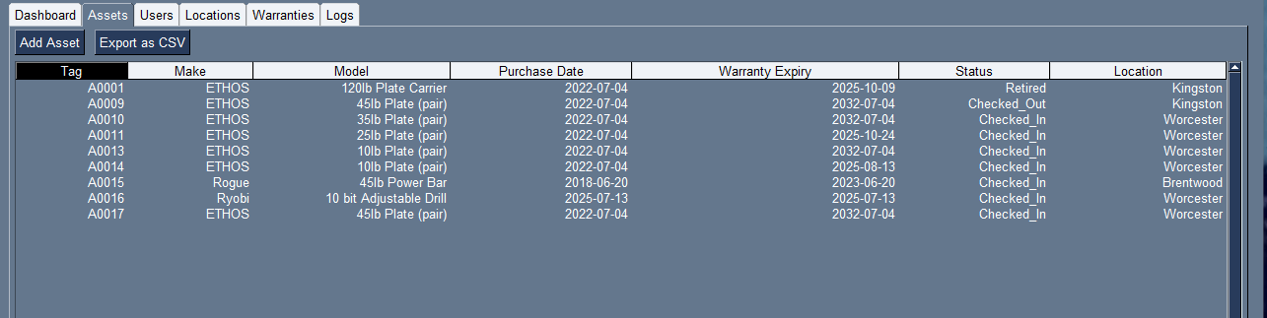

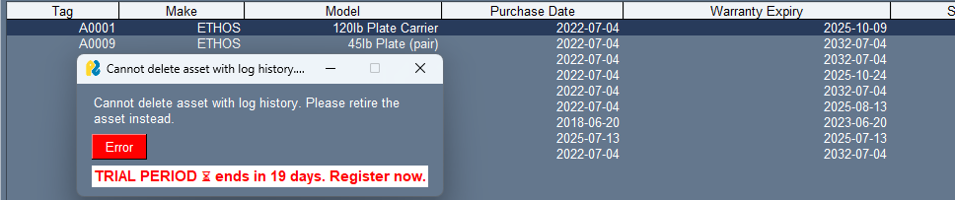

|  |  |
| --- | --- |
| NARRATIVE OVERVIEW | |
| Interface/Dialogue | Check In Popup |
| User Characteristics | Admin with Access to AMS |
| Task Characteristics | Check In Asset |
| System Characteristics | Provisioned with Program or access via network drive. |
| Environmental Characteristics | Windows system, or any properly configured OS |

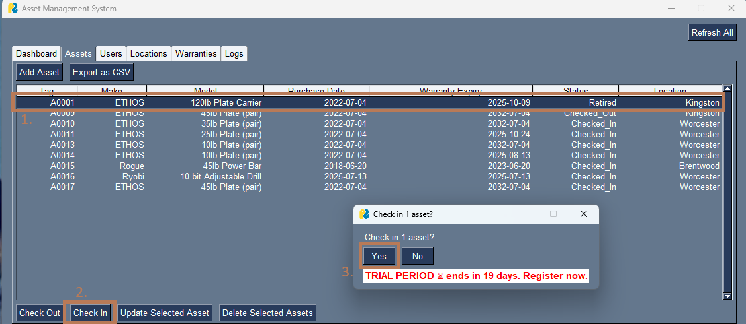

|  |  |
| --- | --- |
| TESTING AND USABILITY ASSESSMENT | |
| Testing Objective : | Ensure Check-In functionality works as expected. Should not allow check-in if status is already checked-in. |
| Testing Procedure : | Select asset, select ‘Check In’ button, select ‘Yes’. |
| Testing Result : | Success, asset is now checked-in. This is post transaction details popup. Below is error when asset is already checked in. |

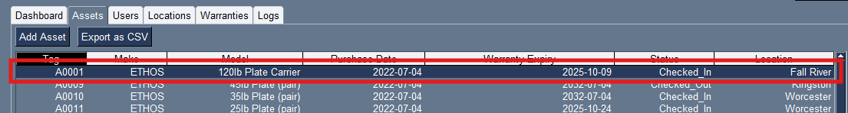

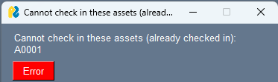

|  |  |
| --- | --- |
| NARRATIVE OVERVIEW | |
| Interface/Dialogue | Check out Popup |
| User Characteristics | Admin with Access to AMS |
| Task Characteristics | Check out Asset |
| System Characteristics | Provisioned with Program or access via network drive. |
| Environmental Characteristics | Windows system, or any properly configured OS |

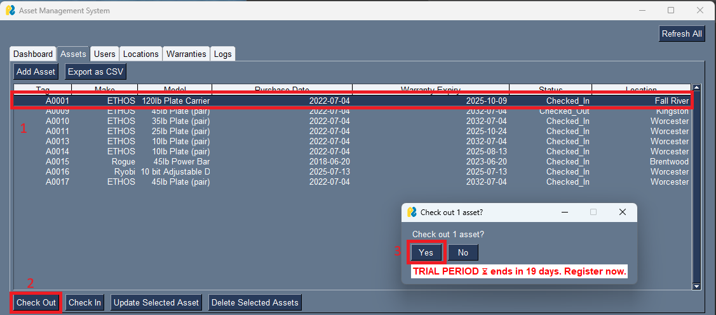

|  |  |
| --- | --- |
| TESTING AND USABILITY ASSESSMENT | |
| Testing Objective : | Ensure Check-out functionality works as expected. Should not allow check-out if status is already checked-out. |
| Testing Procedure : | Select asset, select ‘Check Out’ button, select ‘Yes’. |
| Testing Result : | Success, asset is now checked-out. This is post transaction details popup. Below is error when asset is already checked out. |

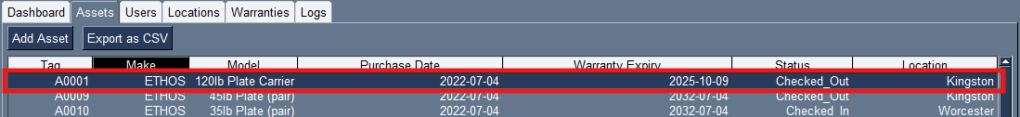

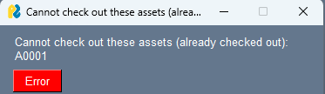

|  |  |
| --- | --- |
| NARRATIVE OVERVIEW | |
| Interface/Dialogue | Update User Popup |
| User Characteristics | Admin with Access to AMS |
| Task Characteristics | Update User in database |
| System Characteristics | Provisioned with Program or access via network drive. |
| Environmental Characteristics | Windows system, or any properly configured OS |

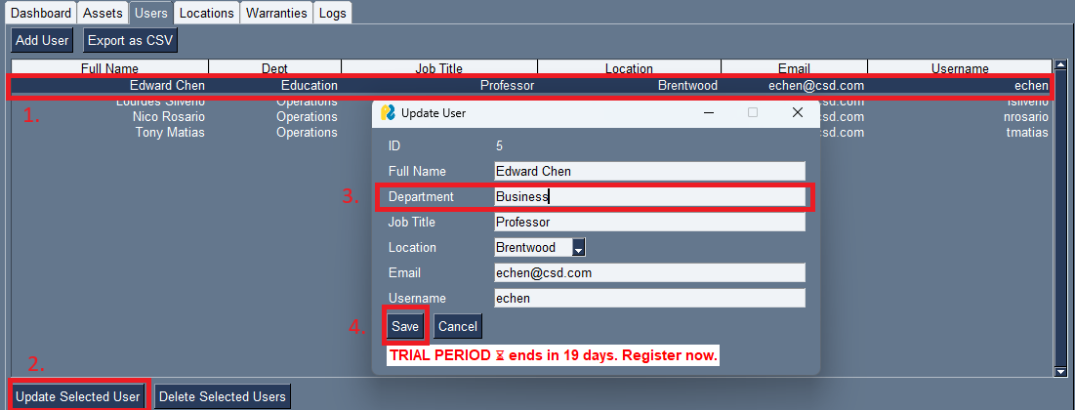

|  |  |
| --- | --- |
| TESTING AND USABILITY ASSESSMENT | |
| Testing Objective : | Ensure ability to update user in database. |
| Testing Procedure : | Select User, select ‘Update Selected User’ button, input meta data where prompted. Select ‘Save’ |
| Testing Result : | Success, user metadata updated. |

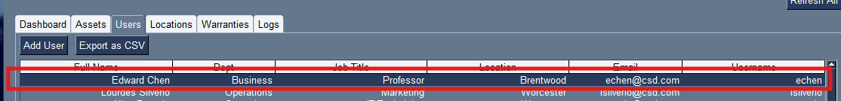

|  |  |
| --- | --- |
| NARRATIVE OVERVIEW | |
| Interface/Dialogue | Delete User Popup |
| User Characteristics | Admin with Access to AMS |
| Task Characteristics | Delete User from Database |
| System Characteristics | Provisioned with Program or access via network drive. |
| Environmental Characteristics | Windows system, or any properly configured OS |

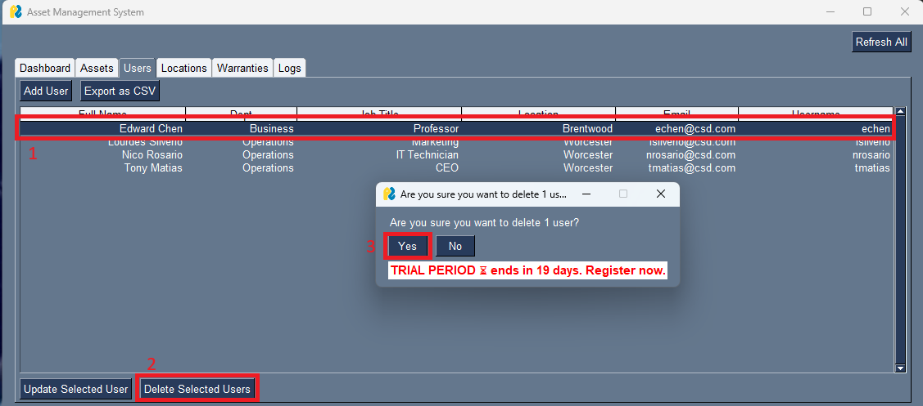

|  |  |
| --- | --- |
| TESTING AND USABILITY ASSESSMENT | |
| Testing Objective : | Ensure ability to delete user from database so long as they have no corresponding logs. |
| Testing Procedure : | Select User, Select ‘Delete User’ button. Verify changes. |
| Testing Result : | Success, below is error when user has corresponding logs. |

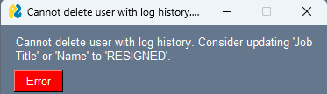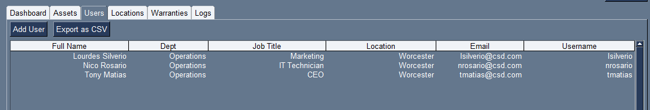

|  |  |
| --- | --- |
| NARRATIVE OVERVIEW | |
| Interface/Dialogue | Delete Location Popup |
| User Characteristics | Admin with Access to AMS |
| Task Characteristics | Delete location in database |
| System Characteristics | Provisioned with Program or access via network drive. |
| Environmental Characteristics | Windows system, or any properly configured OS |

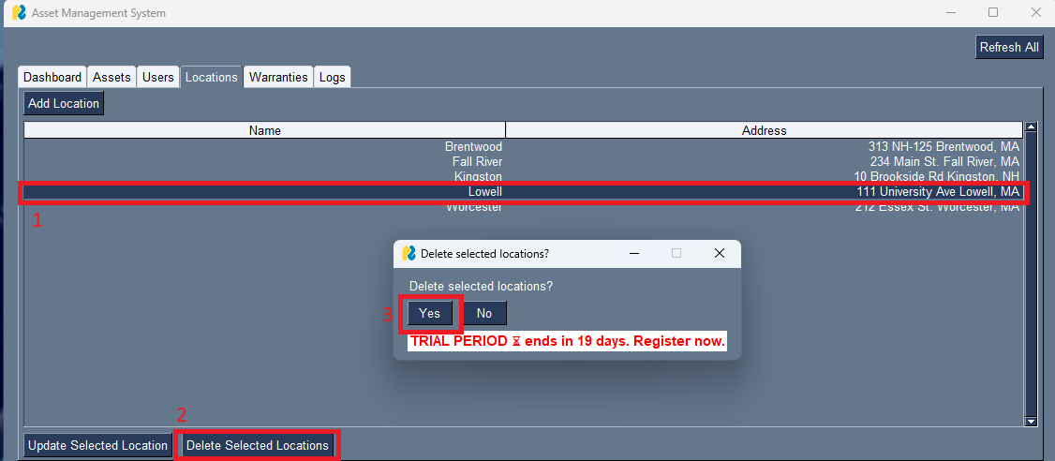

|  |  |
| --- | --- |
| TESTING AND USABILITY ASSESSMENT | |
| Testing Objective : | Ensure ability to delete location in Database |
| Testing Procedure : | Select location, select ‘Delete Selected Locations’ select ‘Yes’. Verify changes |
| Testing Result : | Success. Change has been made. See below for error when location has associated logs. |

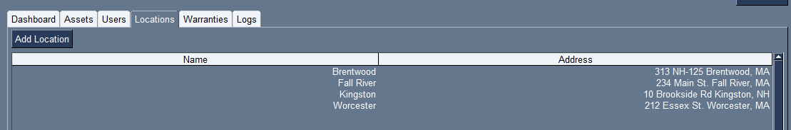

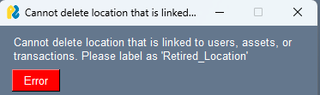

|  |  |
| --- | --- |
| NARRATIVE OVERVIEW | |
| Interface/Dialogue | Update Locations Popup |
| User Characteristics | Admin with Access to AMS |
| Task Characteristics | Update Location in Database |
| System Characteristics | Provisioned with Program or access via network drive. |
| Environmental Characteristics | Windows system, or any properly configured OS |

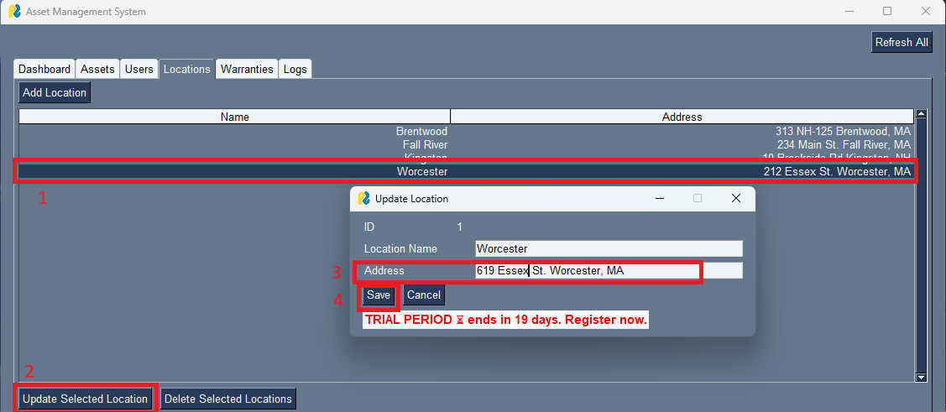

|  |  |
| --- | --- |
| TESTING AND USABILITY ASSESSMENT | |
| Testing Objective : | Ensure ability to update location in Database. |
| Testing Procedure : | Select Location, select ‘Update Selected Location’, enter in metadata to change, select ‘save’. View changes |
| Testing Result : | Success, changes made. |

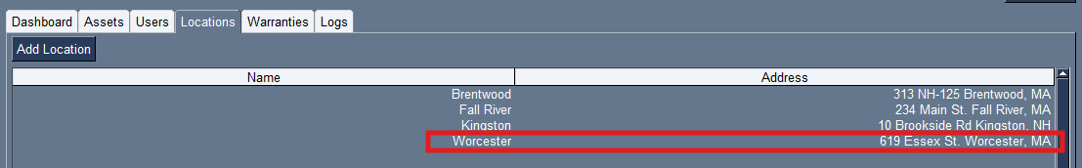

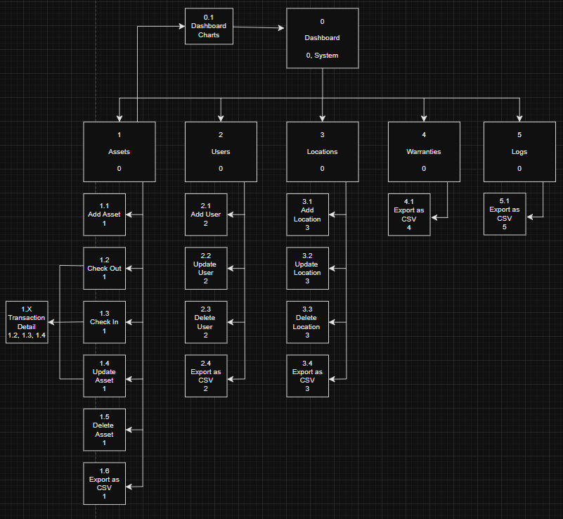9.1 Dialogue Sequence Diagram

**10.0 Documentation**

10.1 User Manual and Training Material

**1.0 System Overview**

Hi everyone, my name is Nico and today I’ll be showing you around the new Conquer HomeWorks Asset Management System (AMS). This AMS is a user friendly application that’s designed to be easy to use and help Conquer staff track, manage, and report on company assets across locations. The system supports asset assignment, check-in/check-out, warranty tracking and full audit transaction logs. Let’s dive into it.

**2.0 Log In and Accessing the Application**

There is no credentials assigned to users as this application is intended to be held and used by limited administrative personnel. Nonetheless, if you are reading this User Manual, you have been listed as staff that will be provisioned this application.

The new Conquer AMS is accessed via the file share drive that the entire company has access to (the network drive in your File Explorer). You will see there is a new folder named ‘Asset Management System’ this is where you will have been given access to run the application. IT has provisioned a shortcut to you desktop in which you can double click and the system will open up.

**3.0 Main Dashboard**

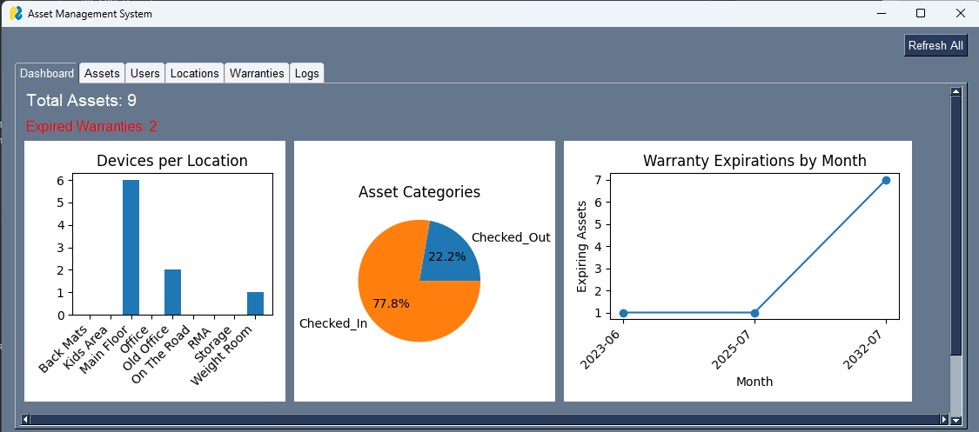

Upon opening, you will be greeted with the main dashboard that holds asset related visuals pulled straight from the database with a couple statistics on Total Assets and Expired Warranties. As defined during the Requirements Gathering phase of this system development project, these were the desired data points to be readily and easily available by the stakeholders. Furthermore its great to see PowerBI like reports ready at a glance.

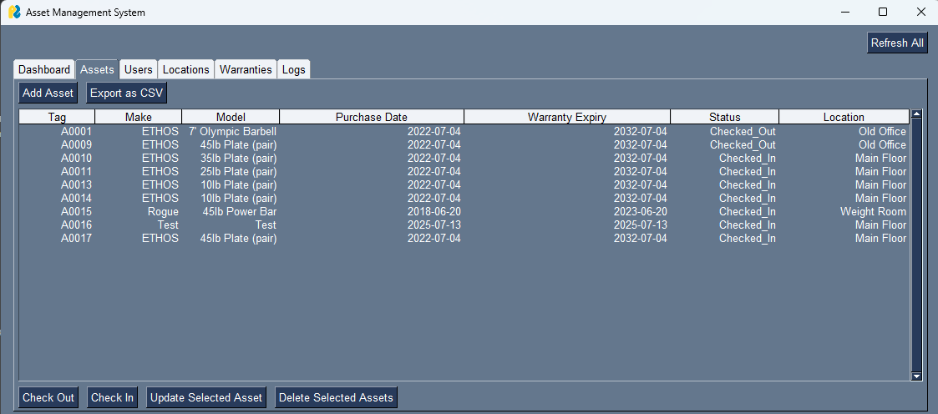**3.0 Assets**

On the top row of tabs, the next on the list is Assets. In here you can Add Assets, check them in or out, export all asset data, update specific asset meta-data, and delete non-transactioned assets.

3.1 Adding Assets



Upon clicking the add asset button at the top of the assets tab, a pop up dialogue will appear. In this dialogue is where you enter in all relevant asset meta-data to store in the database. Asset Tags are automatically generated as items are continuously added and cannot be altered. Make, Model, Status, and Warranty expiration are required per each asset input. After asset metadata is input and you click ‘Save’ the asset will appear in the Assets Tab. Additionally, you can refresh the Dashboard screen to see the asset visuals update.

3.2 Deleting Assets

For the deletion of assets, you must select as least one asset to move forward. In doing so, you select ‘Delete Selected Assets’ and a confirmation dialogue will arise. Select ‘Yes’ to confirm and delete the asset.

**NOTE**

This system was intended to log all asset history, regardless of time or error. If an asset was created in error, it can be easily deleted, however if transactions had already been made (the asset has moved around) it is unlikely an error. Preventing the deletion of assets with transactions is a method of waste/fraud/loss reduction and will be met with error. See below for change post asset deletion and discussed error.

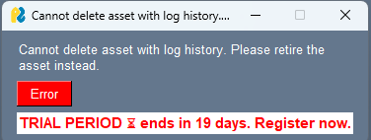

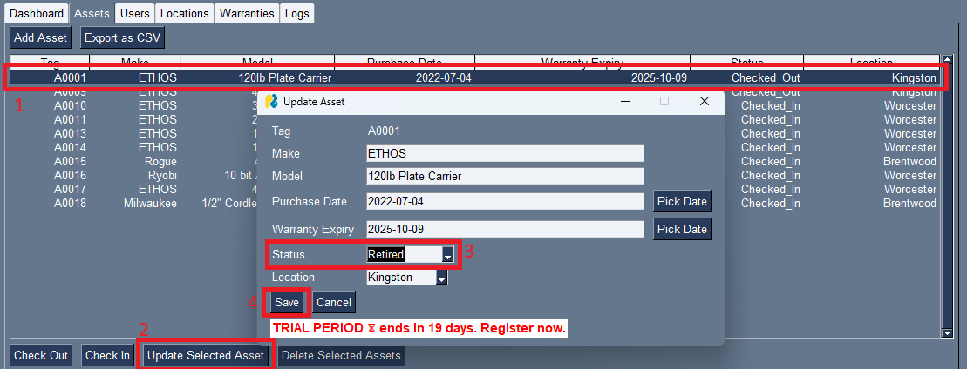3.3 Updating Assets

When updating assets first you must select 1 and only 1 asset and click ‘Update Selected Asset’. This action will open up a dialogue will all asset meta-data. Everything can be changed from status to warranty or purchase information even Make and Model if there were errors. When finished, the user will click save and be prompted to enter the transaction details.



Here is where the user/staff selects who is assigned the asset or making the change, if the asset is changing locations and any accompanying notes. Hit ‘save’ and the asset meta-data will change successfully!

3.4 Check-In/Check-out Assets



The check-in/check-out actions function the same as one another. Start by selecting one or more assets that you want to check-in or out then hit ‘Check Out’ or ‘Check In’. Confirm the action by selecting ‘Yes’ on popup. The same transaction window will appear as previously described. If the asset is already checked in or out, an error will arise describing so.

**4.0 Users**

The next tab over is Users. Here is where all company users will be created and held for asset assignment or transaction logging. As spoken about in the development communications, all Field Staff and Corporate Staff will be added here for asset management. As laptops are provisioned to new users, hardware checked out to field staff, or assets placed in maintenance by IT, all affiliated users will be kept here.

4.1 Add Users



At the Users tab, you have the ability to add users to the database. When ‘Add User’ is selected, the add user dialogue box will appear. Here you will enter in all necessary data for the new user, including department, job title, location, email, etc. Once finished, select ‘Save’ and the record will be added to the database.

4.2 Update User



After selecting a user (only 1), hit ‘Update Selected User’ to view into that users metadata. Edit any data required to be accurate, then select ‘Save’ to save changes.

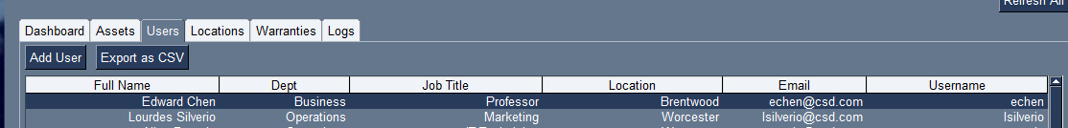

4.3 Delete Users

In order to delete a user, the user must not be correlated with any transactions that have been logged. To do so, select the user you wish to delete, select ‘Delete Selected Users’ and then ‘Save’.



**NOTE**

Similar to assets, users cannot simply be deleted unless created in error. All user transactions must be logged for audit purposes. If a user/staff is no longer with Conquer, their title and department must be changed to ‘Retired’ to reflect full accuracy and integrity of data. Below is the corresponding error.

**5.0 Locations**



Next up is the Locations Tab. Here you are granted full access into all locations that Conquer currently operates out of. These are what help drive the dashboard visuals and auditing logs.

5.1 Add Locations

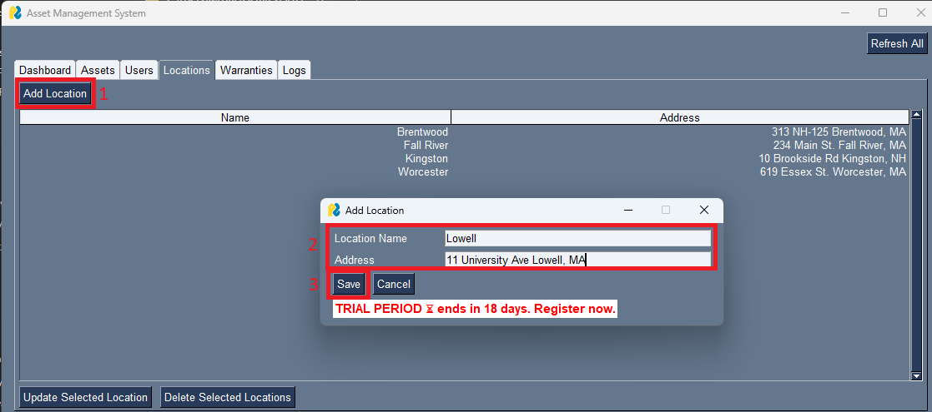

To add a location, select the ‘Add Location’ button and enter in required data in the popup. When finished, select ‘Save’ and view changes.



5.2 Update Locations

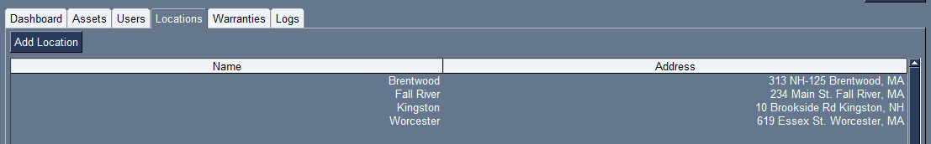To update a location, select a location (only 1) then hit ‘Update Selected Location’ button and enter in required data in the popup. When finished, select ‘Save’ and view changes.

5.3 Delete Locations



For deleting any location, you must first select 1 or more locations. After, select ‘Delete Selected Locations’ and hit ‘Yes’ on the pop up window.

**NOTE**

This system was intended to log all asset history, regardless of time or error. If a Location was created in error, it can be easily deleted, however if transactions had already been made (the location was used in asset transactions) it is unlikely an error. If a location was attempted to be deleted with transactions accompanied by them, they will be met with error.

**6.0 Warranties**

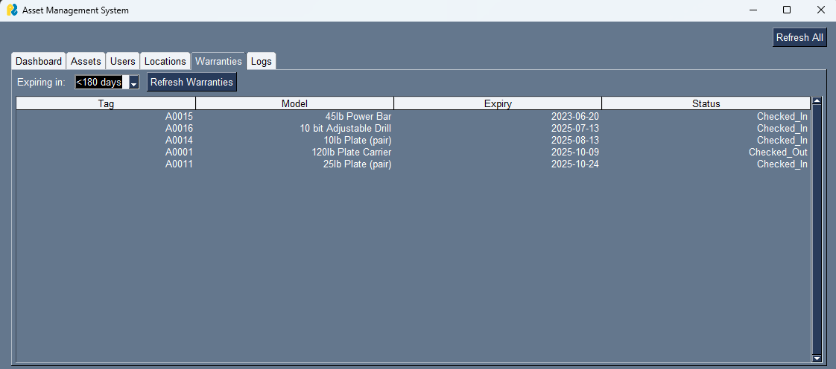

The warranties tab holds reports on ‘soon-to-expire’ warranties for assets currently in circulation. There are 3 drop down options, 30, 90, and 180 days to depict accurate warranty expiration data. This functions at a level of detail deeper than the dashboard warranty visuals to provide a more in-depth view into asset lifecycles.

**7.0 Logs**



The logs tab functions serves as a read only query to the backend to show all transactions that have been made in the history of the application. Mainly for auditing purposes, this tab is for IT and Administration to understand the flow of changes in the organization. AS items statuses’ change, updates are made or users check in/out items, everything will be seen here.

**8.0 Export as CSV**

The Assets, Users, Locations, and Logs tabs have a button on them labeled ‘Export as CSV’. This button brings you to a dialogue when you browse to select your file path, and the file is exported there. Below is an example with Assets.





**9.0 Finishing Notes**

Thank you for reading through this to greater understand the program that is being deployed for your use. If there are any issues, comments, or concerns please reach out to [IT@ConquerHomeWorks.com](mailto:IT@ConquerHomeWorks.com) for more information and assistance.

10.2 System Documentation

**10.2.1 Database Manual**

***FOR Information Technology/Information Systems TEAMS ONLY***

**1.0 VS Code MySQL SHELL**

Navigate to the below link to install the MySQL SHELL add-on for VS Code. Similar shells can be used for your preferred IDE however Visual Studio and VS Code are widely accepted as a standard.

<https://marketplace.visualstudio.com/items?itemName=Oracle.mysql-shell-for-vs-code>

**2.0 Install MySQL Developer Suite**

Navigate to the below link to install the MySQL SHELL Developer Suite. This controls the database and creates the network availability of the database locally.

<https://dev.mysql.com/downloads/installer/>

You will be prompted for administrative privileges twice during the installation.

Next is product selection. For this implementation you will require the following products installed on the host device:

* MySQL Server 8.0
* MySQL Workbench 8.0
* MySQL Router 8.0
* MySQL Shell 8.0

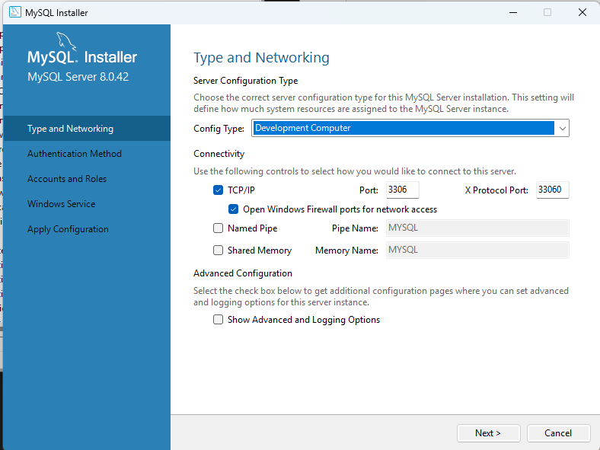Following, is server configuration, specifically config type and networking. Ensure the below information is entered as this will be important later.

Following, is server configuration, specifically config type and networking. Ensure the below information is entered as this will be important later. Next you will be prompted for authentication methods, and use all default parameters. (Use Strong Password Encryption for Authentication (RECCOMENDED)). Create a root password, this will need to be recorded for future use in the program database initialization.

Under Windows Service, use all default values and execute.

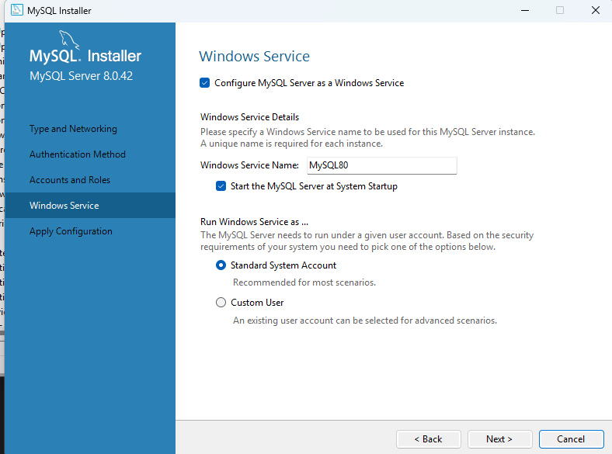

Next will be the MySQL Router Configuration. Retain ALL values to ensure full compatibility with current instructions. Workbench and Shell are simple one click set ups that require no extra configuration outside of default values.

**3.0 Configure VS Code Connector**

* Open the newly arrived MySQL Shell Extension on the left toolbar of VS Code (will need to be searched for via add-ons in Visual Studio).
* Create a new connection.

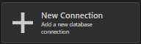

* Fill out Caption and Description.
  + - * 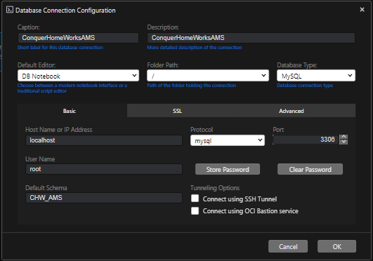To Link MySQL configured connection to this, enter the same recorded root password as created before. Click ‘Store Password’ and enter to get this done. Under ‘Default Schema’, enter the name Schema Name declared for use, and record this for the next step. Hit ok
    - Open Connection and Create Database
      * Run the following script and enter previously recorded values with a user name and password for privilege assignment.
      * Enter values for [Default Schema], [password], [username]
        + Create DATABASE [Default Schema];
        + Create User '[username]'@'localhost' IDENTIFIED by ‘[password]’;
        + Grant ALL on CHW_AMS.* to '[username]'@'localhost';
        + 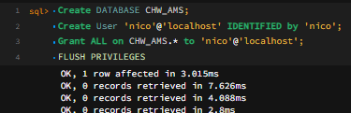FLUSH PRIVILEGES
* DB is now created and ready to be operated on.

**10.2.2 Program Manual**

For final operation to ensure connectivity between the program and the database. Enter in values for [Default Schema], [password], [username] in DB.py. Localhost will typically always stay 127.0.0.1, however if changed during setup, also change here.

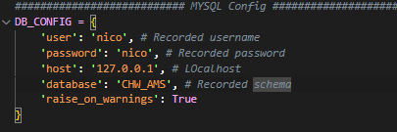

**10.2.3 Testing Data**

Testing data was used and is visible within the training material and documentation during the report. Example assets such as plates, carriers, and tools highlight the actions that can be taken on each asset as well as logs and visuals derived from that data. Similarly, example users and locations were also implemented for training and documentation purposes. All data can be altered or removed in the event of a new setup by an IT administrator pre-rollout.

**10.2.4 Maintenance Manual**

Maintenance intervals are set to semi-annual dates starting post implementation. At that point each change will be notated in the code, if any, following similar structure to that that is already there. Maintaining documentation integrity throughout the process is a requirement for IT staff. All other changes are to be logged in the accompanying PatchNotes.txt for future reference. Copies are periodically saved in the event of failure.

Support for this rollout and all other accompanying needs are to be addressed to [it@conquerhomeworks.com](mailto:it@conquerhomeworks.com) where the help desk administrator will assign development issues to the in-house developer and provide assistance for training, documentation, or non-invasive support. Non-invasive support includes (but is not limited to):

* Documentation Education
* Program Troubleshooting
* Network Drive/Folder troubleshooting
* Desktop/User provisioning
* Audit logs acquisition, if requested

Other more invasive requests, such as system enhancements, bug fixes, or other requests are to be assigned to the developer or other IT/IS team members for review. All stakeholder requests are to be handled directly by the in house developer for the first 60 days post implementation. After that point, the application will be considered finalized and other requests will be considered enhancements for maintenance.

**11.0 Source Code**

**11.1 DB.py (Database functions and initialization)**

**import mysql.connector**

**from mysql.connector import errorcode**

**from datetime import date, timedelta**

***########################### MYSQL Config ###############################################################################***

**DB_CONFIG = {**

**'user': 'nico', *# Recorded username***

**'password': 'nico', *# Recorded password***

**'host': '127.0.0.1', *# LOcalhost***

**'database': 'CHW_AMS', *# Recorded schema***

**'raise_on_warnings': True**

**}**

***# Return successful connection to DB, error if not***

**def get_connection():**

**try:**

**c = mysql.connector.connect(**DB_CONFIG) *# **Unpack dictionary***

**return c**

**except mysql.connector.Error as err: *# Catch mysql errors send output***

**if err.errno == errorcode.ER_ACCESS_DENIED_ERROR:**

**print("Wrong user or password")**

**elif err.errno == errorcode.ER_BAD_DB_ERROR:**

**print("Database does not exist")**

**else: *# Throw others***

**print(err)**

**raise**

***########################### Table Initialization ###############################################################################***

***# Initializes all tables if they don’t already exist***

***# Run on startup to make sure DB is ready***

**def initialize_schema():**

**connection = get_connection() *# Start connection***

**cursor = connection.cursor() *# Cursor = query excecutor, ready executions***

***# Initialize tables***

**queries = [**

**"""**

**CREATE TABLE IF NOT EXISTS locations (**

**id INT AUTO_INCREMENT PRIMARY KEY,**

**name VARCHAR(255) NOT NULL,**

**address VARCHAR(512)**

**) ENGINE=InnoDB**

**""",**

**"""**

**CREATE TABLE IF NOT EXISTS users (**

**id INT AUTO_INCREMENT PRIMARY KEY,**

**full_name VARCHAR(255) NOT NULL,**

**department VARCHAR(255),**

**job_title VARCHAR(255),**

**location_id INT,**

**email VARCHAR(255),**

**username VARCHAR(100) UNIQUE,**

**FOREIGN KEY (location_id) REFERENCES locations(id)**

**ON DELETE SET NULL ON UPDATE CASCADE**

**) ENGINE=InnoDB**

**""",**

**"""**

**CREATE TABLE IF NOT EXISTS assets (**

**id INT AUTO_INCREMENT PRIMARY KEY,**

**tag VARCHAR(100) UNIQUE NOT NULL,**

**make VARCHAR(255),**

**model VARCHAR(255),**

**purchase_date DATE,**

**warranty_expiry DATE,**

**status VARCHAR(50),**

**location_id INT,**

**FOREIGN KEY (location_id) REFERENCES locations(id)**

**ON DELETE SET NULL ON UPDATE CASCADE**

**) ENGINE=InnoDB**

**""",**

**"""**

**CREATE TABLE IF NOT EXISTS transactions (**

**id INT AUTO_INCREMENT PRIMARY KEY,**

**asset_id INT NOT NULL,**

**user_id INT NOT NULL,**

**action VARCHAR(50) NOT NULL,**

**timestamp DATETIME DEFAULT CURRENT_TIMESTAMP,**

**notes TEXT,**

**from_location INT,**

**to_location INT,**

**FOREIGN KEY (asset_id) REFERENCES assets(id),**

**FOREIGN KEY (user_id) REFERENCES users(id),**

**FOREIGN KEY (from_location) REFERENCES locations(id),**

**FOREIGN KEY (to_location) REFERENCES locations(id)**

**) ENGINE=InnoDB**

**"""**

**]**

***# Run each query above***

**for init_query in queries:**

**try:**

**cursor.execute(init_query)**

**except mysql.connector.Error as err: *# Catch mysql table exsists error and ignore***

**if err.errno == errorcode.ER_TABLE_EXISTS_ERROR:**

**continue**

**else: *# Catch other errors and quit***

**cursor.close() *# Cursor close first, then connection***

**connection.close()**

**raise**

**connection.commit() *# Commit changes. Different than work SSMS bc this is transaction based not immediate***

**cursor.close()**

**connection.close()**

***########################### CRUD Actions ###############################################################################***

***########################## ASSETS ##########################***

**def get_assets():**

**connection = get_connection()**

**cursor = connection.cursor(dictionary=True) *# Dictionary returns a dictionary not tuples***

***# Select *, join location for locationid***

**cursor.execute("""**

**SELECT a.id, a.tag,  a.make, a.model,a.purchase_date,a.warranty_expiry,a.status, l.name AS location**

**FROM assets a**

**LEFT JOIN locations l ON a.location_id = l.id**

**ORDER BY a.tag**

**""")**

**rows = cursor.fetchall() *# Gets entries returned by query***

**cursor.close()**

**connection.close()**

***# Return entries as 8 parsed elements***

**return [(**

**r['id'], r['tag'], r['make'], r['model'],**

**r['purchase_date'].isoformat() if r['purchase_date'] else '', *# Format for date, else NULL***

**r['warranty_expiry'].isoformat() if r['warranty_expiry'] else '',**

**r['status'], r['location'] or ''**

**) for r in rows]**

***# Need each elements passed in IN ORDER***

**def insert_asset(tag, make, model, purchase_date, warranty_expiry, status, location_id):**

**connection = get_connection()**

**cursor = connection.cursor()**

**cursor.execute( *# Insert query requires elements IN ORDER***

**"INSERT INTO assets (tag,make,model,purchase_date,warranty_expiry,status,location_id)" " VALUES (%s, %s, %s, %s, %s, %s, %s)",**

**(tag, make, model, purchase_date, warranty_expiry, status, location_id)**

**)**

**connection.commit()**

**cursor.close()**

**connection.close()**

***# Set each element as NONE to fix NULL PARAMETER EXITING issue***

**def update_asset(id_, tag=None, make=None, model=None, purchase_date=None, warranty_expiry=None, status=None, location_id=None):**

**fields = [] *# Stores new element assignments with columnname 'make=%s'***

**params = [] *# Stores new element values 'Dell'***

***# Update passed in fields***

**if tag is not None:**

**fields.append("tag=%s"); params.append(tag)**

**if make is not None:**

**fields.append("make=%s"); params.append(make)**

**if model is not None:**

**fields.append("model=%s"); params.append(model)**

**if purchase_date is not None:**

**fields.append("purchase_date=%s"); params.append(purchase_date)**

**if warranty_expiry is not None:**

**fields.append("warranty_expiry=%s"); params.append(warranty_expiry)**

**if status is not None:**

**fields.append("status=%s"); params.append(status)**

**if location_id is not None:**

**fields.append("location_id=%s"); params.append(location_id)**

***# No update  edge case***

**if not fields:**

**return**

***# Build the update query. ADDED COMMA BC SYNTAX ERROR***

**update_query = f"UPDATE assets SET {', '.join(fields)} WHERE id=%s"**

**params.append(id_) *# Add id for where modifier***

**connection = get_connection()**

**cursor = connection.cursor()**

***# Supplies built query then passed in parameters***

**cursor.execute(update_query, params)**

**connection.commit()**

**cursor.close()**

**connection.close()**

***# Delete whole entry via passed in id***

**def delete_asset(id_):**

**connection = get_connection()**

**cursor = connection.cursor()**

**try:**

**cursor.execute("DELETE FROM assets WHERE id=%s", (id_,))**

**connection.commit()**

**except mysql.connector.IntegrityError as e:**

**if e.errno == errorcode.ER_ROW_IS_REFERENCED_2: *# MySQL error when object has entries in transactions***

**raise ValueError("Cannot delete asset with log history. Please retire the asset instead.")**

**else:**

**raise**

**finally:**

**cursor.close()**

**connection.close()**

***########################## USERS ##########################***

***# Same as assets***

**def get_users():**

**connection = get_connection()**

**cursor = connection.cursor(dictionary=True)**

**cursor.execute("""**

**SELECT u.id, u.full_name, u.department, u.job_title,**

**l.name AS location, u.email, u.username**

**FROM users u**

**LEFT JOIN locations l ON u.location_id = l.id**

**ORDER BY u.full_name**

**""")**

**rows = cursor.fetchall()**

**cursor.close()**

**connection.close()**

**return [(**

**r['id'], r['full_name'], r['department'],**

**r['job_title'], r['location'] or '',**

**r['email'], r['username']**

**) for r in rows]**

***# Same as assets***

**def insert_user(full_name, department, job_title, location_id, email, username):**

**connection = get_connection()**

**cursor = connection.cursor()**

**cursor.execute(**

**"INSERT INTO users (full_name,department,job_title,location_id,email,username)"**

**" VALUES (%s, %s, %s, %s, %s, %s)",**

**(full_name, department, job_title, location_id, email, username)**

**)**

**connection.commit()**

**cursor.close()**

**connection.close()**

***# Same as assets***

**def update_user(id_, full_name=None, department=None, job_title=None, location_id=None, email=None, username=None):**

**fields = []**

**params = []**

**if full_name is not None:**

**fields.append("full_name=%s"); params.append(full_name)**

**if department is not None:**

**fields.append("department=%s"); params.append(department)**

**if job_title is not None:**

**fields.append("job_title=%s"); params.append(job_title)**

**if location_id is not None:**

**fields.append("location_id=%s"); params.append(location_id)**

**if email is not None:**

**fields.append("email=%s"); params.append(email)**

**if username is not None:**

**fields.append("username=%s"); params.append(username)**

**if not fields:**

**return**

**update_query = f"UPDATE users SET {', '.join(fields)} WHERE id=%s"**

**params.append(id_)**

**connection = get_connection()**

**cursor = connection.cursor()**

**cursor.execute(update_query, params)**

**connection.commit()**

**cursor.close()**

**connection.close()**

***# Same as assets***

**def delete_user(id_):**

**connection = get_connection()**

**cursor = connection.cursor()**

**try:**

**cursor.execute("DELETE FROM users WHERE id=%s", (id_,))**

**connection.commit()**

**except mysql.connector.IntegrityError as e:**

**if e.errno == errorcode.ER_ROW_IS_REFERENCED_2: *# MySQL error when object has entries in transactions***

**raise ValueError("Cannot delete user with log history. Consider updating 'Job Title' or 'Name' to 'RESIGNED'.")**

**else:**

**raise**

**finally:**

**cursor.close()**

***########################## LOCATIONS ##########################***

***# Same structure as other tables***

**def get_locations():**

**connection = get_connection()**

**cursor = connection.cursor(dictionary=True)**

**cursor.execute("SELECT id, name, address FROM locations ORDER BY name")**

**rows = cursor.fetchall()**

**cursor.close()**

**connection.close()**

**return [(r['id'], r['name'], r['address'] or '') for r in rows]**

***# Same structure as other tables***

**def insert_location(name, address):**

**connection = get_connection()**

**cursor = connection.cursor()**

**cursor.execute("INSERT INTO locations (name,address) VALUES (%s, %s)", (name, address))**

**connection.commit()**

**cursor.close()**

**connection.close()**

***# Same structure as other tables***

**def update_location(id_, name=None, address=None):**

**fields = []**

**params = []**

**if name is not None:**

**fields.append("name=%s"); params.append(name)**

**if address is not None:**

**fields.append("address=%s"); params.append(address)**

**if not fields:**

**return**

**update_query = f"UPDATE locations SET {', '.join(fields)} WHERE id=%s"**

**params.append(id_)**

**connection = get_connection()**

**cursor = connection.cursor()**

**cursor.execute(update_query, params)**

**connection.commit()**

**cursor.close()**

**connection.close()**

***# Same structure as other tables***

**def delete_location(id_):**

**connection = get_connection()**

**cursor = connection.cursor()**

**try:**

**cursor.execute("DELETE FROM locations WHERE id=%s", (id_,))**

**connection.commit()**

**except mysql.connector.IntegrityError as e:**

**if e.errno == errorcode.ER_ROW_IS_REFERENCED_2: *# MySQL error when object has entries in transactions***

**raise ValueError("Cannot delete location that is linked to users, assets, or transactions. Please label as 'Retired_Location'")**

**else:**

**raise**

**finally:**

**cursor.close()**

**connection.close()**

***########################## TRANSACTIONS ##########################-***

***# Basic insert query no idenitfying params needed***

**def log_transaction(asset_id, user_id, action, notes='', from_loc=None, to_loc=None):**

**connection = get_connection()**

**cursor = connection.cursor()**

***# Insert passed in elements***

**cursor.execute(**

**"INSERT INTO transactions "**

**"(asset_id,user_id,action,notes,from_location,to_location) VALUES (%s,%s,%s,%s,%s,%s)",**

**(asset_id, user_id, action, notes, from_loc, to_loc)**

**)**

**connection.commit()**

**cursor.close()**

**connection.close()**

***# Select * queries for filtered and unfiltered logs***

**def get_transactions(filter_asset_tag=None):**

**connection = get_connection()**

**cursor = connection.cursor(dictionary=True)**

***# added for filter by asset (-LOG_ASSET_FILTER-) button***

**if filter_asset_tag and filter_asset_tag != 'All':**

**cursor.execute("""**

**SELECT t.timestamp, a.tag, a.model, u.full_name,**

**t.action, t.notes, fl.name AS from_loc, tl.name AS to_loc**

**FROM transactions t**

**JOIN assets a ON t.asset_id = a.id**

**JOIN users u ON t.user_id = u.id**

**LEFT JOIN locations fl ON t.from_location = fl.id**

**LEFT JOIN locations tl ON t.to_location = tl.id**

**WHERE a.tag = %s**

**ORDER BY t.timestamp DESC**

**""", (filter_asset_tag,))**

**else: *# Emprty where modifier***

**cursor.execute("""**

**SELECT t.timestamp, a.tag, a.model, u.full_name,**

**t.action, t.notes, fl.name AS from_loc, tl.name AS to_loc**

**FROM transactions t**

**JOIN assets a ON t.asset_id = a.id**

**JOIN users u ON t.user_id = u.id**

**LEFT JOIN locations fl ON t.from_location = fl.id**

**LEFT JOIN locations tl ON t.to_location = tl.id**

**ORDER BY t.timestamp DESC**

**""" )**

***# Returned entries***

**rows = cursor.fetchall()**

**cursor.close()**

**connection.close()**

***# Parse***

**return [[**

**r['timestamp'], r['tag'], r['model'], r['full_name'],**

**r['action'], r['notes'], r['from_loc'] or '', r['to_loc'] or ''**

**] for r in rows]**

***########################## HELPER FUNCTIONS ##########################***

***# Returns next available asset tag***

**def get_next_asset_tag():**

**connection = get_connection()**

**cursor = connection.cursor()**

***# Check last id (max(id)) on assets, +1 = next id***

**cursor.execute("SELECT COALESCE(MAX(id),0) + 1 FROM assets")**

**next_id = cursor.fetchone()[0] *# Fets first row, 1 value***

**cursor.close()**

**connection.close()**

***# Alter returned Asset Tag (leading zeros for now)***

**return f"A{next_id:04d}"**

***# Returns list of assets within warranty window***

**def get_warranties_within(days=30):**

***# Calculate today + window returns formatted***

**cutoff = (date.today() + timedelta(days=days)).isoformat()**

**connection = get_connection()**

**cursor = connection.cursor(dictionary=True)**

**cursor.execute(**

**"SELECT tag, model, warranty_expiry, status "**

**"FROM assets WHERE warranty_expiry <= %s "**

**"ORDER BY warranty_expiry ASC",**

**(cutoff,)**

**)**

**rows = cursor.fetchall()**

**cursor.close()**

**connection.close()**

***# list***

**return [[**

**r['tag'], r['model'], r['warranty_expiry'], r['status']**

**] for r in rows]**

***# Take locationName grab ID***

**def map_location_name_to_id(name):**

**connection = get_connection()**

**cursor = connection.cursor()**

**cursor.execute("SELECT id FROM locations WHERE name = %s", (name,))**

**row = cursor.fetchone() *# GRab top row***

**cursor.close()**

**connection.close()**

***# if row if populated***

**return row[0] if row else None**

**11.2 Main.py (Popups, Events, and Handling logic)**

***# Reinstall pysimplegui for license***

***# & "C:\Program Files (x86)\Microsoft Visual Studio\Shared\Python39_64\python.exe"***

***# ` -m pip install --force-reinstall --extra-index-url https://PySimpleGUI.net/install PySimpleGUI***

***# Run program bc enviorment issues***

***# & "C:\Program Files (x86)\Microsoft Visual Studio\Shared\Python39_64\python.exe" "C:\Users\MrUnr\Documents\AssetManagementProj\ConquerAssetManagementSystem\Main2.py"***

**import PySimpleGUI as psg**

**from db import (initialize_schema,get_assets, get_next_asset_tag, insert_asset, update_asset, delete_asset,get_users,**

**insert_user, update_user, delete_user,get_locations, insert_location, update_location, delete_location,**

**log_transaction, get_transactions, get_warranties_within)**

**from matplotlib.backends.backend_tkagg import FigureCanvasTkAgg**

**import matplotlib.pyplot as plt**

**from matplotlib.ticker import MaxNLocator**

**import csv**

**from collections import Counter**

**import datetime**

***########################### MAIN TABS ###############################################################################***

***# Need visuals***

**def make_dashboard_tab():**

**assets = get_assets()**

**total_devices = len(assets) *# Total Devices display***

**expired_warranties = len(get_warranties_within(0)) *# Expired Warranties Display***

***# Canvas creates placeholders for charts. Need separate list for horizontal visuals***

**chart_row = [**

**psg.Canvas(key='Canvas_Bar_Graph',     background_color='white', size=(200, 200), expand_x=True, expand_y=True),**

**psg.Canvas(key='Canvas_Pie_Chart',     background_color='white', size=(400, 400), expand_x=True, expand_y=True),**

**psg.Canvas(key='Canvas_Line_Graph',  background_color='white', size=(200, 200), expand_x=True, expand_y=True)**

**]**

***# Layout list, switched from plain calls, displays objects in order***

**layout = [**

**[psg.Text(f"Total Assets: {total_devices}", font=('Any', 14), key='Total_Devices')], *# Text on top***

**[psg.Text(f"Expired Warranties: {expired_warranties}", font=('Any', 12), text_color='red', key='Expired_Warranties')],**

**chart_row**

**]**

***# Changed to column for scroll bars***

**tab = [[psg.Column(layout, scrollable=True, vertical_scroll_only=False, expand_x=True, expand_y=True)]]**

***# Whole tab with 2 text then charts***

**return tab**

***# Assets w/ buttons***

**def make_assets_tab():**

**layout = [**

**[psg.Button('Add Asset'), psg.Button('Export as CSV', key='Export Assets')], *# Top row of event buttons***

**[psg.Table(values=[], headings=['Tag','Make','Model','Purchase Date', 'Warranty Expiry', 'Status','Location'], key='Asset_Table', enable_events=True, select_mode=psg.TABLE_SELECT_MODE_EXTENDED, auto_size_columns=True, num_rows=10, expand_x=True, expand_y=True)],**

**[psg.Button('Check Out'), psg.Button('Check In'), psg.Button('Update Selected Asset'), psg.Button('Delete Selected Assets')] *# Bottom row of event buttons***

**]**

**return layout**

***# Users w/ buttons***

**def make_users_tab():**

**layout = [**

**[psg.Button('Add User'), psg.Button('Export as CSV', key='Export Users')], *# Top row of event buttons***

**[psg.Table(values=[], headings=['Full Name','Dept','Job Title','Location','Email','Username'], key='User_Table', enable_events=True, select_mode=psg.TABLE_SELECT_MODE_EXTENDED, auto_size_columns=True, num_rows=10, expand_x=True, expand_y=True)],**

**[psg.Button('Update Selected User'), psg.Button('Delete Selected Users')] *# Bottom row of event buttons***

**]**

**return layout**

***# Locations w/ buttons***

**def make_locations_tab():**

**layout = [**

**[psg.Button('Add Location')], *# Top row of event buttons***

**[psg.Table(values=[], headings=['Name','Address'], key='Location_Table', enable_events=True, select_mode=psg.TABLE_SELECT_MODE_EXTENDED, auto_size_columns=True, num_rows=10, expand_x=True, expand_y=True)],**

**[psg.Button('Update Selected Location'), psg.Button('Delete Selected Locations')] *# Bottom row of event buttons***

**]**

**return layout**

***# Warranties w/ dropdown & buttons***

**def make_warranties_tab():**

**layout = [**

**[psg.Text('Expiring in:'), psg.Combo(['<30 days','<90 days','<180 days'], default_value='<30 days', key='Warranty_Filter'), psg.Button('Refresh Warranties')], *# Top row of dropdown (combo) with Refresh***

**[psg.Table(values=[], headings=['Tag','Model','Expiry','Status'], key='Warranty_Table', auto_size_columns=True, num_rows=10, expand_x=True, expand_y=True)]**

**]**

**return layout**

***# Logs w/ dropdown & buttons***

**def make_logs_tab():**

**layout = [**

**[psg.Text('Filter by Asset:'), psg.Combo(values=['All'], default_value='All', key='Log_Filter', enable_events=True), psg.Button('Export as CSV', key='Export Logs')], *# Top row of dropdown (combo) with Export***

**[psg.Table(values=[], headings=['Timestamp','Tag','Model','User','Action','Notes','From Loc','To Loc'], key='Log_Table', auto_size_columns=True, num_rows=10, expand_x=True, expand_y=True)]**

**]**

**return layout**

***########################### CCORE GUI ###############################################################################***

**def make_gui():**

**initialize_schema()**

**tab_group = psg.TabGroup([[**

**psg.Tab('Dashboard', make_dashboard_tab()),**

**psg.Tab('Assets', make_assets_tab()),**

**psg.Tab('Users', make_users_tab()),**

**psg.Tab('Locations', make_locations_tab()),**

**psg.Tab('Warranties', make_warranties_tab()),**

**psg.Tab('Logs', make_logs_tab())**

**]], expand_x=True, expand_y=True) *# Allow stretch***

**layout = [**

**[psg.Push(), psg.Button('Refresh All', key='Refresh All')], *# Refresh ALL button***

**[tab_group]**

**]**

***# Actual GUI Window***

**window = psg.Window('Asset Management System', layout, background_color = None , resizable=True, finalize=True, size=(1125, 500))**

***# Populate tabs***

**draw_dashboard_charts(window)**

**load_assets(window)**

**load_users(window)**

**load_locations(window)**

***# Set default filters so these next two actually load something***

**window['Warranty_Filter'].update('<30 days')**

**load_warranties(window, days=30)**

**window['Log_Filter'].update('All')**

**load_logs(window)**

**return window**

***########################### POP UP TABS ###############################################################################***

**def add_asset_popup(loc_names):**

***# Create Asset Entries***

**layout = [**

**[psg.Text('Make', size=(12,1)), psg.Input(key='Make')],**

**[psg.Text('Model', size=(12,1)), psg.Input(key='Model')],**

**[psg.Text('Purchase Date', size=(12,1)), psg.Input(key='Purchase_Date'), psg.CalendarButton('Pick Date', target='Purchase_Date', format='%Y-%m-%d')],**

**[psg.Text('Warranty Expiry', size=(12,1)), psg.Input(key='Warranty_Date'), psg.CalendarButton('Pick Date', target='Warranty_Date', format='%Y-%m-%d')],**

**[psg.Text('Status', size=(12,1)), psg.Combo(['Checked_In','Checked_Out','Retired','In_Repair','Damaged'],default_value='Checked_In', key='Status')],**

**[psg.Text('Location', size=(12,1)), psg.Combo(loc_names, key='Location')],**

**[psg.Button('Save'), psg.Button('Cancel')]**

**]**

***# Window***

**return psg.Window('Add Asset', layout, modal=True, finalize=True)**

**def update_asset_popup(current_vals, loc_names):**

***# Current_vals list: [tag, make, model, purchase_date, warranty_expiry, status, location]***

**layout = [**

**[psg.Text('Tag', size=(12,1)), psg.Text(current_vals[0])],**

**[psg.Text('Make', size=(12,1)), psg.Input(current_vals[1], key='Make')],**

**[psg.Text('Model', size=(12,1)), psg.Input(current_vals[2], key='Model')],**

**[psg.Text('Purchase Date', size=(12,1)), psg.Input(current_vals[3], key='Purchase_Date'), psg.CalendarButton('Pick Date', target='Purchase_Date', format='%Y-%m-%d')],**

**[psg.Text('Warranty Expiry', size=(12,1)), psg.Input(current_vals[4], key='Warranty_Date'), psg.CalendarButton('Pick Date', target='Warranty_Date', format='%Y-%m-%d')],**

**[psg.Text('Status', size=(12,1)), psg.Combo(['Checked_In','Checked_Out','Retired','In_Repair','Damaged'],default_value=current_vals[5],key='Status')],**

**[psg.Text('Location', size=(12,1)), psg.Combo(loc_names, default_value=current_vals[6], key='Location')],**

**[psg.Button('Save'), psg.Button('Cancel')]**

**]**

**return psg.Window('Update Asset', layout, modal=True, finalize=True)**

**def add_location_popup():**

***# Create Location Entries***

**layout = [**

**[psg.Text('Location Name', size=(15,1)), psg.Input(key='Location_Name')],**

**[psg.Text('Address',       size=(15,1)), psg.Input(key='Location_Address')],**

**[psg.Button('Save'), psg.Button('Cancel')]**

**]**

***# Window***

**return psg.Window('Add Location', layout, modal=True, finalize=True)**

**def edit_location_popup(loc_id, name, address):**

***# Edit Location Entries***

**layout = [**

**[psg.Text('ID', size=(12,1)), psg.Text(str(loc_id))],**

**[psg.Text('Location Name', size=(15,1)), psg.Input(name, key='Location_Name')],**

**[psg.Text('Address', size=(15,1)), psg.Input(address, key='Location_Address')],**

**[psg.Button('Save'), psg.Button('Cancel')]**

**]**

***# Window***

**return psg.Window('Update Location', layout, modal=True, finalize=True)**

**def add_user_popup(loc_names):**

***# Add User Entries***

**layout = [**

**[psg.Text('Full Name', size=(12,1)), psg.Input(key='Full_Name')],**

**[psg.Text('Department', size=(12,1)), psg.Input(key='Department')],**

**[psg.Text('Job Title', size=(12,1)), psg.Input(key='Job_Title')],**

**[psg.Text('Email', size=(12,1)), psg.Input(key='Email')],**

**[psg.Text('Username', size=(12,1)), psg.Input(key='UserName')],**

**[psg.Text('Location', size=(12,1)),**

**psg.Combo(loc_names, key='Location')],**

**[psg.Button('Save'), psg.Button('Cancel')]**

**]**

***# Window***

**return psg.Window('Add User', layout, modal=True, finalize=True)**

**def edit_user_popup(current_vals, loc_names):**

***# Edit User Entries***

***# current_vals = [id, full_name, dept, job_title, loc_name, email, username]***

**layout = [**

**[psg.Text('ID', size=(12,1)), psg.Text(str(current_vals[0]))],**

**[psg.Text('Full Name', size=(12,1)), psg.Input(current_vals[1], key='Full_Name')],**

**[psg.Text('Department', size=(12,1)), psg.Input(current_vals[2], key='Department')],**

**[psg.Text('Job Title', size=(12,1)), psg.Input(current_vals[3], key='Job_Title')],**

**[psg.Text('Location', size=(12,1)), psg.Combo(loc_names, default_value=current_vals[4], key='Location')],**

**[psg.Text('Email', size=(12,1)), psg.Input(current_vals[5], key='Email')],**

**[psg.Text('Username', size=(12,1)), psg.Input(current_vals[6], key='UserName')],**

**[psg.Button('Save'), psg.Button('Cancel')]**

**]**

***# Window***

**return psg.Window('Update User', layout, modal=True, finalize=True)**

***# Window that records transaction data post asset update***

**def transaction_popup(user_names, loc_names, default_user=None, default_from=None, default_to=None, default_notes=''):**

**layout = [**

**[psg.Text('User', size=(12,1)), psg.Combo(user_names, default_value=default_user, key='Transaction_User', readonly=True)], *# User dropdown selection***

**[psg.Text('From Location', size=(12,1)), psg.Combo(loc_names, default_value=default_from, key='Transaction_From_Loc', readonly=True)], *# From Location drop down selection***

**[psg.Text('To Location', size=(12,1)), psg.Combo(loc_names, default_value=default_to, key='Transaction_To_Loc',   readonly=True)], *# To Location drop down selection***

**[psg.Text('Notes', size=(12,1)), psg.Multiline(default_notes, key='Transaction_Notes', size=(40,4))], *# Notes multiline entry box***

**[psg.Button('Save'), psg.Button('Cancel')]**

**]**

**win = psg.Window('Transaction Details', layout, modal=True, finalize=True)**

**while True: *# Keep open***

**event , vals = win.read() *# Read selections***

***# Canceled***

**if event in (psg.WIN_CLOSED, 'Cancel'):**

**win.close()**

**return None**

***# Saved***

**if event == 'Save':**

***# Record Entries***

**user_selection = vals['Transaction_User']**

**from_selection = vals['Transaction_From_Loc']**

**to_selection = vals['Transaction_To_Loc']**

**notes = vals['Transaction_Notes'].rstrip()**

***# Handle missing locs or user***

**if not (from_selection and to_selection and user_selection):**

**psg.popup_error('User, From Location and To Location are required.')**

**continue**

**win.close()**

**return {**

**'user': user_selection,**

**'from_loc':from_selection,**

**'to_loc': to_selection,**

**'notes': notes**

**}**

***# SaveAs popup with windows file explorer system dialog***

**def export_csv_popup(default_filename, file_types=(('CSV Files','*.csv'),)):**

**layout = [**

**[psg.Text('Please select "Browse" and enter destination.')],**

***# Filename box with FileSaveAs windows system popup .csv extension***

**[psg.Input(default_filename, key='Path', size=(40,1), readonly=True), psg.FileSaveAs(button_text='Browse…', key='-BROWSE-', file_types=file_types, default_extension='.csv')],**

**[psg.Push(), psg.Button('Save'), psg.Button('Cancel')]**

**]**

***# Create Window***

**window = psg.Window('Save As CSV', layout, modal=True, finalize=True)**

**path = None**

**while True:**

**event, vals = window.read()**

***# Closed***

**if event in (psg.WIN_CLOSED, 'Cancel'):**

**break**

***# Saved***

**if event == 'Save':**

**location = vals['Path']**

***# Empty handler***

**if not location:**

**psg.popup_error('Please choose a file location first.')**

**continue**

**path = location**

**break**

**window.close()**

**return path**

***########################### HELPER FUNCTIONS ###############################################################################***

**def _embed_figure(window, canvas_key, figure):**

**canvas_elem = window[canvas_key] *# Full Canvas Element for processing***

**tk_canvas   = canvas_elem.TKCanvas**

***# Destroy existing widgets (fix refreesh duplication bug)***

**for child in tk_canvas.winfo_children():**

**child.destroy()**

***# Embed the new figures***

**fig_canvas = FigureCanvasTkAgg(figure, tk_canvas)**

**fig_canvas.draw()**

**fig_canvas.get_tk_widget().pack(fill='both', expand=True)**

***# Return action change***

**def _determine_action(old_status, new_status):**

**if old_status == new_status:**

**return 'UPDATE_ASSET'**

***# Status changed, return the action***

**if new_status == 'Checked_Out':**

**return 'CHECK_OUT'**

**elif new_status == 'Checked_In':**

**return 'CHECK_IN'**

**elif new_status == 'In_Repair':**

**return 'UPDATE_ASSET_REPAIR'**

**elif new_status == 'Retired':**

**return 'UPDATE_ASSET_RETIRED'**

**elif new_status == 'Damaged':**

**return 'UPDATE_ASSET_DAMAGED'**

**else:**

***# Edge cases***

**return 'UPDATE_ASSET'**

***############################ LOAD FUNCTIONS ###############################################################################***

**def load_assets(win):**

**rows = get_assets()**

***# Store AssetIDs***

**win.asset_ids = []**

**for row in rows:**

**win.asset_ids.append(row[0]) *# Row[0] = assetID***

**table_data = []**

**for row in rows:**

**asset_row = list(row[1:])  *# Skip the first column and take the rest***

**table_data.append(asset_row)**

**win['Asset_Table'].update(values=table_data)**

**def load_users(win):**

**rows = get_users()**

***# Store UserIDs***

**win.user_ids = []**

**for row in rows:**

**win.user_ids.append(row[0])  *# Save userID***

**table_data = []**

**for row in rows:**

**user_row = list(row[1:])  *# Skip the first column and take the rest***

**table_data.append(user_row)**

**win['User_Table'].update(values=table_data)**

**def load_locations(win):**

**rows = get_locations()**

***# Store LocationIDs***

**win.loc_ids = []**

**for row in rows:**

**win.loc_ids.append(row[0])  *# Store location ID***

**table_data = []**

**for row in rows:**

**loc_row = list(row[1:])  *# Skip the first column and take the rest***

**table_data.append(loc_row)**

**win['Location_Table'].update(values=table_data)**

**def load_warranties(win, days):**

**data = get_warranties_within(days)**

**win['Warranty_Table'].update(values=data)**

**def load_logs(win, asset_tag=None):**

**data = get_transactions(asset_tag)**

**win['Log_Table'].update(values=data)**

***########################### CHART FUNCTIONS ###############################################################################***

**def draw_dashboard_charts(window):**

***# Update top dashboard labels***

**assets = get_assets() *# Refresh Assets***

**total_devices = len(assets)**

**window['Total_Devices'].update(f"Total Assets: {total_devices}") *# Refresh Total Asset Count***

**expired_warranties = len(get_warranties_within(0))**

**window['Expired_Warranties'].update(f"Expired Warranties: {expired_warranties}") *# Refresh Expired Warranties***

***############ Devices per Location (bar) ############***

***# Get all location names from the database***

**locations = get_locations()  *# [id, name, address]***

***# Lisst of name***

**location_names = []**

**for loc in locations:**

**location_names.append(loc[1])  *# loc[1] == name***

***# Count how many assets are in each location***

**location_counts = []**

**for name in location_names:**

**count = 0**

**for asset in assets:**

**if asset[7] == name:  *# asset[7] == location name***

**count += 1**

**location_counts.append(count)**

***# Create bar chart figure***

**fig_bar, ax_bar = plt.subplots(figsize=(3, 3))**

**if location_names:**

**ax_bar.bar(location_names, location_counts) *# (x,y)***

**ax_bar.yaxis.set_major_locator(MaxNLocator(integer=True))  *# Show ints on y axis***

**ax_bar.set_xticklabels(location_names, rotation=45, ha='right')  *# or rotation=90 for vertical***

**else:**

**ax_bar.bar(['No locations'], [1], color='#dddddd')  *# Placeholder if no locations***

**ax_bar.set_title('Devices per Location') *# Title***

**fig_bar.tight_layout()**

**_embed_figure(window, 'Canvas_Bar_Graph', fig_bar) *# Embed into figure w/ key***

***############ Category Breakdown (pie) ############***

***# Pull all statuses***

**statuses = []**

**for asset in assets:**

**if len(asset) > 6:**

**statuses.append(asset[6])  *# asset[6] == status***

**if statuses:**

***# List each status type***

**status_type = list(set(statuses))**

***# Count times each category appears***

**status_counts = []**

**for status in status_type:**

**count = statuses.count(status)**

**status_counts.append(count)**

**else:**

**status_type = ['No categories']**

**status_counts = [1]**

***# Create pie chart figure***

**fig_cat, ax_cat = plt.subplots(figsize=(3, 3))**

**ax_cat.pie(status_counts, labels=status_type, autopct='%1.1f%%')**

**ax_cat.set_title('Asset Categories') *# Title***

**fig_cat.tight_layout()**

**_embed_figure(window, 'Canvas_Pie_Chart', fig_cat)**

***############ Warranty Expirations Over Time (line) ############***

***# Get warranty expiry dates from assets***

**expiry_dates = []**

**for asset in assets:**

**expiry_str = asset[5]  *# asset[5] == warranty_expiry***

**if expiry_str:**

**expiry_date = datetime.datetime.strptime(expiry_str, '%Y-%m-%d') *# Format str > date - time***

***# Add formatted dates to lsit***

**expiry_dates.append(expiry_date)**

***# Convert each date into month  eg 2025-07-23 > '2025-07'***

**month_labels = []**

**for date in expiry_dates:**

**month_str = date.strftime('%Y-%m')**

**month_labels.append(month_str)**

***# Count warranty expirations in each month***

**month_counter = Counter(month_labels)**

***# Sort months***

**sorted_months = sorted(month_counter.keys())**

**month_counts = []**

**for month in sorted_months:**

**month_counts.append(month_counter[month])**

***# Create line chart***

**fig_line, ax_line = plt.subplots(figsize=(4, 3))**

**if sorted_months:**

**ax_line.plot(sorted_months, month_counts, marker='o') *# (x,y)***

**ax_line.set_title('Warranty Expirations by Month') *# Title***

**ax_line.set_ylabel('Expiring Assets') *# y title***

**ax_line.set_xlabel('Month') *# x title***

**ax_line.set_xticklabels(sorted_months, rotation=45, ha='right') *# Slight rotation to fit, not vert***

**ax_line.yaxis.set_major_locator(MaxNLocator(integer=True))  *# Whole numbers only***

**else:**

***# For no data***

**ax_line.text(0.5, 0.5, 'No warranty data', ha='center', va='center')**

**fig_line.tight_layout()**

**_embed_figure(window, 'Canvas_Line_Graph', fig_line)**

***########################### MAIN ###############################################################################***

**def main():**

***# Let the dogs out***

**window = make_gui()**

***# Event loop***

**while True:**

**event, vals = window.read()**

**if event in (psg.WIN_CLOSED,): *#Exitted window***

**break**

***######## GUI EVENTS ############################################***

***# Refresh Button***

**if event == 'Refresh All':**

***# Redraw charts***

**draw_dashboard_charts(window)**

***# REload Assets, Users, Locations***

**load_assets(window)**

**load_users(window)**

**load_locations(window)**

***# Reload Warranties (use whatever filter is currently set)***

**warranty_selection = window['Warranty_Filter'].get()**

**try:**

**days = int(warranty_selection.strip('< days')) *# Format selection***

**except:**

**days = 30 *# Default***

**load_warranties(window, days)**

***# Reload Logs (filter is already in the combo)***

**load_logs(window)**

***######## ASSET EVENTS ############################################***

***# Deleted Selected Assets button on Assets Tab***

**if event == 'Delete Selected Assets':**

**selection = vals['Asset_Table'] *# Selected Asset***

**if not selection:**

**psg.popup_error('Please select at least one asset to delete.') *# Throw if no selection***

**else:**

**if psg.popup_yes_no('Delete selected assets?')=='Yes': *# If yes (no auto closes)***

**for i in selection:**

***# Delete each, error if failed***

**try:**

**delete_asset(window.asset_ids[i])**

**except ValueError as ve:**

**psg.popup_error(str(ve))**

***# Reload***

**load_assets(window)**

***# Update Selected Assets button on Assets Tab***

**if event == 'Update Selected Asset':**

**selection = vals['Asset_Table'] *# Selected asset***

**if len(selection) != 1: *# ONLY 1***

**psg.popup_error('Please select exactly one asset to update.')**

**else:**

***# Get asset for edit***

**aid = selection[0] *# [0] == selected asset id***

**assets = get_assets()  *# Pull all assets***

***# Assign each element to var. assets[idx] == asset with matching idx***

**aid, tag, old_make, old_model, old_pur, old_warr, old_status, old_loc = assets[aid]**

***# Get users for drop down***

**users = get_users() *# Get all users***

**user_names = [u[1] for u in users] *# u[1] == name, for each user***

**user_map = {u[1]: u[0] for u in users} *# u[0] == user id, map names to ids for each***

***# Get locaitons for drop down***

**locations  = get_locations() *# Get all locations***

**loc_names = [l[1] for l in locations] *# Location names***

**loc_map   = {l[1]: l[0] for l in locations} *# Map names to id's***

***# Populate pop up with current values***

**current_vals = [tag, old_make, old_model, old_pur or '', old_warr or '', old_status, old_loc]**

**popup = update_asset_popup(current_vals, loc_names)**

**while True:**

**popup_event, popup_values = popup.read() *# Hold asset values, create event var***

**if popup_event in (psg.WIN_CLOSED, 'Cancel'): *# Window closed***

**popup.close()**

**break**

**if popup_event == 'Save': *# Save button hit***

***# Record new entered values***

**new_make = popup_values['Make'].strip()**

**new_model = popup_values['Model'].strip()**

**new_pur = popup_values['Purchase_Date'].strip() or None**

**new_warr = popup_values['Warranty_Date'].strip() or None**

**new_status = popup_values['Status']**

**new_loc = popup_values['Location']**

***# Validate new entires***

**if not (new_make and new_model and new_loc):**

**psg.popup_error('Make, Model & Location are required.')**

**continue**

***# Transaction Popup w/ new data (minus old loc)***

**transaction = transaction_popup(**

**user_names,**

**loc_names,**

**default_user=None,**

**default_from=old_loc,**

**default_to=new_loc,**

**default_notes=''**

**)**

**if not transaction:**

***# user cancelled transaction***

**continue**

***# Get id of mapped element from transaction***

**user_id = user_map[transaction['user']]**

**from_loc_id = loc_map[transaction['from_loc']]**

**to_loc_id = loc_map[transaction['to_loc']]**

**notes = transaction['notes']**

***# Update asset w/ new vars***

**update_asset(**

**aid,**

**make=new_make,**

**model=new_model,**

**purchase_date=new_pur,**

**warranty_expiry=new_warr,**

**status=new_status,**

**location_id=to_loc_id**

**)**

***# determine action, return defined code***

**action_code = _determine_action(old_status, new_status)**

***# log transaction w/ action code***

**log_transaction(**

**asset_id=aid,**

**user_id=user_id,**

**action=action_code,**

**notes=transaction['notes'],**

**from_loc=from_loc_id,**

**to_loc=to_loc_id**

**)**

***# Close and refresh***

**popup.close()**

**load_assets(window)**

**break**

***# Check out button on Assets Tab***

**if event == 'Check Out':**

**selection = vals['Asset_Table'] *# GRab selected asset elements***

**if not selection:**

**psg.popup_error('Please select at least one asset to check out.')**

**else:**

***# Get current***

**assets = get_assets()**

**status_map = {a[0]: a[6] for a in assets} *# map statuses to assets id***

**tag_map = {a[0]: a[1] for a in assets} *# map ids to asset tags***

**location_map = {a[0]: a[7] for a in assets} *# map id to location name***

**selection_ids = [window.asset_ids[i] for i in selection] *# grab ids from selected asset***

***# For ids in selected assets check if checked out***

**already_out = []**

**for aid in selection_ids:**

**if status_map.get(aid) == 'Checked_Out':**

**already_out.append(aid)**

***# If asset(s) already out, get asset name and throw error***

**if already_out:**

**names = []**

**for aid in already_out:**

**names.append(tag_map[aid])**

**psg.popup_error('Cannot check out these assets (already checked out):\n' + ', '.join(names))**

**continue**

***# Confirmation pop up***

**count = len(selection_ids)**

**if psg.popup_yes_no(f'Check out {count} asset{"s" if count>1 else ""}?') != 'Yes':**

**continue**

***# Populate user drop down, get users, map ids to names***

**users = get_users()**

**user_names= [u[1] for u in users]**

**user_map = {u[1]: u[0] for u in users}**

***# Populate locations drop down, get locations, map ids to locations***

**loc_rows  = get_locations()**

**loc_names = [l[1] for l in loc_rows]**

**loc_map = {l[1]: l[0] for l in loc_rows}**

***# Use first assets location as from location***

**first_id = selection_ids[0]**

**current_loc_name = location_map.get(first_id, None)**

***# Log transaction info, populate with current vals***

**transaction = transaction_popup(**

**user_names,**

**loc_names,**

**default_user=None,**

**default_from=current_loc_name,**

**default_to=None,**

**default_notes=''**

**)**

**if not transaction:**

**continue**

***# Get ids of changes w/ userid***

**user_id = user_map[transaction['user']]**

**from_id = loc_map[transaction['from_loc']]**

**to_id = loc_map[transaction['to_loc']]**

***# Update asset and log transaction***

**for aid in selection_ids: *# for each, check out***

**update_asset(aid, status='Checked_Out', location_id=to_id)**

**log_transaction(**

**asset_id=aid,**

**user_id=user_id,**

**action='CHECK_OUT',**

**notes=transaction['notes'],**

**from_loc=from_id,**

**to_loc=to_id**

**)**

***# Refresh and throw confirmation***

**load_assets(window)**

**psg.popup(f'{count} asset{"s" if count>1 else ""} checked out.')**

***# Check in button on Assets Tab***

***# Copy of Check out with name and list changes***

**if event == 'Check In':**

**selection = vals['Asset_Table'] *# Get selected asset(s) elements***

**if not selection: *# At least 1 must be selected***

**psg.popup_error('Please select at least one asset to check in.')**

**else:**

**assets = get_assets()**

**status_map = {a[0]: a[6] for a in assets} *# a[0] == id, a[6] == status***

**tag_map = {a[0]: a[1] for a in assets} *# a[1] == tag***

**location_map = {a[0]: a[7] for a in assets} *# a[7] == location name***

**selection_ids = [window.asset_ids[i] for i in selection] *# Get ids from selection***

**already_in = []**

**for aid in selection_ids:**

**if status_map.get(aid) == 'Checked_In':**

**already_in.append(aid)**

***# for asset(s) already w/ checked in, get names and throw error***

**if already_in:**

**names = []**

**for aid in already_in:**

**names.append(tag_map[aid])**

**psg.popup_error('Cannot check in these assets (already checked in):\n' + ', '.join(names))**

**continue**

***# Get item number, confirmation popup***

**count = len(selection_ids)**

**if psg.popup_yes_no(f'Check in {count} asset{"s" if count>1 else ""}?') != 'Yes':**

**continue**

***# Populate user drop down, get users, map ids to names***

**users = get_users()**

**user_names = [u[1] for u in users]**

**user_map = {u[1]: u[0] for u in users}**

***# Populate locations drop down, get locations, map ids to locations***

**loc_rows = get_locations()**

**loc_names = [l[1] for l in loc_rows]**

**loc_map = {l[1]: l[0] for l in loc_rows}**

***# Use first assets location as from location***

**first_id = selection_ids[0]**

**current_loc_name = location_map.get(first_id, None)**

***# Log transaction info, populate with current vals***

**transaction = transaction_popup(**

**user_names,**

**loc_names,**

**default_user=None,**

**default_from=current_loc_name,**

**default_to=None,**

**default_notes=''**

**)**

**if not transaction:**

**continue**

***# Get ids of changes w/ userid***

**user_id = user_map[transaction['user']]**

**from_id = loc_map[transaction['from_loc']]**

**to_id = loc_map[transaction['to_loc']]**

***# Update asset and log transaction***

**for aid in selection_ids: *# for each, check out***

**update_asset(aid, status='Checked_In', location_id=to_id)**

**log_transaction(**

**asset_id=aid,**

**user_id=user_id,**

**action='CHECK_IN',**

**notes=transaction['notes'],**

**from_loc=from_id,**

**to_loc=to_id**

**)**

**load_assets(window)**

**psg.popup(f'{count} asset{"s" if count>1 else ""} checked in.')**

***# Add Asset Button on Assets Tab***

**if event == 'Add Asset':**

***# Get locations for dropdown***

**loc_rows = get_locations()**

**loc_names = [r[1] for r in loc_rows]**

**loc_map   = {r[1]: r[0] for r in loc_rows}  *# [id]: [loc name]***

***# Add asset popup***

**popup = add_asset_popup(loc_names)**

**while True:**

**popup_event, popup_vals = popup.read()**

***# Break when closed***

**if popup_event in (psg.WIN_CLOSED, 'Cancel'):**

**popup.close()**

**break**

***# Saved processsing***

**if popup_event == 'Save':**

***# inputted values to vars***

**make = popup_vals['Make'].strip()**

**model = popup_vals['Model'].strip()**

**pur = popup_vals['Purchase_Date'].strip() or None**

**warr = popup_vals['Warranty_Date'].strip() or None**

**status = popup_vals['Status']**

**loc_id = loc_map.get(popup_vals['Location'])**

***# require make model and loc***

**if not make or not model or loc_id is None:**

**psg.popup_error('Make, Model & Location are required.')**

**continue**

***# create asset***

**tag = get_next_asset_tag()**

**insert_asset(**

**tag,**

**make,**

**model,**

**pur,    *# purchase_date as 'YYYY-MM-DD' or None***

**warr,   *# warranty_expiry as 'YYYY-MM-DD' or None***

**status,**

**loc_id**

**)**

**popup.close()**

**load_assets(window)**

**break**

***# Export Assets Button***

**if event == 'Export Assets':**

**assets = get_assets()  *# (id, tag, make, model, pur, warr, status, loc)***

***# need min 1***

**if not assets:**

**psg.popup_error('No assets to export.')**

**else:**

***# prompt file***

**path = export_csv_popup('assets.csv')**

**if path:**

**with open(path, 'w', newline='') as file:**

**writer = csv.writer(file)**

***# header***

**writer.writerow(['Tag','Make','Model', 'Purchase Date','Warranty Expiry', 'Status','Location'])**

***# data***

**for _, tag, make, model, pur, warr, status, loc in assets:**

**writer.writerow([tag, make, model, pur, warr, status, loc])**

***# throw confirm***

**psg.popup(f'Assets exported to:\n{path}')**

***######## USER EVENTS ############################################***

***# Add User Button on Users Tab***

**if event == 'Add User':**

***# get locations for combo***

**loc_rows  = get_locations()**

**loc_names = [r[1] for r in loc_rows]**

**loc_map   = {r[1]: r[0] for r in loc_rows} *# [id]: [loc name]***

***# throw pop up***

**popup = add_user_popup(loc_names)**

**while True:**

**popup_event, popup_vals = popup.read()**

**if popup_event in (psg.WIN_CLOSED, 'Cancel'):**

**popup.close()**

**break**

**if popup_event == 'Save':**

**full_name = popup_vals['Full_Name'].strip()**

**dept      = popup_vals['Department'].strip()**

**job       = popup_vals['Job_Title'].strip()**

**email     = popup_vals['Email'].strip()**

**username  = popup_vals['UserName'].strip()**

**loc_id    = loc_map.get(popup_vals['Location'])**

***# require make model and loc***

**if not (full_name and username and loc_id):**

**psg.popup_error('Full Name, Username & Location are required.')**

**continue**

***# Create user***

**insert_user(full_name, dept, job, loc_id, email, username)**

**popup.close()**

**load_users(window)**

**break**

***# Update Selected User Button on Users Tab***

**if event == 'Update Selected User':**

**selection = vals['User_Table']**

***# Error for < 1 selected***

**if len(selection) != 1:**

**psg.popup_error('Please select exactly one user to update.')**

**else:**

**idx = selection[0] *# [0] seletec users id(s)***

**users = get_users() *# (id,full_name,dept,job,loc_name,email,username)***

***# assign element to var.***

**user_id, fn, dp, jt, loc_name, em, un = users[idx] *# users[idx] == user with matching idx***

**current_vals = [user_id, fn, dp, jt, loc_name, em, un]**

***# Get locations for drop down***

**loc_rows  = get_locations()**

**loc_names = [r[1] for r in loc_rows]**

**loc_map   = {r[1]: r[0] for r in loc_rows} *# loc_id : loc_name***

***# ready to edit, pass in locations and selected user data***

**popup = edit_user_popup(current_vals, loc_names)**

**while True:**

**popup_event, popup_values = popup.read()**

***# handle close***

**if popup_event in (psg.WIN_CLOSED, 'Cancel'):**

**popup.close()**

**break**

***# handle save***

**if popup_event == 'Save':**

***# record new values***

**new_fn = popup_values['Full_Name'].strip()**

**new_dp = popup_values['Department'].strip()**

**new_jt = popup_values['Job_Title'].strip()**

**new_em = popup_values['Email'].strip()**

**new_un = popup_values['UserName'].strip()**

**new_loc_id = loc_map.get(popup_values['Location'])**

***# assert name, user, and loc exsistssssssssssssssssssssssssssssssssssssssssssssssssssssssssssssssssssss***

**if not (new_fn and new_un and new_loc_id):**

**psg.popup_error('Full Name, Username & Location are required.')**

**continue**

**update_user(**

**user_id,**

**full_name=new_fn,**

**department=new_dp,**

**job_title=new_jt,**

**location_id=new_loc_id,**

**email=new_em,**

**username=new_un**

**)**

**popup.close()**

**load_users(window)**

**break**

***# Delete Selected Users Button on Users Tab***

**if event == 'Delete Selected Users':**

**selection = vals['User_Table'] *# Selected User***

**if not selection: *# Throw if no selection***

**psg.popup_error('Please select at least one user to delete.')**

**else:**

**count = len(selection) *# Count for dialog***

**response = psg.popup_yes_no(f'Are you sure you want to delete {count} user{"s" if count != 1 else ""}?') *# Confirm, no auto closes***

**if response == 'Yes':**

***# Collect IDs first***

**selected_ids = [window.user_ids[i] for i in selection]**

**for user_id in selected_ids: *# Delete each user, error if failed***

**try:**

**delete_user(user_id)**

**except ValueError as ve:**

**psg.popup_error(str(ve))**

***# Reload***

**load_users(window)**

***# Export Users to CSV***

**if event == 'Export Users':**

**users = get_users()  *# (id, full_name, dept, job_title, loc, email, username)***

***# assert at least 1***

**if not users:**

**psg.popup_error('No users to export.')**

**else:**

**path = export_csv_popup('users.csv')**

**if path:**

**with open(path, 'w', newline='') as f:**

**writer = csv.writer(f)**

***# Header***

**writer.writerow(['Full Name','Department','Job Title', 'Location','Email','Username'])**

***# data***

**for _, full_name, dept, job_title, loc, email, username in users:**

**writer.writerow([full_name, dept, job_title, loc, email, username])**

**psg.popup(f'Users exported to:\n{path}')**

***######## LOCATION EVENTS ###########################################***

***# Delete Selected Locations Button on Locations Tab***

**if event == 'Delete Selected Locations':**

**selection = vals['Location_Table']  *# Selected Location***

**if not selection: *# Throw if no selection***

**psg.popup_error('Please select at least one location to delete.')**

**else:**

**if psg.popup_yes_no('Delete selected locations?')=='Yes': *# Confirm, no auto closes***

**for i in selection:**

**try:**

**delete_location(window.loc_ids[i]) *# Delete each location, error if failed***

**except ValueError as ve:**

**psg.popup_error(str(ve))**

***# Reload***

**load_locations(window)**

***# All Location Button on Locations Tab***

**if event == 'Add Location':**

***# throw popup***

**popup = add_location_popup()**

**while True:**

**popup_event, popup_vals = popup.read()**

***# window exited***

**if popup_event in (psg.WIN_CLOSED, 'Cancel'):**

**popup.close()**

**break**

***# save hit***

**if popup_event == 'Save':**

***# input loc pop up vals***

**name = popup_vals['Location_Name'].strip()**

**address = popup_vals['Location_Address'].strip()**

***# assert loc name***

**if not name:**

**psg.popup_error("Location name is required.")**

**continue**

**insert_location(name, address)**

**popup.close()**

**load_locations(window)**

**break**

***# Update Selected Location Button on Locations Tab***

**if event == 'Update Selected Location':**

**selection = vals['Location_Table']**

***# assert 1 is selected***

**if len(selection) != 1:**

**psg.popup_error('Please select exactly one location to update.')**

**else:**

**idx = selection[0] *# selected loc id***

**loc_rows = get_locations()**

***# fix IndexError: list index out of range***

**if idx < 0 or idx >= len(loc_rows):**

**psg.popup_error('Selection out of range. Please refresh and try again.')**

**continue**

***# Assign attributes via loc id***

**loc_id, cur_name, cur_addr = loc_rows[idx]**

***# Throw edit pop up***

**popup = edit_location_popup(loc_id, cur_name, cur_addr)**

**while True: *# while open***

**popup_event, popup_values = popup.read()**

***# Handle close***

**if popup_event in (psg.WIN_CLOSED, 'Cancel'):**

**popup.close()**

**break**

***# Update record***

**if popup_event == 'Save':**

***# new inputs***

**new_name = popup_values['Location_Name'].strip()**

**new_addr = popup_values['Location_Address'].strip()**

**if not new_name: *# require name fix entry break***

**psg.popup_error('Location Name cannot be empty.')**

**continue**

**update_location(loc_id, new_name, new_addr)**

**popup.close()**

**load_locations(window)**

**break**

***######## WARRANTY EVENTS ################################################***

***# Update warranties drop down***

**if event == 'Refresh Warranties':**

***# get combo days***

**days = int(vals['Warranty_Filter'].strip('< days'))**

**load_warranties(window, days)**

***######## LOG EVENTS ########################################################***

***# Enable log filtering***

**if event ==  'Log_Filter':**

**tag = vals['Log_Filter']**

**load_logs(window, tag)**

**if event == 'Export Logs':**

**asset_filter = window['Log_Filter'].get()  *# All or implement tag***

**logs = get_transactions(asset_filter)     *# [timestamp,tag,model,user,action,notes,from,to]***

***# assert 1 exsists***

**if not logs:**

**psg.popup_error('No log entries to export.')**

**else:**

**path = export_csv_popup('logs.csv')**

**if path:**

**with open(path, 'w', newline='') as f:**

**writer = csv.writer(f)**

***# headers***

**writer.writerow(['Timestamp','Tag','Model', 'User','Action','Notes', 'From Location','To Location'])**

***# dump***

**for row in logs:**

**writer.writerow(row)**

**psg.popup(f'Logs exported to:\n{path}')**

**window.close()**

**if __name__ == '__main__':**

**main()**

**12.0 GPT & TurnItIn**

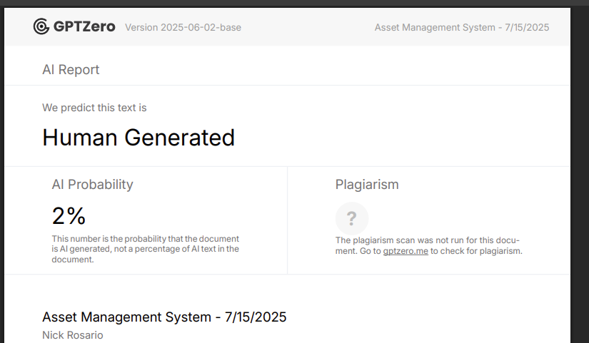

TurnItIn gave me 4% for the structure of the TESTING AND USABILITY ASSESSMENT. I assume this wont hinder my grade.

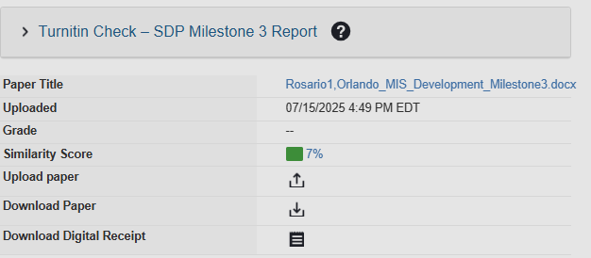

Asset Management System

MILESTONE 1 - Graded

Orlando Nico Rosario

Project plan (Introduction, System Service Request, User Requirements, Feasibility Study, Gantt and PERT Charts, and Baseline Project Plan)

Table of Contents

Milestone 1

**1.0 Introduction** 3

**2.0 System Planning and Selection** 4

2.1 Service Request Form 4

2.2 Scenario 5

**2.2.1 Project Scope** 5

**2.2.2 Project Alternatives** 5

**2.2.3 Project Feasibility** 6

*2.2.3.1 Economic* 6

*2.2.3.2 Operational* 6

*2.2.3.3 Technical* 7

*2.2.3.4 Schedule 7*

*2.2.3.5 Legal and Contractual* 7

*2.2.3.6 Political* 7

2.3 Project Tasks 8

2.4 Budgeting 11

2.5 ROI and Break-Even Analysis 13

2.6 Communication Plan 14

2.7 Project Standards and Procedures 15

2.8 Risk Assessment 16

2.9 Baseline Project Plan 17

2.10 Project Scope Statement 19

**3.0 User Requirements** 20

**4.0 System Requirements** 20

**5.0 GPT Zero and Turnitin Scores** 21

**1.0 Introduction**

Conquer HomeWorks is an inter-state home remodeling shop that has grown beyond its current systems of organization. In 2020 Conquer was formed on the basis of providing local, personalized solutions for people considering home remodeling consultation, design, and construction. However, over the past 5 years, Conquer has taken on over 300 concurrent clients and expanded to more than 50 employee and 5 locations in Massachusetts alone. With the burst in business and employment need, there must be internal efforts to maintain organization and protect business assets.

As the amount of hardware in use continues to grow, maintaining visibility and accountability has become and challenge for the locations Directors of Operations (DOO) as well as the Information Technology (IT) department. With hardware being provisioned to users not coming back, hardware lost in transit, and no formal tracking of these multi thousand dollar items, there is a great need for a formal management system that can be local, and not an excel spreadsheet.

This new system should allow for the insertion of new assets (devices, specialty hardware, and licenses), management of users and locations, warranty tracking, and asset retirement in one system. Logs should be able to be pulled on device assignment history and reports of devices close to warranty expiration.

**2.0 System Planning and Selection**

2.1 Service Request Form

2.2 Scenario

**2.2.1 Project Scope**

The project being presented is as Asset Management System (AMS) that will provide an all-in-one management solution for hardware and software assets across the organization. The system will support asset assignment to users, warranty tracking, and device check-ins/checkouts. For IT and Management alike, administrators will be able to view current assignments, usage logs, and generate reports on company assets. This system is not intended to support items that could be considered consumable (construction supplies, paint, or custom ordered material) or provide employee hardware usage data. Integration into other system can be discussed post integration.

**2.2.2 Project Alternatives**

During our research many options and paths were considered. The underlying factor for each option that was considered is the need to stray away from our current system of using excel sheets. While there is no upfront cost to development or training, there are major error rates, no audit capability, high threat of loss, fraud, or abuse, and its overall not scalable.

Option One, purchase an off the shelf, ‘Turnkey’ software. Products such as Asset Tiger or FreshService ITAM provide a variety features with mobile functionalities and tech support but have limited customization to organization specific needs, recurring costs, and are ultimately cloud hosted, which come with their own set of vulnerabilities.

Option Two, using open source software such as Snipe-IT. Snipe-IT has no cost to license, many enterprise deployments and an active community with integration capabilities and public API’s. However, Snipe-IT requires a heavy understanding of various technical standpoints that can be daunting to maintain or deploy. Snipe-IT provides various features that are not required by Conquer and could lead to increased implementation time as well as support limited to community or paid tiers.

Option Three, developing software internally. This option was ultimately chosen as the system can be customized to specific needs of Conquer and avoids unnecessary features while being scalable. This does require development time, documentation, and testing but provides intimate knowledge of a lightweight application that can easily be supported for future case.

**2.2.3 Project Feasibility**

*2.2.3.1 Economic (more details in 2.4 and 2.5)*

The development of an in-house, lightweight, scalable solution is not as impactful as we originally thought. Only requiring 4 weeks of actual development, this application can be set for completion in less time than stakeholders would spend in a knowledge phase for outsourced systems. The long term savings outweigh the upfront cost, being beyond justifiable from an economic standpoint.

Conquer has been facing hardware losses due to our poor practices and insecure system. Repurchasing of various multi-thousand dollar items and double booking of shared devices or tools brings the company losses financially and in-field operating hours. That’s lost billable hours, and heavily reduced operational efficiency.

Over the next 12-24 months, the system is expected to save tens of thousands on equipment losses, lost billable hours, and reallocate IT hours to more important needs.

*2.2.3.2 Operational*

Primary users of this new systems, Directors of Operations (DOOs), IT staff, and Administrative Support Staff already have integrated into their workflows the preexisting shared excel document use. Moving to an integrated, UI based system will make this easier than before and will benefit these staff directly.

This systems design is intended to replace the existing system with one that has less reliance on email chains and shared folders and directly updates workflows easily. Asset check-in/checkout, assignment, and tracking is all already being done, just in a more archaic way. Adoption/integration time is expected to be minimal and widely accepted by users as a long overdue update.

*2.2.3.3 Technical*

The project builds onto existing systems put in place from the IT department. This new system will be hosted on the preexisting Conquer server and reside on a network drive for enterprise wide updates to be shared and managed, together. Shortcuts can be placed or created onto the required personnels desktops for easier access. Hosting on the server allows all Admins with access to the new ‘Asset Management Folder’ and Asset Management System means no extra server space or hosting systems are required, driving down recurring cost.

This system is feasible within Conquers’ current infrastructure, as detailed above, and aligns with current staff knowledgebases. The application will be python-based and developed with a GUI for front-end use, using MySQL for the backend database. This stack is both lightweight and highly responsive allowing for quick and easy operation. Both Python and MySQL are widely supported and documented meaning anyone can learn the intrinsics of the system, even with little programatical knowledge. No licensure or new hardware is needed, reducing overall project cost exponentially.

*2.2.3.4 Schedule*

This project is feasible within a 50-60 day period, using business hours. All core development is scheduled to get done within 3-4 weeks and have been broken down into Gantt and PERT charts. Supportive tasks are spread out throughout this project development and balanced to avoid deadline pressures or work overflows. Dependencies have been declared, and realistic time estimates have been made, this project can be comfortably finalized within 2 months.

*2.2.3.5 Legal*

All subsystems are hosted internally and are secured via inhouse security protocols. Conquer does not need to apply and compliance standards to this system. Python and MySQL carry permissive licensing, requiring no extra permission for use. The Asset Management System does not involve any data sharing with third parties as it will be created in house. With this, the project is legally and contractually feasible.

*2.2.3.6 Political*

This project has strong internal support from leadership and DOO’s. All parties agree that a new system should be created and implemented with potential, minor resistance from the field teams. Finance will benefit from improved visibility and reduced equipment losses. This system is intended for all-around workflow simplification.

2.3 Project Tasks

|  |  |  |  |
| --- | --- | --- | --- |
| TASK | Estimated Business Days | Begin Date | End Date |
| 1 - Requirements Gathering | 3 | 6/2/2025 | 6/4/2025 |
| 2 - System Design | 5 | 6/4/2025 | 6/11/2025 |
| 3 - Database Engineering | 5 | 6/11/2025 | 6/18/2025 |
| 4 - GUI Development | 5 | 6/18/2025 | 6/25/2025 |
| 5 - Logic Development | 5 | 6/25/2025 | 7/2/2025 |
| 6 - Reporting Development | 3 | 7/2/2025 | 7/7/2025 |
| 7 - Testing and Debugging | 5 | 7/7/2025 | 7/14/2025 |
| 8 - Documentation | 3 | 7/14/2025 | 7/17/2025 |
| 9 - Installation | 2 | 7/17/2025 | 7/21/2025 |

**Estimated Time**

✅ The **Gantt chart and PERT chart** must use **estimated times (ETs)** consistently.

**Gantt Chart**

✅ Your Gantt chart should clearly **show the critical path**, with critical activities connected throughout.  
✅ **Color the critical path in red using MSP** for clear visualization.

**PERT Table with Estimated Total Completion**

|  |  |  |  |  |  |
| --- | --- | --- | --- | --- | --- |
| TASK | Estimated Duration (Days) | | | Estimated Time | Dependencies |
| O | R | P | (O+4R+P)/6 |
| 1 - Requirements Gathering | 2 | 3 | 4 | 3.0 |  |
| 2 - System Design | 5 | 7 | 9 | 7.0 | 1 |
| 3 - Database Engineering | 5 | 7 | 9 | 7.0 | 1,2 |
| 4 - GUI Development | 5 | 7 | 9 | 7.0 | 1,2 |
| 5 - Logic Development | 5 | 7 | 9 | 7.0 | 3, 4 |
| 6 - Reporting Development | 3 | 5 | 7 | 5.0 | 5 |
| 7 - Testing and Debugging | 5 | 7 | 9 | 7.0 | 6 |
| 8 - Documentation | 2 | 3 | 4 | 3.0 | 6 |
| 9 - Installation | 2 | 4 | 6 | 5.0 | 8 |
|  | Estimated Total Completion Time: | | | 51 Days |  |

✅ The start and end dates in the Gantt chart indicate that the estimated total completion time is 50 days.

**Critical Path and Pert Diagram**

|  |  |  |  |  |
| --- | --- | --- | --- | --- |
| TASK | TE | TI | Slack | Critical Path? |
| 1 - Requirements Gathering | 3 | 3 | 0 | Yes |
| 2 - System Design | 7 | 7 | 0 | Yes |
| 3 - Database Engineering | 7 | 7 | 0 | Yes |
| 4 - GUI Development | 7 | 7 | 0 | Yes |
| 5 - Logic Development | 7 | 7 | 0 | Yes |
| 6 - Reporting Development | 5 | 5 | 0 | Yes |
| 7 - Testing and Debugging | 7 | 9.5 | 2.5 | No |
| 8 - Documentation | 3 | 3 | 0 | Yes |
| 9 - Installation | 4 | 4 | 0 | Yes |

✅ The critical path(s) in the PERT chart should be highlighted in red.

**Slack**

✅ Slacks should be **derived from MSP Gantt/Network results** rather than manually assigned. Please include MSP results for verification.

2.4 Budgeting

**Tangible Benefits**

|  |  |  |
| --- | --- | --- |
| Benefit | Detail | Amount |
| Recovered Assets | Lost/Misplaced/Stolen Asset reduction (est. 6 ) | ~$9,000 |
|  |
| Downtime Reduction | Inactive field hours awaiting replacement hardware (@100/hr) | ~$5,000 |  |
|  |
| Hardware Reordering | Reduced duplication of hardware (ordering when assumed lost, est. 3) | ~$4,500 |  |
|  |
| License/Software Control | Removing unused licenses (est. 5) | ~$100 |  |
|  |
| Warranty Control | Warranties revitalizing broken/damaged assets (est. 5) | ~$7,500 |  |
|  |
|  | Estimated Total Savings Year 0 | ~$21,600 |  |
| *Discount Rate 12%* | Estimated Total Savings Year 1 | ~$19,008 |  |
| *Discount Rate 12%* | Estimated Total Savings Year 2 | ~$16,727 |  |
| *Discount Rate 12%* | Estimated Total Savings Year 3 | ~$14,719 |  |
| *Discount Rate 12%* | Estimated Total Savings Year 4 | ~$12,953 |  |

✅ Ensure that tangible benefits are correctly tallied. The total should be $26,100.

With the introduction of this new system, end users (DOO’s, IT Staff, and administrative support staff) will experience a streamlined, efficient, and new way of asset management and reporting. All hardware is now accounted for and can be tracked to staff across all management tiers and various locations if stocked. This will hold accountability to people and departments, reducing loss, preventing abuse and fraud, and limiting misplacement. All hardware that is pre-allocated to field techs will no longer be double booked, and field visits will be properly prepared for reducing inactive field hours. A great reduction in hardware reordering is expected as there will be less loss and less ad hoc/as needed purchasing. Expenses are reduced on that front because of proper initial preparation. Audits of expiring or out of use licenses can be pulled for cost reduction. Warranties can now be actively accounted for, and device can be tracked as ‘In Warranty’ streamlining warranty claim workflows and getting hardware back into the hands of staff.

**One Time Costs – Year 0**

|  |  |  |
| --- | --- | --- |
| Benefit | Detail | Amount |
| Internal Development | 28 work days @ $35/hr (avg rate) (IT gets paid anyways) | ~$7,840 |
|  |
| User Training | Onboarding Admins, presentation and meeting with Admins (2 Hour Meeting) | ~$300 |  |
|  |
| Documentation and Training Material | Creating Internal User Guides 3 work days @ $35/hr | ~$840 |  |
|  |
| Host Infrastructure | Existing OnPrem Server | ~$0 |  |
|  |
|  | Estimated Total Cost Year 0 | ~$8,980 |  |

There are set costs for the creation and implementation of this system, accounted for above. These mainly consist of costs of labor for our staff that would be an expense if we outsourced the system development to a Software Development Company or IT Managed Service Provider. Ultimately, IT staff would be getting paid their hourly rates anyways and this can be looked at not as a one-time cost, but part of regular staff salaries. Of course this could also be turned into a bonus or overtime budget for IT staff incentive. Thankfully, we already hold an onprem server at the headquartered location in Lawrence, MA and staff already have VPN access via Cisco provisioned to their devices for access to Network Drives within this onprem server from any of our 5 shop locations. This all limits the hosting infrastructure cost as it simply already is set in place. This project is really built off of what we already have, limiting costs, maximizing return, and generating operational efficiency.

**Recurring Costs – Year 1-5**

|  |  |  |
| --- | --- | --- |
| Benefit | Detail | Amount |
| Annual Trainings | 1 Hour Meeting with Admins | ~$150 |
|
| Application Maintenance | As Needed Patches and HotFixes (est. semi-annually 4hr each @ 35/hour | ~$280 |
|
|
|  | Estimated Recurring Costs | ~$430 |

|  |  |  |  |  |  |  |  |
| --- | --- | --- | --- | --- | --- | --- | --- |
|  |  |  |  |  |  |  |  |
|  | Years | | | | | | |
|  | 0 | 1 | 2 | 3 | 4 | 5 | Totals |
| Net Economic Benefit | $ - | $ 21,600.00 | $ 21,600.00 | $ 21,600.00 | $ 21,600.00 | $ 21,600.00 |  |
| Discount Rate (12%) | 1.00 | 0.8929 | 0.7972 | 0.7118 | 0.6355 | 0.5674 |  |
| PV of Benefits | $ - | $ 19,008.00 | $ 16,727.04 | $ 14,719.80 | $ 12,953.42 | $ 11,398.01 |  |
|  |  |  |  |  |  |  |  |
| NPV of All Benefits |  | $ 19,008.00 | $ 35,735.04 | $ 50,454.84 | $ 63,408.26 | $ 74,806.27 | $ 74,806.27 |
|  |  |  |  |  |  |  |  |
| One Time Cost | $ 8,980.00 |  |  |  |  |  |  |
|  |  |  |  |  |  |  |  |
| Recurring Costs | $ - | $ (430.00) | $ (430.00) | $ (430.00) | $ (430.00) | $ (430.00) |  |
| Discount Rate (12%) | 1.00 | 0.8929 | 0.7972 | 0.7118 | 0.6355 | 0.5674 |  |
| PV of Costs | $ - | $ (378.40) | $ (332.99) | $ (293.03) | $ (257.87) | $ (226.92) |  |
|  |  |  |  |  |  |  |  |
| NPV of All Cost | $ (8,980.00) | $ (9,358.40) | $ (9,691.39) | $ (9,984.42) | $ (10,242.29) | $ (10,469.21) | $ (10,469.21) |
|  |  |  |  |  |  |  |  |
| Overall NPV |  |  |  |  |  |  | $ 85,275.48 |
|  |  |  |  |  |  |  |  |
| ROI = Overall NPV/NPV of All Costs | |  |  |  |  |  | 815% |
|  |  |  |  |  |  |  |  |
| Break-Even Analysis | |  |  |  |  |  |  |
| Years | | 0 | 1 | 2 | 3 | 4 | 5 |
| Yearly NPV CashFlow | | $ (8,980.00) | $18,629.60 | $16,394.05 | $14,426.77 | $12,695.55 | $11,171.09 |
| Overall NPV CashFlow | | $ (8,980.00) | $9,649.60 | $26,043.65 | $40,470.42 | $53,165.97 | $64,337.06 |
|  |  |  |  |  |  |  |  |
| Project Break-Even occurs between year 0 and 1 | | | | |  |  |  |
| Use First Year of Positive cashflow to calculate break even fraction = .482 | | | | |  |  |  |
| Year 0 Cash Flow/ Year 1 CashFlow =.482 | | |  |  |  |  |  |
| Actual Break-Even occurred at .482 years | | | | |  |  |  |
| Break-even occurs on December 21, 2025. A great Christmas present! | | | | |  |  |  |
| (365*.48 = 175days, 175 + install date of 6/21/25 = 12/21/25) | | | |  |  |  |  |

2.5 ROI and Break-Even Analysis

✅ Some figures require corrections:

* **Install date is 7/21/2025**.
* **Break-even date** is counted from the start date i.e., 6/2/2025, not the install date.

✅ Missing **Break-Even Chart**.

2.6 Communication Plan

|  |  |  |  |
| --- | --- | --- | --- |
| Stakeholders | Goal | Medium | Date/Frequency |
| IT/IS, CTO, Project Manager, Directors of Operations, COO, Administrative Support Staff | Initial Project Plan Meeting, discuss timeframes, budget, concerns, high level system capabilities | F2F | 6/4/2025 |
|  |
|  |
| CTO, Project Manager | High level Project Updates and Progress | F2F or Teams | Thursday Weekly |  |
| Assigned IT/IS Developer and Project Manager | Discuss last week’s completions, current week schedule/workflow | F2F or Teams | Monday Weekly |  |
|  |
| CTO, Project Manager, Assigned IT/IS Developer | Implementation workflows, post development ideas and concerns, application walkthrough | F2F or Teams | 7/16/2025 |  |
|  |
| IT/IS, CTO, Project Manager, Directors of Operations, COO, Administrative Support Staff | Implementation Announcement, Documentation Overview, changes to expect | F2F | 7/17/2025 |  |
|  |
|  |
| IT/IS, DOO's, Administrative Support Staff | Hands on Application Training, Q&A | F2F or Teams | 7/18/2025 |  |
|  |
| IT/IS, CTO, Project Manager | Project Close, questions comments concerns, possible future integrations | F2F or Teams | 7/21/2025 |  |
|  |
| IT/IS, CTO, Project Manager, Directors of Operations, COO, Administrative Support Staff | End User Survey to measure overall feeling towards application | email | 7/25/2025 |  |
|  |
|  |

✅ Provide narratives for your **communication plan**.

2.7 Project Standards and Procedures

To ensure fluid progress and transparency throughout the process, weekly meetings have been put into place between IT/IS, CTO, and the PM. The project manager hold the responsibility of ensuring that all parties are properly informed and operate within the same goals and objectives. The CTO receives project check-ins and ensure work is being completed. The IT/IS developer provides project updates that align with the Project Tasks list to the PM and manages timeliness and work. Any and all concerns or time-related issues are to be addressed within these meetings.

To ensure the application considerations are being met, the project manager will relay any and all information from the CTO down to the developer. IT/IS helpdesk staff will communicate and infromation that comes in via email to the project manager and passed off to the appropriate party.

This system will be integrated into HR workflows as hardware agreements are delivered to onboarded staff, devices are assigned to them physically and digitally. Similar process will be followed for offboarding.

All documentation will follow a predefined format of naming conventions and structures to ensure all end users can pick up and operate fluidly. All code will contain comment documentation in cleartext for debugging and tracking for future, potential IT/IS staff to review. Clear guidelines have been set for application development and the IT/IS developer will code features in that are in best interest of the company.

Post integration a survey will be sent out to all end users that are to have contact with the new system as a medium of conveying ideas, unknown bugs, and possible integrations into other systems. These responses can be sent to the helpdesk email account for assignment and review to the developer and potentially addressed in future patches or hotfixes.

2.8 Risk Assessment

This system will wholly manage nearly one hundred thousand dollars ($100,000) worth of assets belonging to Conquer and with hardware there is always risk of fraud and abuse from any employee in contact with any device. We aim to minimize risk of hardware abuse or fraud with the built in logging functionality. Logs can be pulled from any user with access to the system and view into changes (transactions) between devices and assigned personnel. Where staff that may try to abuse the trust and agreement signed by them, the logs count device assignment history and can be addressed as such. Similar goes with admins, if many hardware units are being assigned or re-assigned to staff, these transactions are reported in the system and can be used for disciplinary or legal action.

Similarly, this system is available to risk via threat actors at a system level. With the specific libraries used in the system and SQL usage, malicious code can be injected (SQL Injections) or ran on staff devices to export or capture this data. While the database may not hold any sensitive data, injections can alter data bypassing log functions. These are worst case scenarios but should be considered, nonetheless. Hi threat cases are to be reported and logged, discussed and responded to within the IS/IT department, then appropriately forwarded to the Director of IT.

2.9 Baseline Project Plan

**Introduction**

*Project Overview* – Conquer HomeWorks is moving to replace its outdated methods of asset management to one that can manage assignment, movement, and lifecycle tracking for hardware, software, and field tools.

*Recommendation –* Develop a lightweight system in-house using Python and MySQL to support operational needs. This avoids bloat, offers full open source control, and is scalable for future wants and needs.

**System Assessment**

*Alternatives –* Three alternatives were measured: current Excel Sheets, purchasing Turn-Key software, or deploying open-source systems. Each was ruled out because of limitations in control, cost, or complexity.

*System Description* – New system will allow for users and device registration, check-in/checkouts, warranty tracking, and reporting infrastructure. All data will be stored on an internet MySQL database and accessible via a GUI.

**Project Feasibility**

*Economic* – Initial costs are estimated around $8,980 for development and training with an annual savings exceeding $21,000. The system will pay for itself within the first year.

*Operational* – The system is similar to current workflows that are familiar to end users, however, are more efficient. This minimizes training and encourages faster system acclimation.

*Technical* – Python and MySQL are widely used and integratable within existing infrastructure. This application will be hosted on Conquers on premise server.

*Legal and Contractual* – No third parties are involved, and all tools are permissible without licensing. Data is hosted internally regulating data concerns.

*Political* – There is already strong support from all stakeholders for the system. Minor resistance may come from field teams but is manageable, nonetheless.

*Schedules, Timeline, and Resource* – Development is expected to take 4-5 weeks with the entire process taking just under 2 months. All tasks and their dependencies are tracked with Gantt and PERT charts with IT/IS staff handling most of the project.

**Implementation**

*Team Configuration and Management* – This project is being managed by Project Manager Orlando Rosario and developed by IT/IS developer Nico Rosario. Orlando is to check in with Nico on a weekly basis on project updates and progress.

*Communication Plan* – Check-ins are every Monday and Thursday between IT/IS, CTO, and the PM. Milestone reviews and end user feedback sessions are scheduled for during walkthroughs and rollout phases.

*Technical* – System will use PythonGUI for the GUI and MySQL for the backend database. This will all be hosted on the Conquer existing server. Shortcuts will be created for end users to copy and paste onto their laptops. The system will have managed access via network permissions.

*Project Standards and Procedures* – Documents and code are to follow consistent formatting, with plaintext comments for clarity. Notes, feedback, and bugs reports are to be tracked and addressed through an internal process.

2.10 Project Scope Statement

**General Project Information**

*Project Name*: Conquer HomeWorks Asset Management System

*Sponsor*: Tony Matias Owner and CEO

*Project Manager*: Orlando Rosario

**Problem/Opportunity Statement**

Conquer HomeWorks currently uses Excel sheets to manage hardware and software. This results in asset loss, no reporting, and no tracking. A formal system needs to be developed for tracking, accountability, and lifecycle management.

**Project Objectives**

Design and implement an asset management application that can track assignments, check-in/checkout, lookup warranty status, and report for all Conquer Assets.

**Business Benefits**

* Reduces Losses
* Improved Field Uptime
* Enhance Tracking
* Improved Budgeting with less expenses
* Reliable Asset Data

**Deliverables**

* Python GUI application with MySQL backend
* Check-in/Checkout functionality
* Asset tracking dashboards and reports
* Documentation and material for user training

**Estimated Project Duration**

2-2.5 Months

✅ ~50 days.

**3.0 User Requirements**

This systems allows users CRUD actions to assets, pull asset logs, and view into warranties. Users are required to understand company policy regarding assets and their provisioning regulations. Documentation will be provided for additional learning material but participation during the training meeting is mandatory for this new system.

Users must be able to register new devices, assign them to the proper staff, check hardware in or out, and mark items as damaged for processing. Users can only access this via their company assigned device on the company network via direct or VPN access.

**4.0 System Requirements**

**Hardware:**

End User:

* Laptop
* Access to Company Network

Server:

* LAN connection
* Sufficient Hard Drive Storage

**Software:**

End User:

* Windows, MacOS, or Linux enabled device
* Network Drive Connectivity
* Up to date system drivers

System:

* Python 3.9
* MySQL 8.0 Suite and Connector
* Configured drive for network storage
* PySimpleGUI

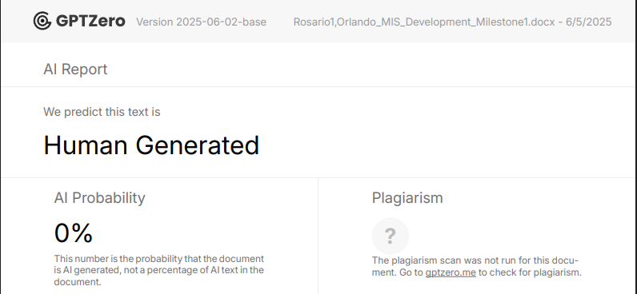**5.0 GPT Zero and Turnitin Scores**

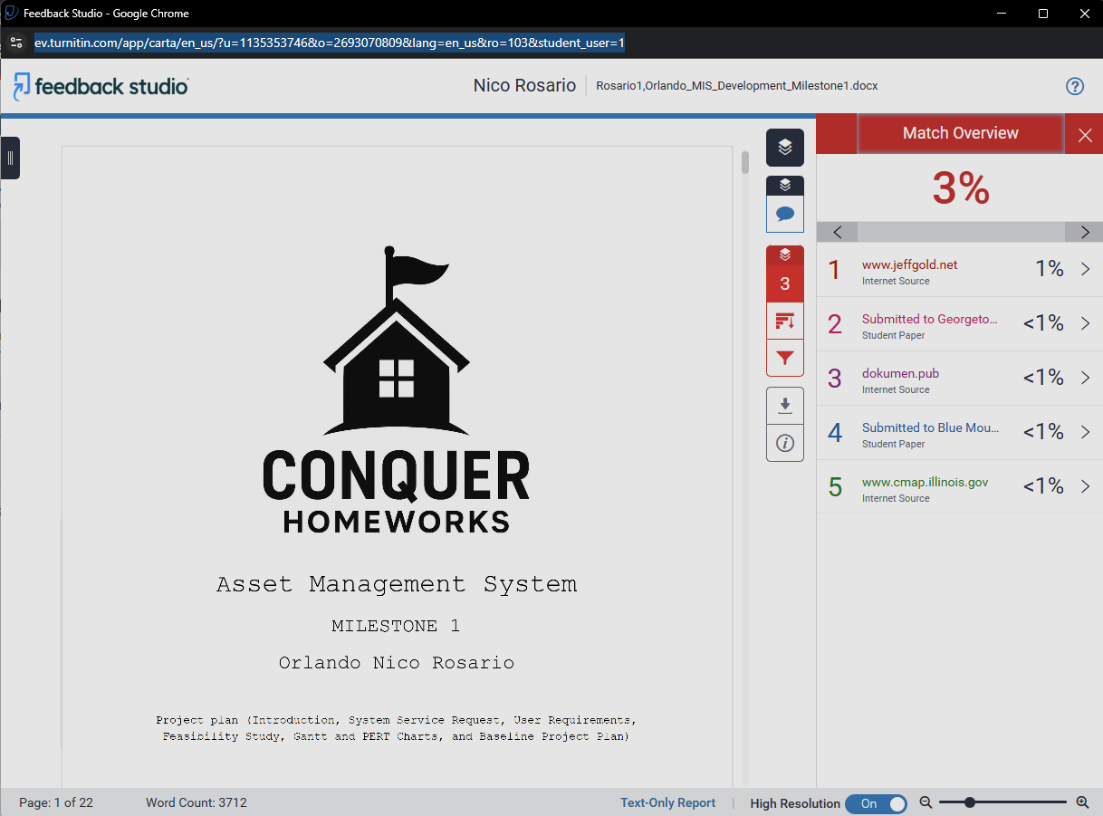

Asset Management System

MILESTONE 2 - Graded

Orlando Nico Rosario

Table of Contents

Milestone 2

**5.0 Data Flow Diagrams** 22

5.1 Context Diagram 22

5.2 Level 0 Diagram 23

5.3 Leveled Diagrams 24

**5.3.1 Level 1 Data Flow Diagrams** 24

**5.3.2 Primitive Data Flow Diagrams 26**

**5.3.3 Gap Analysis 26**

**5.3.4 Naming Standards for Processes 26**

**5.3.5 Naming Standards for Data Flows 26**

**5.3.6 Data Consistency and Conservation 26**

**6.0 Entity Relationship Diagrams** 27

6.1 Relationships and Cardinalities Explained 27

6.2 Conceptual Entity Relationship Diagrams 28

6.3 Entity Relationships 29

**7.0 Data Dictionary** 30

**8.0 GPT Zero and Turnitin Scores** 31

**5.0 Data Flow Diagrams**

5.1 Context Diagram

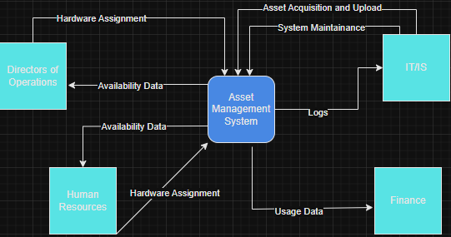

✅ **Missing "0" in Context Diagram**: The correct number for the **Context Diagram is "0"**.

The context diagram above depicts a generalized high-level view for the use of the new system. This focuses on who interacts with the system and what is being done. Directors of Operations (DOOs) and HR handle most of the asset transactions with assignments to field technicians and newly onboarded staff. The main transactions from these end points include check-in/checkouts, hardware damage logging, and movement tracking to name a few. IT/IS is responsible for uploading new assets and downloading data for reporting or logs. Additionally, they provide application maintenance, hardware maintenance, warranty processing, and location tracking. Finance uses system logs to determine the life cycle of hardware with retired device counts, date/times, and warranty data. This diagram keeps things simple, so we are all clear on the generalized use of the system.

5.2 Level 0 Diagram

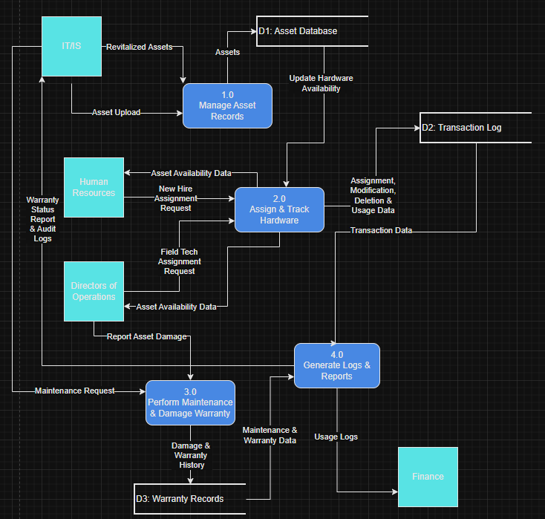

✅ **Inconsistent data flow names.**

**✅ Incorrect data flow names. Verbs are not allowed in data flow names; if a verb is needed, it likely indicates a process instead.**

From a Level 0 perspective, we can break down the core system into 4 subsystems. Asset Records management holds the input of assets into the database done by IT/IS. The data within the database is available to HR and the Directors of Operations (DOO) for assignment to new staff and field technicians. Each assignment and asset modification is tracked and logged in the systems backend. DOO’s are required to log any and all damaged assets into the system for maintenance or warranty. IT/IS is responsible for handling those warranties and providing maintenance to the system, these actions are logged. All records are available for download for IT/IS auditing and Finance budgeting efforts. Everything ties back to the internal database to maintain order and organization.

5.3 Leveled Diagrams

**5.3.1 Level 1 Data Flow Diagrams**

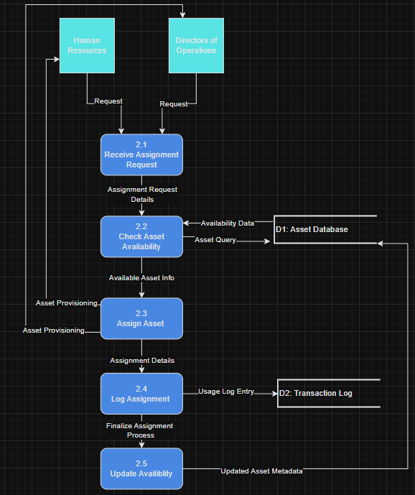2.0 Assign & Track Hardware

✅ **Inconsistent data flow names.**

**✅ Undefined data flow names in Level-0 - “Asset Query” and “Updated Asset Metadata”.**

Above we are taking subprocess 2.0 (Assign & Track Hardware) and breaking it down into its own subprocesses. This visualizes asset requests from start to finish. Whether the request is from HR or the DOO’s, its fed into a centralized request intake process. The details are passed in and checked for availability on the backend database. If good, asset data is passed down and the hardware provisioned back to the requesting party. Asset changes are then logged and availability updated in the backend. The breakdown makes the process easier to understand and gives insight into how user input becomes a more structured assignment process ensuring visibility and accountability across the board.

3.0 Perform Maintenance & Damage Warranty

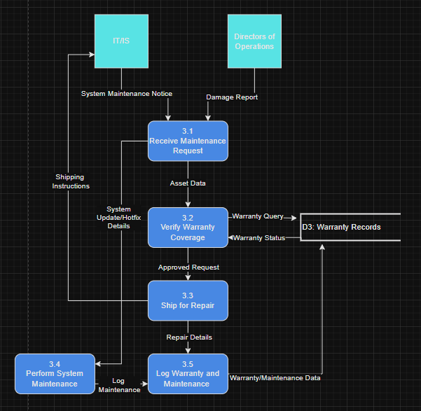

✅ **Inconsistent data flow names.**

**✅ Undefined data flow names in Level-0 - “Shipping Instructions” and “Warranty/Maintenance Data”.**

For the Perform Maintenance & Damage Warranty process (3.0), we broke it up to capture the 2 main parts of the process, system maintenance and asset revitalization. DOO’s are to submit damage reports on hardware that is in circulation in that location. Asset data is passed through to verify warranty coverage. Hardware is then shipped out for warrantied repair or replacement and logged within the system. IT/IS typically manages the shipping out process as delegated by the department. System maintenance is performed after a request is made via the communication plan or other forms of request. After the update is done, the maintenance is logged and sent to the warranty records. All actions are tracked, and readily available for audit.

**5.3.2 Primitive Data Flow Diagram**

The primitive data flow diagram is capped out at level 1 for subprocess 2.0 and 3.0. The other actions would be too simple to breakdown as they are boiled down to single queries or logging. Subprocess 3.0 and 3.0 were the most complex parts of the system. They had multiple steps, required logic, and interacted with external and internal components. Each process was broken in 5 subprocesses that fully describe the entirety of the process. These level 1 diagrams portray the most primitive level in the systems modelling and provide intimate knowledge of the system deepest functions.

**5.3.3 Gap Analysis**

Gap analysis was performed to determine if any discrepancies were present in any of the diagrams, nothing was found. There are plenty of discrepancies in the old model, the previous system. These included double booked tools, no warranty validation, no automated assignment, and no logs. These are moved to be repaired with the new system and its automated features.

**5.3.4 Naming Standards for Processes**

All process are labeled using the verb-noun format as required to clearly describe all functions. Examples include “Assign & Tracking Hardware” and “Verify Warranty Coverage”, these ensures understanding across all domains.

**5.3.5 Naming Standards for Data Flows**

Data flows are named with clear noun phrases, as required, to describe the infromation as it moves. Examples like “Asset Query” and “Assignment Request” keeps the focus on what is being passed not how its processed.

**5.3.6 Data Consistency and Conservation**

Every data flow and data store in the diagram is consistent across all diagrams. If a data store receives asset info in one process, it’s the same format in the other. Data conservation is maintained because data entering the system is either transformed, stored, or forwarded without being lost.

**6.0 Entity Relationship Diagrams**

6.1 Relationships and Cardinalities Explained

The Asset Management System database consists of 4 entities, Locations, Users, Transactions, and Assets. All but locations receives foreign keys from one another with transactions being the main host of data, used for logging and audits. The Users entity has a 1:M relationship with transactions as only one user can be in a transaction, but multiple transactions can occur for one user. Each user and asset is assigned a location. Locations can have multiple users and assets, but users and assets can only have one location.

As stated prior, the transactions table linked together assets, users, and locations (from and to locations) to capture movement of items. Each location can be associated with multiple transactions, in either location column, while transactions can only have 1 source and final destination. All relationships are reflected in the data flow diagrams via the data flows and stores such as the transaction log data store and the transactions table.

6.2 Conceptual Entity Relationship Diagram

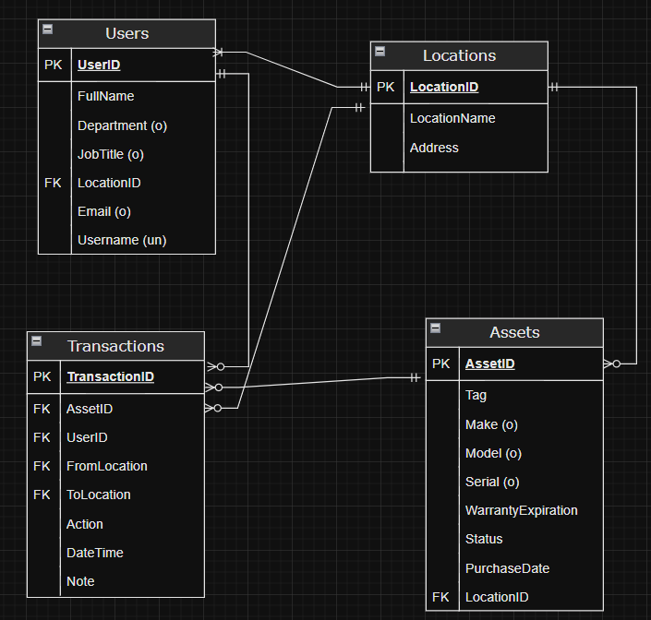

✅ Two-way relationships are missing. Refer to **Figure 7.3** in the textbook for proper **two-way relationship representation**.

6.3 Entity Relationships

There are ternary relationships between the following:

* Transactions, Users, Assets: A user starts the transaction to check out or reassign a hardware asset and that transaction records which user operated on which asset, this is logged.
* Transactions, Locations, Assets: An asset is moved from one location to another via a transaction. Both locations, the asset, and the time are logged via transactions table.

The binary relationships include:

* Users, Locations: Each user is assigned to one location, and one location can have many users.
* Assets, Location: Similarly, each asset has one location, and one location can have many assets.
* Transactions, Users: A user performs a transaction, and that transaction can only have one user assigned to it.
* Transactions, Assets: An asset is altered via a transaction, one transaction links to one asset however one asset may have many transactions.

**7.0 Data Dictionary**

|  |  |  |  |  |  |
| --- | --- | --- | --- | --- | --- |
| Entity | Attribute | Type | Size | Example | Description |
| Users | UserID (PK) | int | 25 | 21 | User Primary Key |
| Users | FullName | varchar | 100 | Jacob Gull | Users First and Last Name |
| Users | Department | varchar | 100 | Finance | User Department |
| Users | JobTitle | varchar | 100 | Associate | Users Position at Conquer HW |
| Users | LocationID (FK) | int | 25 | 35 | Users assigned location |
| Users | Email | varchar | 100 | [jgull@chw.com](mailto:jgull@chw.com) | User company Email |
| Users | Username | varchar | 100 | jgull | Username (email minus domain) |
| Transactions | TransactionID (PK) | int | 25 | 55646 | Transaction Primary Key |
| Transactions | AssetID (FK) | int | 25 | 56 | Asset foreign Key |
| Transactions | UserID (FK) | int | 25 | 21 | User foreign Key |
| Transactions | FromLocation (FK) | int | 25 | 5 | Source Location Foreign Key |
| Transactions | ToLocation (FK) | int | 25 | 4 | Destination Location Foreign Key |
| Transactions | Action | varchar | 100 | Move | Operation on Asset |
| Transactions | DateTime | date | 20 -> 12 | 06/07/2025 9:31am | Time of operation |
| Transactions | Note | varchar | 800 | Changed Branches | Optional Note Input |
| Location | LocationID (PK) | int | 25 | 5 | Location Primary Key |
| Location | LocationName | varchar | 100 | Woburn | Location/Office name |
| Location | Address | varchar | 100 | 111 Unicorn Ave, Woburn MA 01801 | Location Mailing Address |
| Assets | AssetID (PK) | int | 25 | 56 | Asset primary key |
| Assets | Tag | varchar | 100 | Impact Gun | Asset general item name |
| Assets | Make | varchar | 100 | Snap On | Asset brand |
| Assets | Model | varchar | 100 | Monster Lithium Cordless | Asset Model Name |
| Assets | Serial | varchar | 100 | WG599451 | Asset Serial Number |
| Assets | WarrantyExpiration | date | 20 -> 12 | 7/9/31 12:00 AM | Asset Warranty expiration date |
| Assets | Status | varchar | 100 | In Field | Asset operation status |
| Assets | PurchaseDate | date | 20 | 7/9/21 12:00 AM | Asset date of purchase |
| Assets | LocationID (FK) | int | 25 | 5 | Asset active location foreign key |

✅ Use prototypes or actual examples of forms and reports—such as receipts, invoices, and summary reports—to help identify the necessary entities and attributes.

✅ Refer to your data examples and assign appropriate data sizes accordingly.

**8.0 Milestone 2 Turnitin & GPT Zero**

